**NIFTY PREDICTION FOR 22/07/2019:**

**NIFTY HEADING TOWARDS OUR TARGETS 11330/11300 LEVELS.**

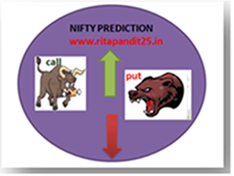

**HOLDING 11300 CAN SEE 11550 LEVELS. TRADING BELOW 11278 CAN SEE 11200/11130 LEVELS.**

**SAR: 11610 NS. PRICE HOLDING BELOW SAR.**

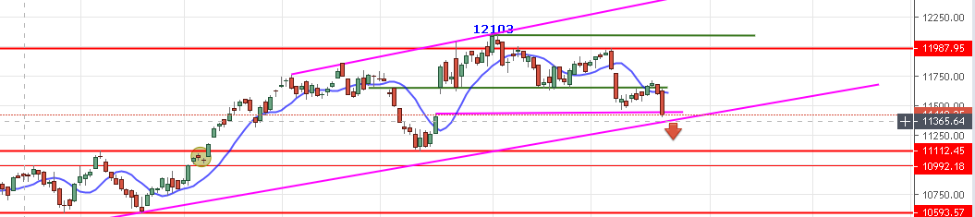

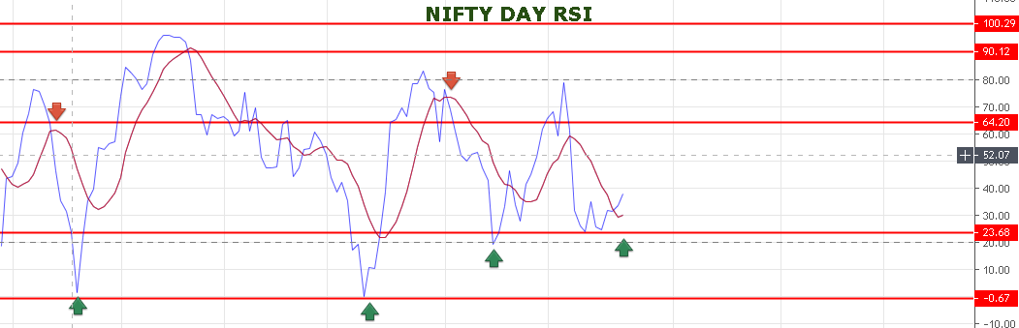

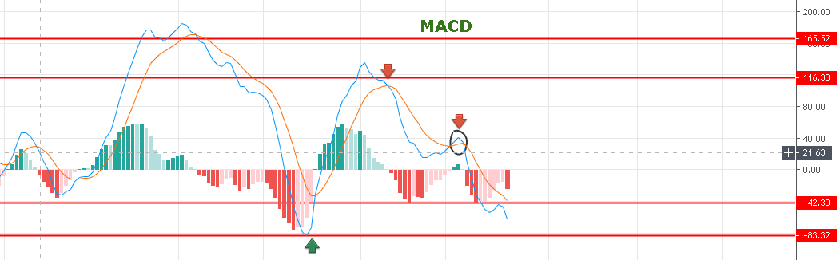

[**https://youtu.be/M4a1m2UlGfI**](https://youtu.be/M4a1m2UlGfI)

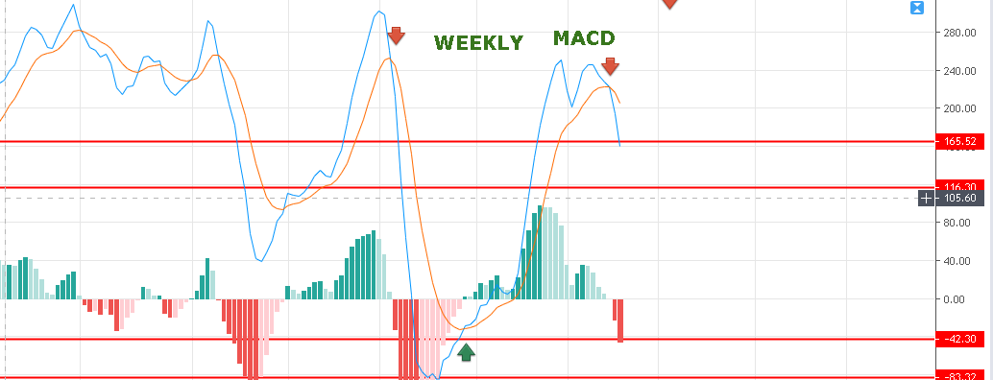

**WEEKLY MACD LOOKS HORRIBLE.**

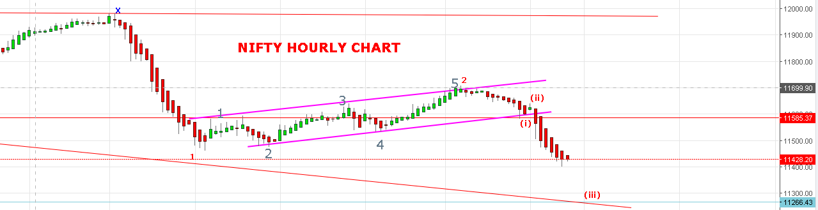

**IF WAVE (iii) DONE @11399 OR WILL DO @11330 THEN WAVE (iv) WILL BOUNCE TOWARDS 11550 LEVELS.**

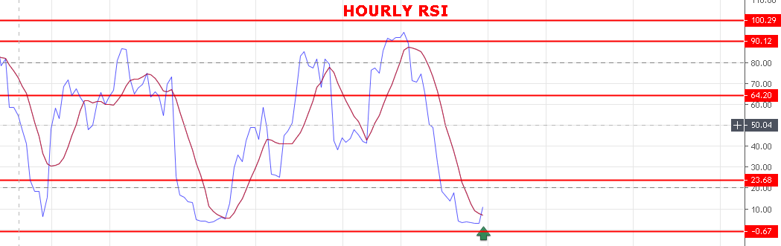

**HOURLY RSI AT OVERSOLD ZONE.**

**WEAK BELOW 11560 NS.**

**STRONG ABOVE 11640 NS.**

**BEARISH BELOW 11278 NS.**

**BULLISH ABOVE 11720 NS.**

**SUPPORT: 11355-11330-11300-11280.**

**RESISTANCE: 11485-11503-11540-11565.**

**NIFTY OPTION FOR 22/07/2019:**

**BUY 11400 CE 25 JULY@88 STOP 76 TGT 94-99-115-124-140.**

**BUY 11400 PE 25 JULY@67 STOP 50 TGT 77-88-93-103-113-127.**

**PE TO BUY BELOW 11392 NS, CE ABOVE 11460 NS.**

**NOTE: Once we made Profit in Two or Third Trade Rs2000/5000 then Exit Trading for the Day. Over Trading and Greed results Losses.IN CASE OF LOSS MORE THAN 5000 EXIT TRADE FOR THE DAY. My work is to give call just ignore it if you made handsome profit for the day. ALWAYS KEEP STOP LOSS AND FOLLOW REENTER RULES.NEVER TRADE IN BULK QTY. MAX QTY 10 LOTS MIN 1 LOT.**