**NIFTY PREDICTION FOR 08/07/2019:**

**NIFTY HOLDING BELOW 11850 CAN SEE 11761-11680 LEVELS.**

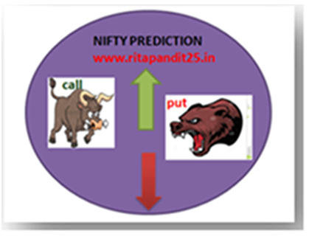

**SAR: 11862 NS. PRICE CLOSED BELOW SAR.**

**NIFTY FORMS LONG BEARISH CANDLE ALMOST MARUBOZU.**

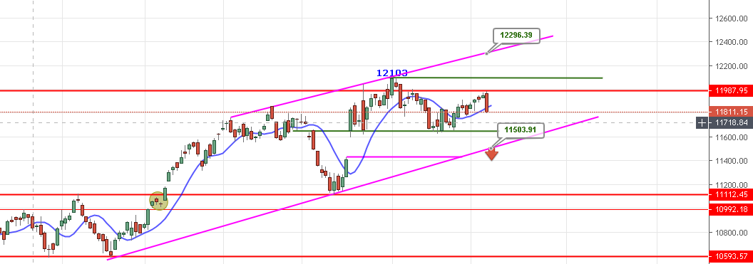

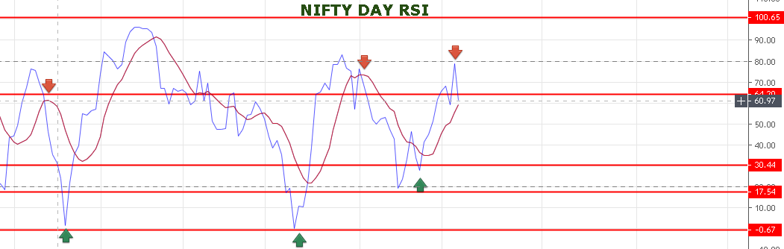

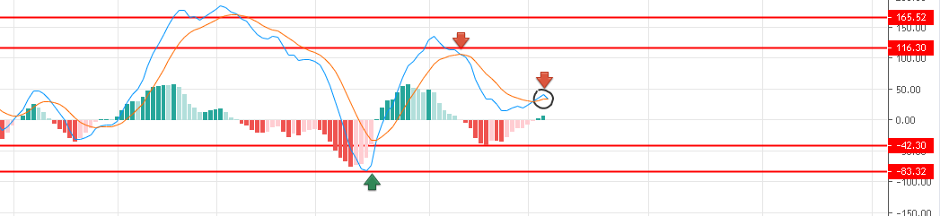

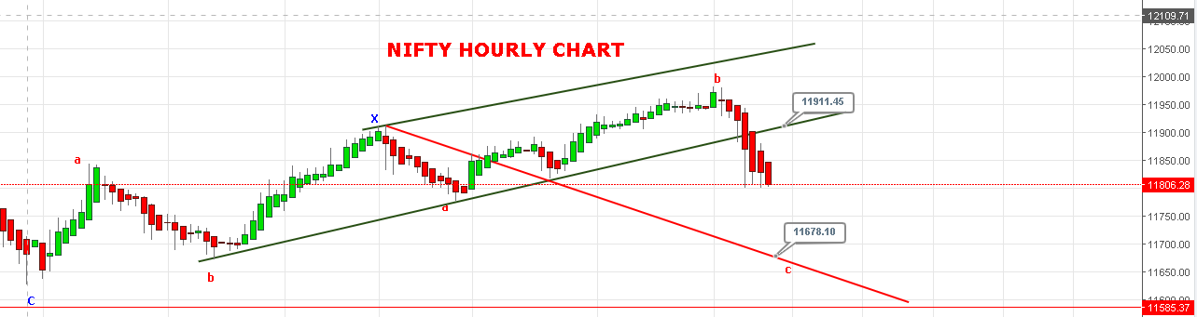

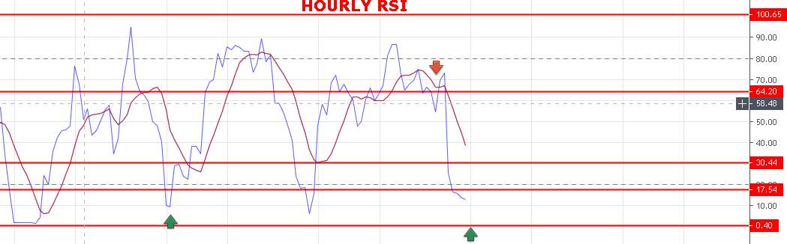

**WEAK BELOW 11846 NS.**

**STRONG ABOVE 1900 NS.**

**BEARISH BELOW 11614 NS.**

**BULLISH ABOVE 11945 NS.**

**SUPPORT: 11788-11726-11707-11645.**

**RESISTANCE: 11840-11871-11898-11919.**

**WE CAN SEE ONE SIDE MOVE ON MONDAY.**

**NIFTY OPTION FOR 08/07/2019:**

**BUY 11800 CE 11 JULY@89+ STOP 73 TGT 105-119-131-140.**

**BUY 11850 PE 11 JULY@110+ STOP 91 TGT 130-144-158-169-180.**

**PE TO BUY BELOW 11796 NS, CE ABOVE 11836 NS.**

**NOTE: Once we made Profit in Two or Third Trade Rs2000/5000 then Exit Trading for the Day. Over Trading and Greed results Losses.IN CASE OF LOSS MORE THAN 5000 EXIT TRADE FOR THE DAY. My work is to give call just ignore it if you made handsome profit for the day. ALWAYS KEEP STOP LOSS AND FOLLOW REENTER RULES.NEVER TRADE IN BULK QTY. MAX QTY 10 LOTS MIN 1 LOTS.**