**BANK NIFTY PREDICTION FOR 22/07/2019:**

**BANK NIFTY HEADING TOWARDS OUR TARGETS 29550/29500 LEVELS.**

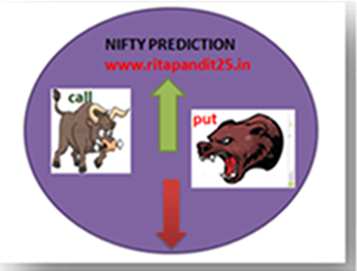

**HOLDING BELOW 29500 CAN SEE 29200 LEVELS. HOLDING 29500 CAN SEE 29950/30000 LEVELS.**

**SAR: 30592 BNS. PRICE CLOSED BELOW SAR SECOND DAY. SHORT STOP 30592 BNS.**

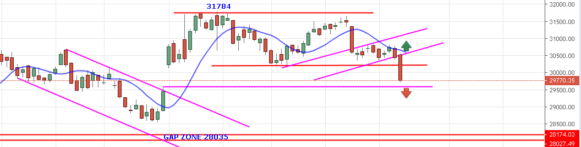

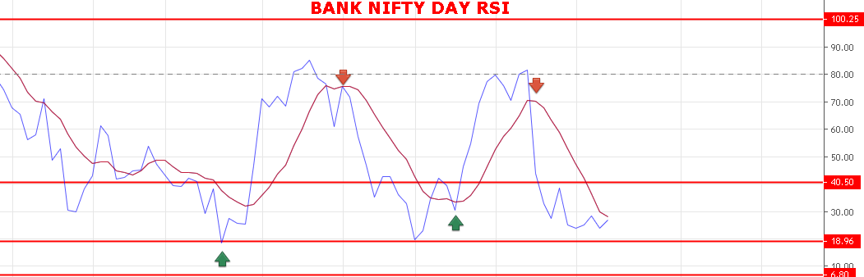

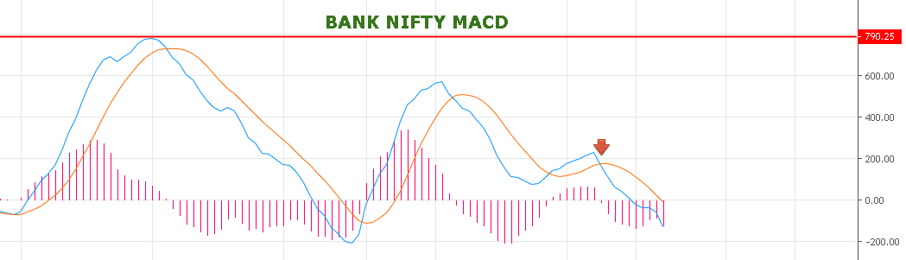

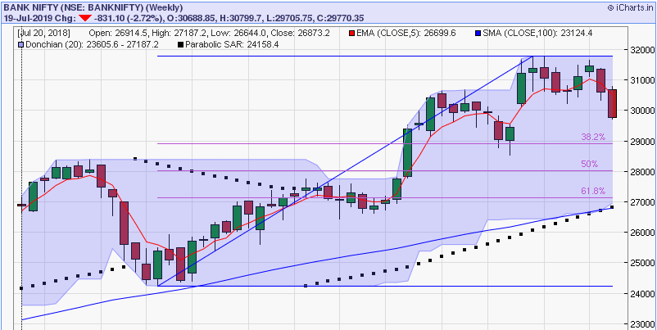

**WEEKLY CHART SUGGESTS PRICE WILL FIND SUPPORT NEAR 38.2% FIBO RETRACEMENT @28950 LEVELS. AS LONG PRICE HOLDING BELOW 30515 WE CAN SEE DOWNWARDS MOVE TILL 28950. IF BREAK 28950 ON WEEKLY CLOSING BASIS THEN 28000 TO 27200 WOULD BE NEXT SUPPORT.**

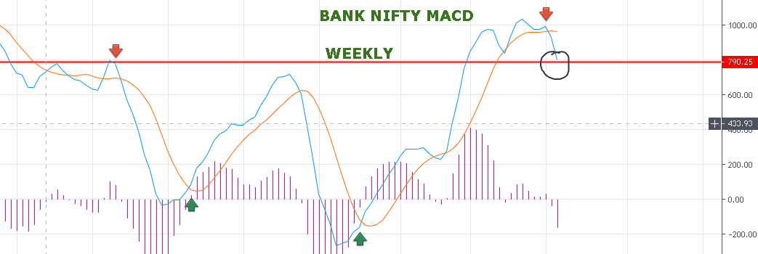

**IF WEEKLY MACD BREAK BELOW RED LINE THEN ABOVE LEVEL CAN SEE.**

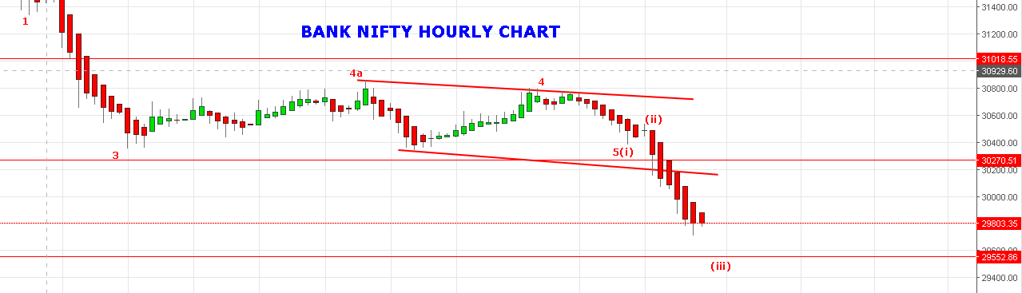

**SUB WAVE 5(iii) DONE@29700 OR WILL DO 29550 THEN WAVE (iv) WILL BOUNCE FOR 29900/30000 LEVELS.**

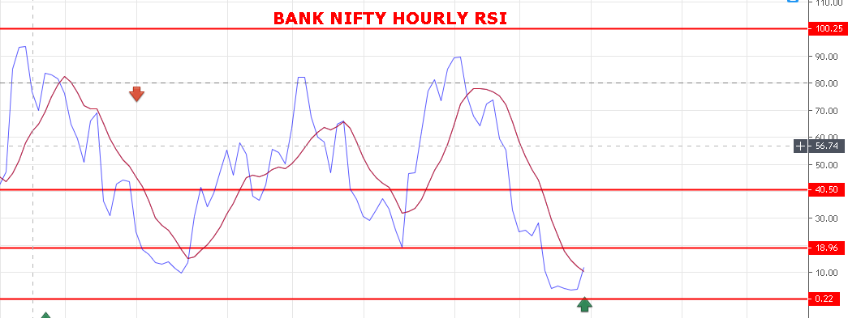

**HOURLY RSI AT OVERSOLD ZONE.**

**WEAK BELOW 30500**

**STRONG ABOVE 30600 BNS.**

**BEARISH BELOW 29500 BNS.**

**BULLISH ABOVE 31700 BNS.**

**SUPPORT: 29647-29610-29570-29550-29515-29482.**

**RESISTANCE: 29850-29930-30026-30060-30100.**

**BANK NIFTY OPTION FOR 22/07/2019:**

[**https://youtu.be/EVnvv_XjIs8**](https://youtu.be/EVnvv_XjIs8)

**BUY29800 CE 25 JULY@236 STOP 200 TGT 252-270-291-310-350.**

**BUY 29600 PE 25 JULY@185+ STOP 145 TGT 200-230-260-295-315.**

**PE TO BUY BELOW 29690 BNS, CE ABOVE 29900 BNS.**

**NOTE: Once we made Profit in Two or Third Trade Rs2000/5000 then Exit Trading for the Day. Over Trading and Greed results Losses.IN CASE OF LOSS MORE THAN 5000 EXIT TRADE FOR THE DAY. My work is to give call just ignore it if you made handsome profit for the day. ALWAYS KEEP STOP LOSS AND FOLLOW REENTER RULES.NEVER TRADE IN BULK QTY. MAX QTY IN BN 20 LOTS MIN 2 LOTS.**