**BANK NIFTY PREDICTION FOR 12/07/2019:**

**WEEKLY TREND WILL COME IN FORCE: BANK NIFTY SUPPLY ZONE 30850 IF NOT HOLD ABOVE THEN 30500-30250 LEVEL CAN SEE.**

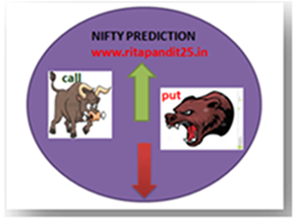

**SAR: 31038. PRICE STILL BELOW STOP AND REVERSE (SAR).**

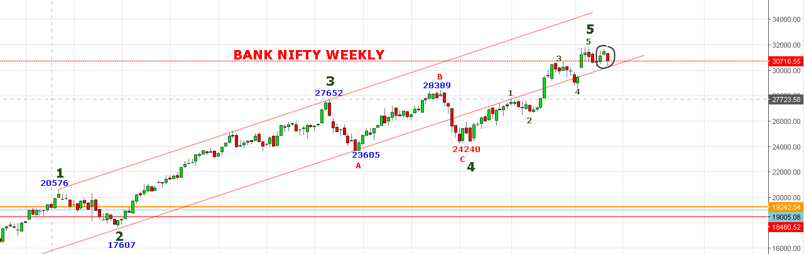

**WEEKLY CHART STILL BEARISH AND UNTIL PRICE CROSS 31330 WE CAN’T SEE FURTHER UPSIDE.PRICE NEAR SUPPORT CHANNEL @29990 LEVELS. SELL ON RISE RALLY.**

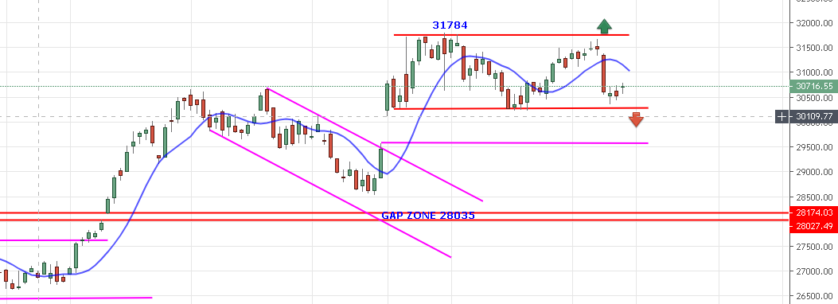

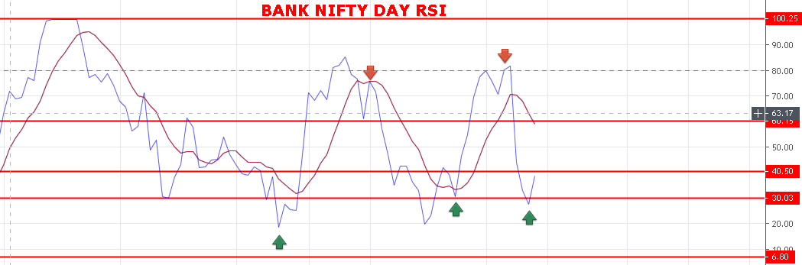

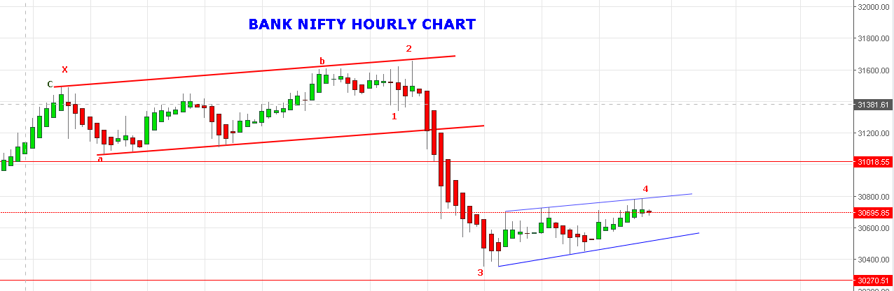

**BREAK OF 30500 ONLY WILL CONFIRM START OF 5TH DOWN WAVE FOR 29990 LEVELS.**

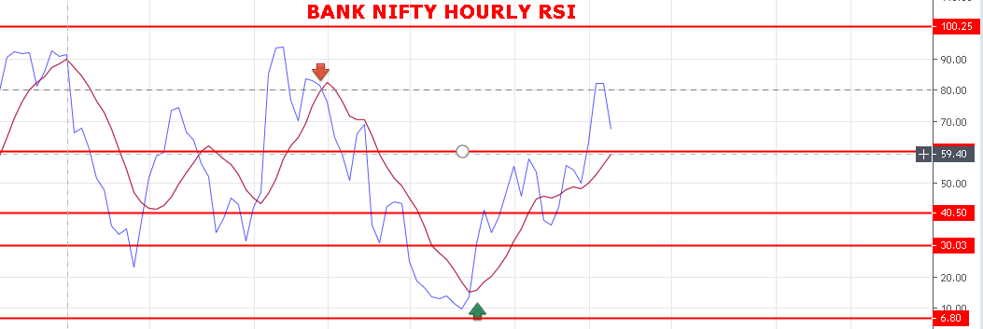

**WEAK BELOW 30850 BNS**

**STRONG ABOVE 30900 BNS.**

**BEARISH BELOW 30500 BNS ONLY.**

**BULLISH ABOVE 31200 BNS.**

**SUPPORT: 30640-30600-30570-30540-30485.**

**RESISTANCE: 30790-30820-30850>30900-30950.**

**BANK OPTION FOR 12/07/2019:**

**BUY 30800 CE 18 JULY@205+ STOP 175 TGT 235-250-280-298-330.**

**BUY 30700 PE 18 JULY@252+ STOP 216 TGT 275-290-320-350-385.**

**PE TO BUY BELOW 30640 BNS, CE ABOVE 30800 BNS.**

**NOTE: Once we made Profit in Two or Third Trade Rs2000/5000 then Exit Trading for the Day. Over Trading and Greed results Losses.IN CASE OF LOSS MORE THAN 5000 EXIT TRADE FOR THE DAY. My work is to give call just ignore it if you made handsome profit for the day. ALWAYS KEEP STOP LOSS AND FOLLOW REENTER RULES.NEVER TRADE IN BULK QTY. MAX QTY IN BN 20 LOTS MIN 2 LOTS.**