**NIFTY PREDICTION FOR 17/06/2019:**

**NIFTY HEADING TOWARDS 11743-11737<11710-11680, IF HOLD BELOW 11856 LEVELS. TRADING ABOVE 11888 CAN SEE 11950 LEVELS.**

**SAR: 11915 NS.**

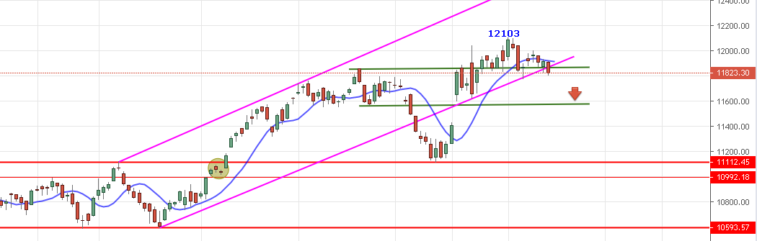

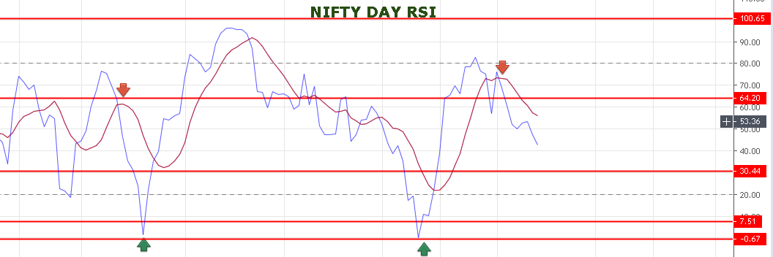

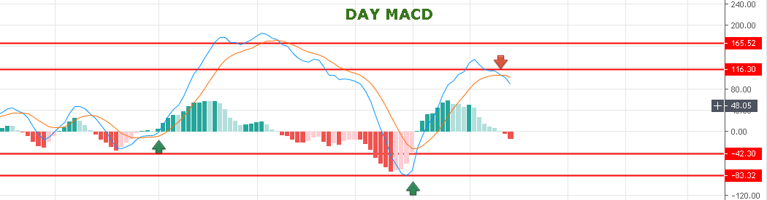

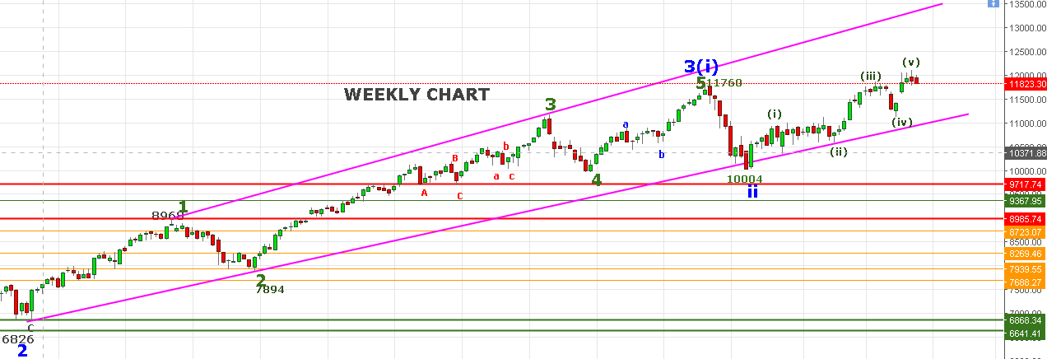

**WEEKLY SUPPORT: 11710-11495.**

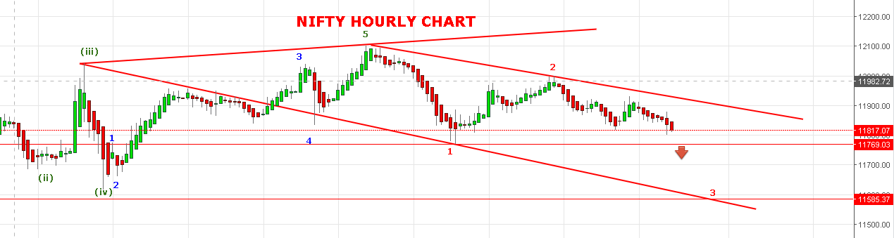

**TRADING BELOW 11707 CAN SEE 11645-11620 LEVELS. CLOSING BELOW 11614 CAN SEE 11585-11495 LEVELS.**

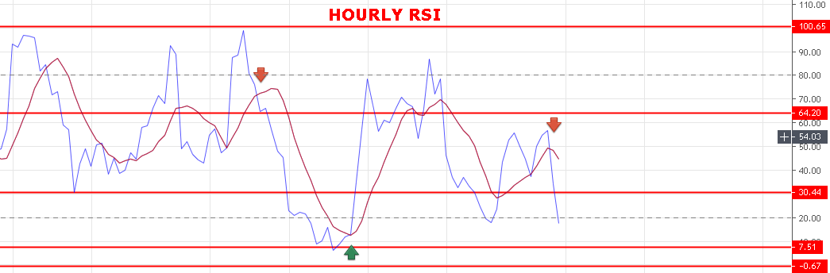

**STRONG ABOVE 11900.**

**WEAK BELOW 11888 NS.**

**BEARISH BELOW 11769 NS.**

**BULLISH ABOVE 11933 NS.**

**SUPPORT: 11769-11743-11709-11680.**

**RESISTANCE: 11855-11879-11886-11895.**

**NIFTY OPTION FOR 17/06/2019:**

**BUY 11750 CE 20 JUNE @139 STOP 112 TGT 148-155-161-175.**

**BUY 11900 PE 20 JUNE @117+ STOP 103 TGT 130-140-155-170-191.**

**HOLDING 11700 PE 20 JUNE @25 STOP 18 TGT 36-44-48-52>65.**

**PE TO BUY BELOW 11800 BNS, CE ABOVE 11857 NS.**

**NOTE: Once we made Profit in Two or Third Trade Rs2000/5000 then Exit Trading for the Day. Over Trading and Greed results Losses. My work is to give call just ignore it if you made handsome profit for the day.**