**NIFTY PREDICTION FOR 14/06/2019:**

**NIFTY TRADING ABOVE 11948 CAN SEE 11960-11977. TRADING BELOW 11888 CAN SEE 11850 LEVEL.**

**SAR: 11920 NS.**

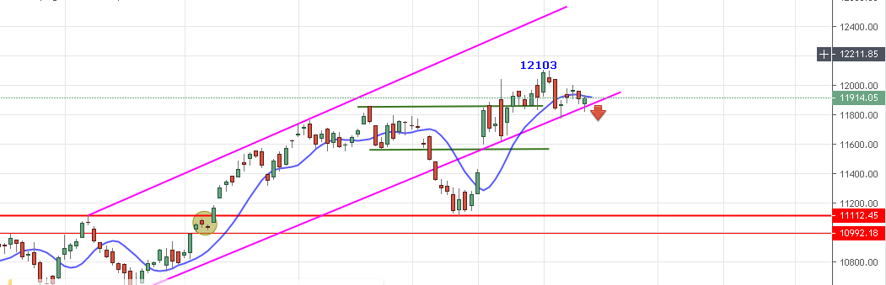

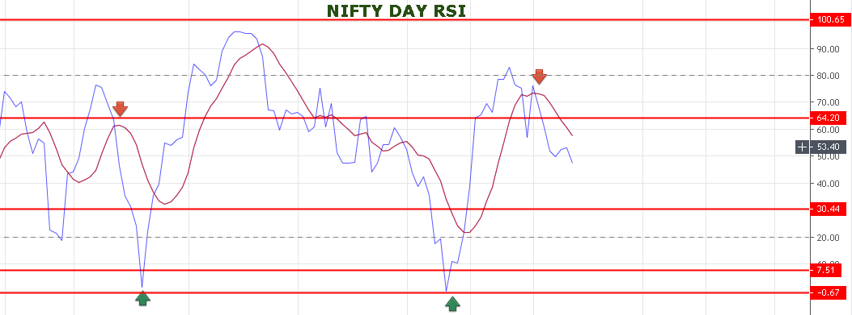

**TRADING BELOW 11850 CAN SEE 11823 LEVELS. CLOSING BELOW 11823 CAN SEE 11700-11650 LEVELS.**

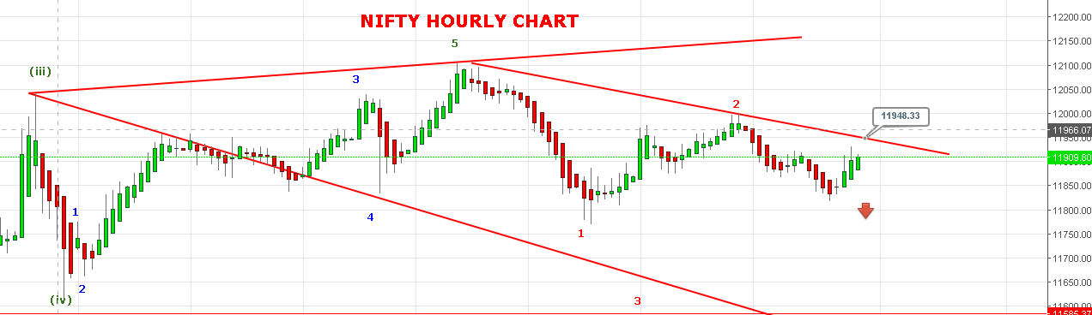

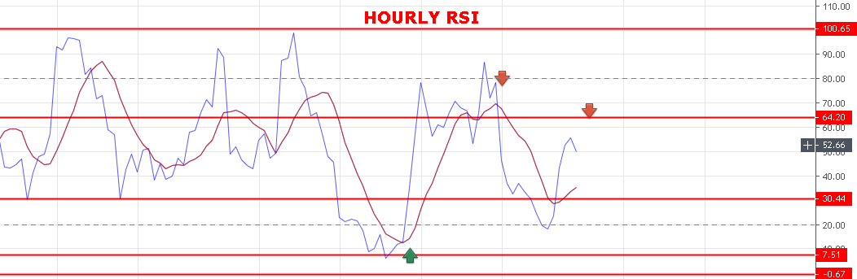

**WEAK BELOW 11888 NS.**

**BEARISH BELOW 11850 NS.**

**STRONG ABOVE 11950 NS.**

**BULLISH ABOVE 12000 BNS.**

**SUPPORT: 11888-11860-11845-11823-11810.**

**RESISTANCE: 11946-11963-11977-12000.**

**NIFTY OPTION FOR 14/06/2019:**

**BUY 11900 CE 20 JUNE @89 STOP 72 TGT 100-108-115-121-130.**

**BUY 12000 PE 20 JUNE@127+ STOP 110 TGT 142-154-175-197.**

**BUY PE BELOW 11893 NS, CE ABOVE 11948 NS.**

**NOTE: Once we made Profit in Two or Third Trade Rs2000/5000 then Exit Trading for the Day. Over Trading and Greed results Losses. My work is to give call just ignore it if you made handsome profit for the day.**