**NIFTY PREDICTION FOR 10/06/2019:**

**NIFTY HOLDING ABOVE 11973 CAN SEE 12200 LEVELS. HOLDING BELOW 11941 CAN SEE 11730 LEVELS.**

**SAR: 11933 BNS.**

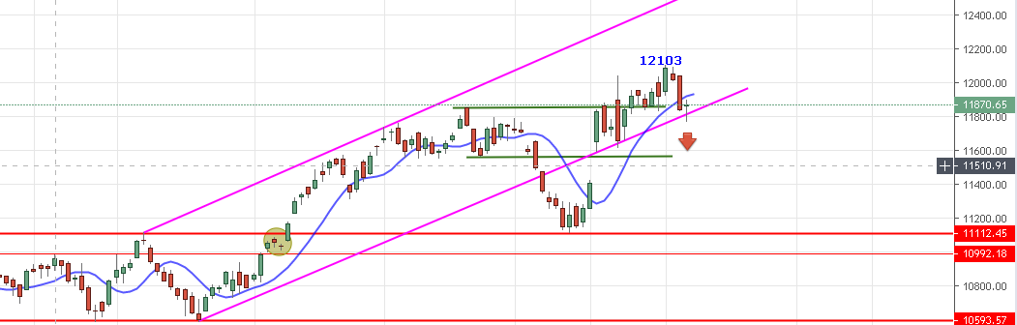

**NIFTY BREAK 11829 LOW MADE ON 31ST MAY AND MADE NEW LOW 11769 . NIFTY HOLDING BELOW SAR CAN SEE 11730 LEVELS. IF PRICE CLOSED ABOVE 11972 THEN WE CAN SEE NEW HIGH ABOVE 12103 LEVELS.**

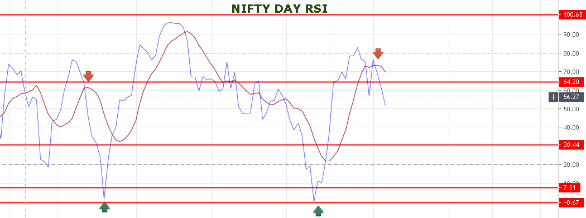

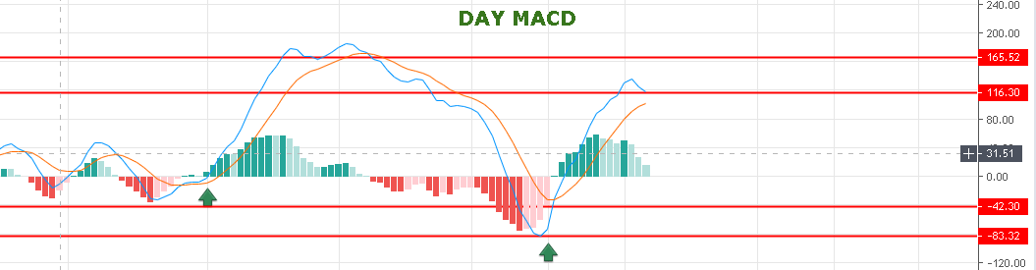

**BOTH DAY RSI AND DAY MACD SHOWING NEAGTIVE DIVERGENCE. SO MORE FALL TO COME.**

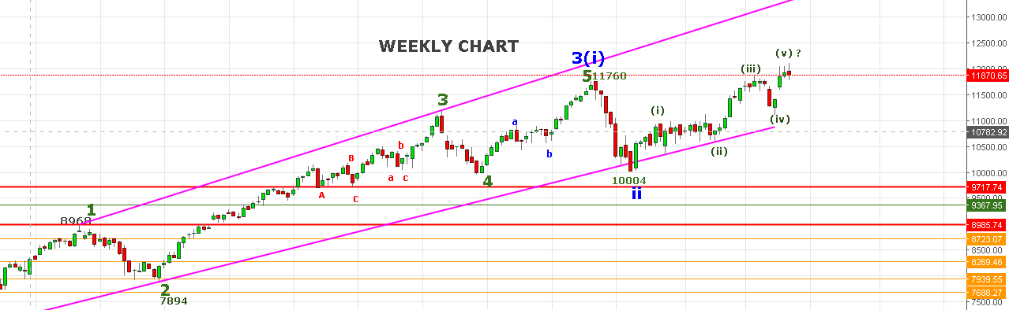

**WEEKLY SUPPORT 11690 & 11450. TRADING ABOVE 12000 CAN SEE 12320 LEVELS.**

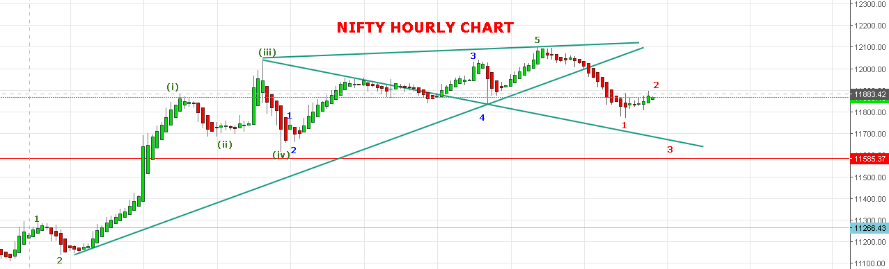

**HOLDING BELOW 11910 CAN SEE 11780 TO 11730 LEVELS. HOLDING ABOVE 11910 CAN SEE 11940-11950 LEVELS.**

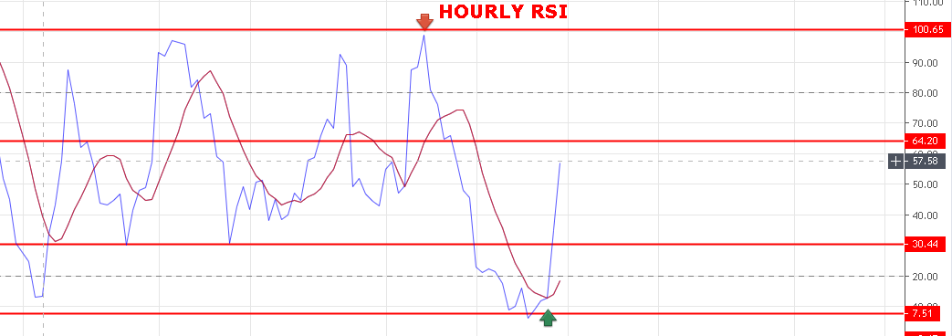

**STRONG ABOVE 11850 NS.**

**BULLISH ABOVE 11972 NS.**

**WEAK BELOW 11829 NS.**

**BEARISH BELOW 11730 NS.**

**SUPPORT: 11852-11829-11810<11780-11730-11690.**

**RESISTANCE: 11898-11919-11952-11972-11998.**

**NIFTY FUTURE FOR 10/06/2019:**

**BUY NF@11921+ STOP 11900 TGT 11941-11972-11999-12020.**

**SHORT NF@11870 STOP 11900 TGT 11853-11827-11805-11780.**

**NIFTY OPTION FOR 10/06/2019:**

**BUY 11900 CE 13 JUNE @70+ STOP 58 TGT 82-92-99-105-118-130.**

**BUY 11800 PE 13 JUNE@53+ STOP 43 TGT 65-71-82-89-100.**

**HOLDING 11900 CE STOP 48. HOLDING 11800 PE STOP 34.**

**IF NIFTY HOLD ABOVE 11910 FOR AN HOUR THEN EXIT PE . IF NIFTY HOLD BELOW 11850 THEN EXIT CE.**

**PE WILL GAIN BELOW 11846 NS, CE WILL GAIN ABOVE 11911 NS.**