**BANK NIFTY PREDICTION FOR 17/06/2019:**

**BANK NIFTY HEADING TOWARDS 30330<30190 LEVELS IF HOLD BELOW 30700 LEVELS.**

**SAR: 31090 BNS.**

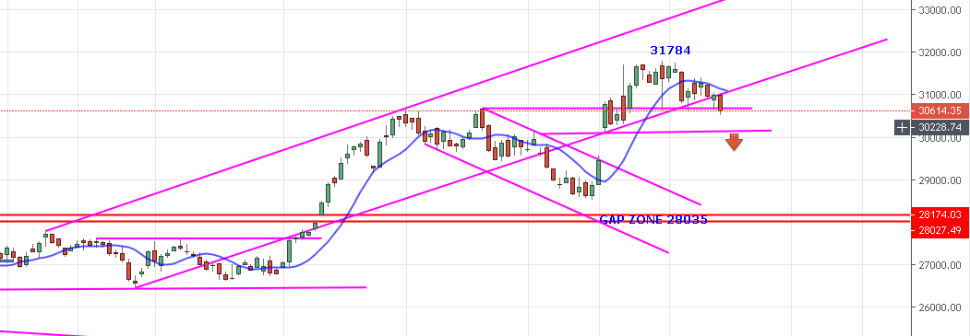

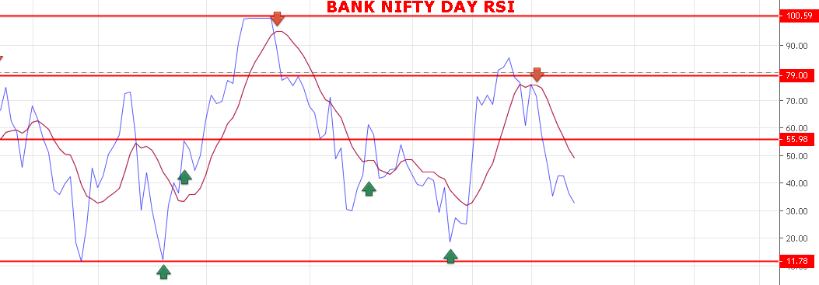

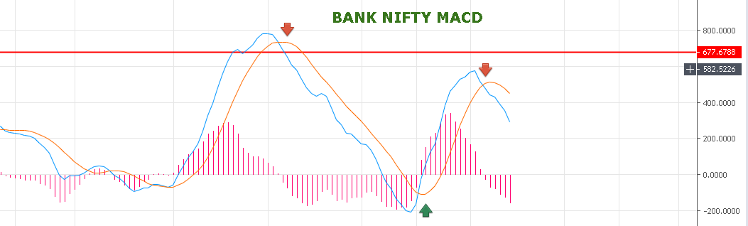

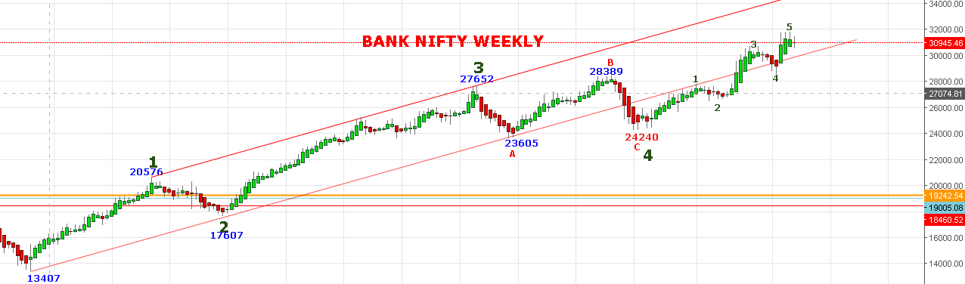

**WEEKLY SUPPORT 30300. CLOSING BELOW 30300 CAN SEE 29500 LEVELS. CLOSING ABOVE 31400 CAN SEE 32000-32500 LEVELS.**

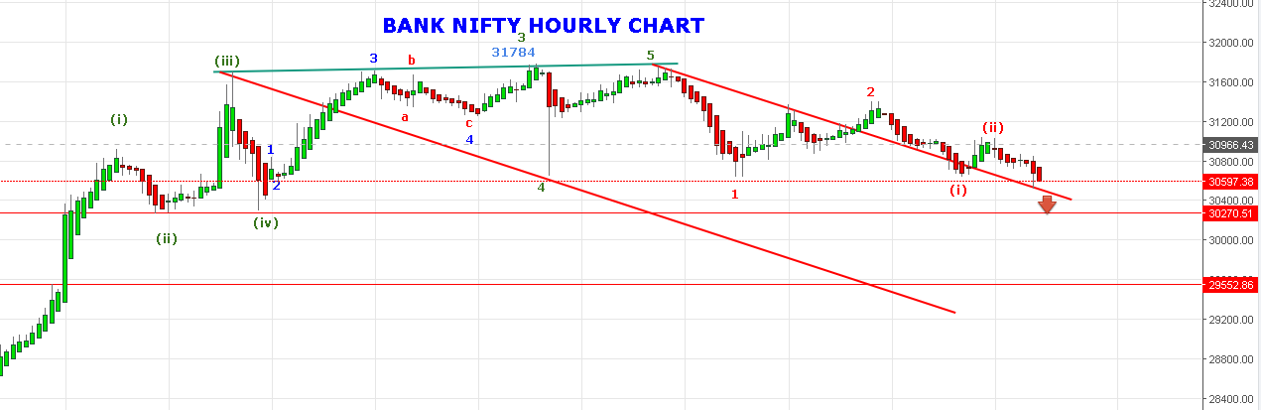

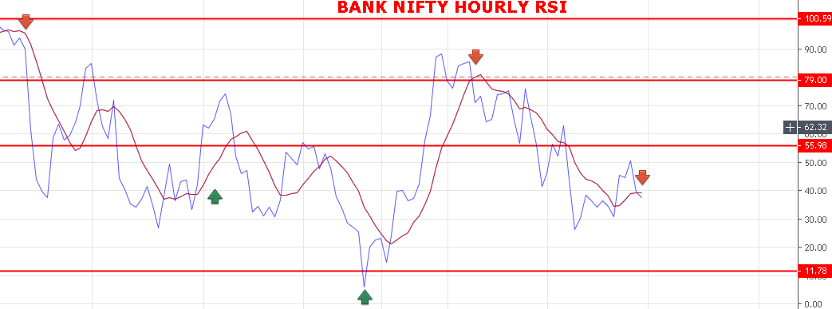

**WEAK BELOW 30840 BNS.**

**BEARISH BELOW 30504 BNS.**

**STRONG ABOVE 30900 BNS.**

**BULLISH ABOVE 31000 BNS.**

**SUPPORT: 30435-30380-30330-30300-30255-30190.**

**RESISTANCE: 30720-30790-30845-30900.**

**BANK NIFTY OPTION FOR 17/06/2019:**

**BUY 30600 PE 20 JUNE@280-310 STOP 240 TGT 390-430-470-500-550-600.**

**BUY 30500 CE 20 JUNE@397 STOP 330 TGT 430-450-475-499-520-550.**

**HOLDING 30300 PE 20 JUNE @140 STOP 100 TGT 187-215-235-248-282>350-390.**

**PE TO BUY BELOW 30540 BNS, CE ABOVE 30725 BNS.**

**NOTE: Once we made Profit in Two or Third Trade Rs2000/5000 then Exit Trading for the Day. Over Trading and Greed results Losses. My work is to give call just ignore it if you made handsome profit for the day.**