NIFTY PREDICTION FOR 30/05/2019:
NIFTY HOLDING 11817 LEVELS CAN BOUNCE TOWARDS 12050 LEVELS. TRADING BELOW 11766 CAN SEE 11686 TO 11465 LEVELS.
SAR: 11759 NS.
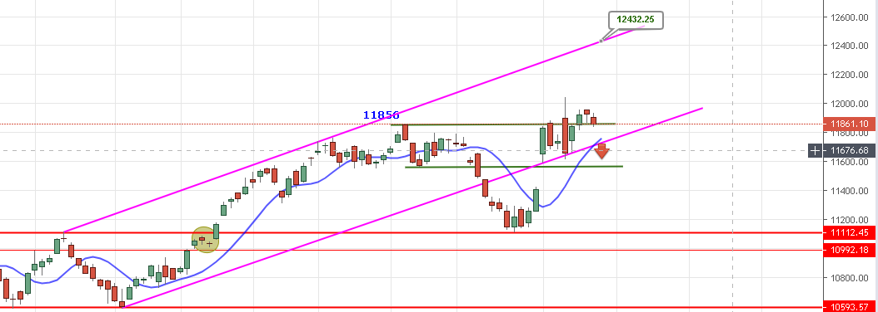
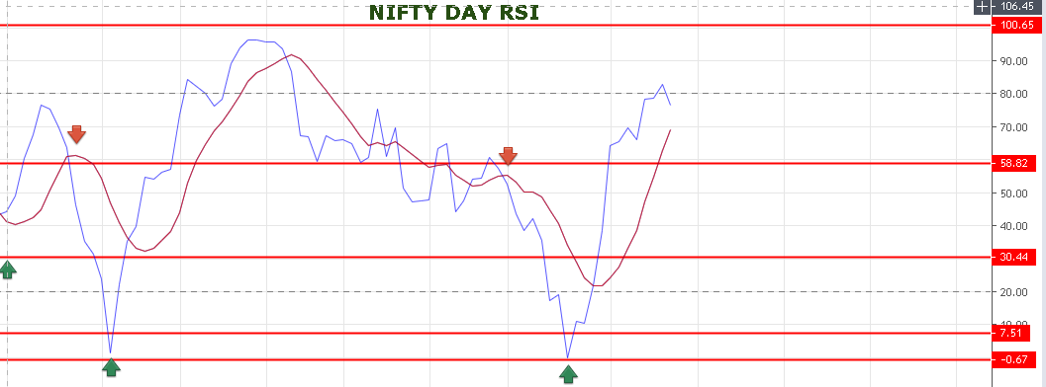
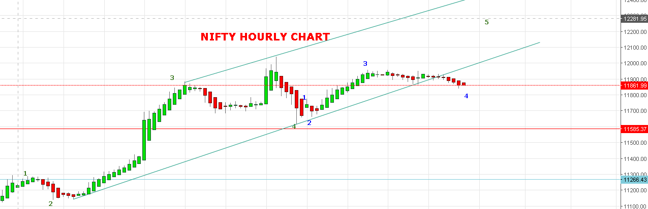
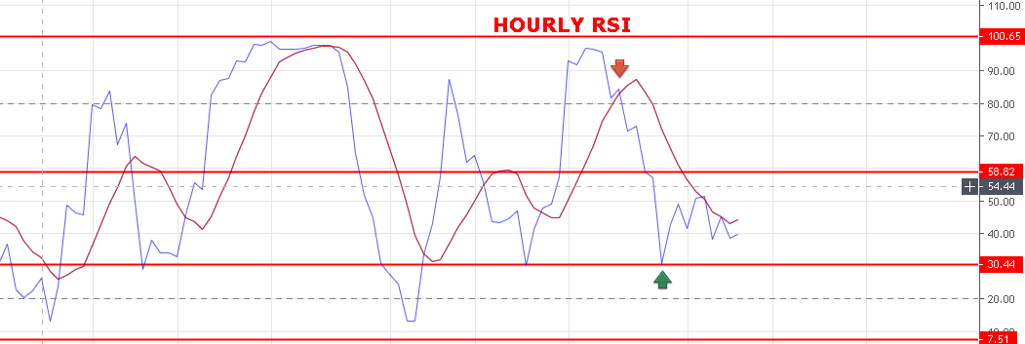
BUY ABOVE 11897, SELL BELOW 11817 NS.
WEAKNESS REMAIN BELOW 11870 NS.
STRONG ABOVE 11897 NS.
BULLISH ABOVE 11940 NS.
BEARISH BELOW 11766 NS.
SUPPORT: 11803-11780-11766-11740-11724-11671-11612.
RESISTANCE: 11920-11955-11982-11998-12051-12110-12171.
EXPIRY LOWER CASE: 11750.
EXPIRY UPPER CASE: 11960.
NIFTY OPTION FOR 30/05/2019:
HOLDING 12050 CE 06 JUNE STOP 24.
BUY 12050 CE 06 JUNE @49 STOP 37 TGT 58-65-75-87.
BUY 11900 PE 30 MAY@79 STOP 61 TGT 91-100-113-131-140.
PE TO BUY BELOW 11817 NS, CE WILL GAIN ABOVE 11897 NS.
FOLLOW ABOVE CALLS, DON’T WAIT FOR MY INSTRUCTIONS.

