NIFTY PREDICTION FOR 27/05/2019:
NIFTY HOLDING 11770 LEVELS CAN SEE 11896-11940-12300 LEVELS.TRADING BELOW 11740 CAN SEE 11650 TO 11550 LEVELS.
SAR: 11595 NS.
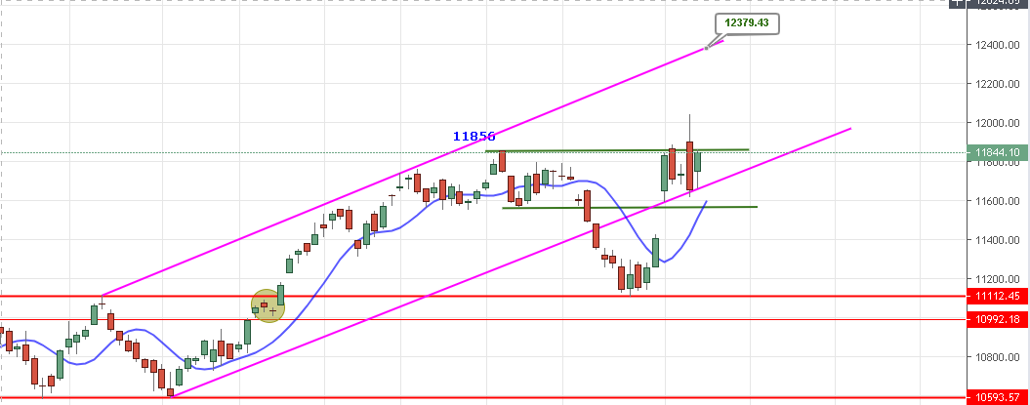
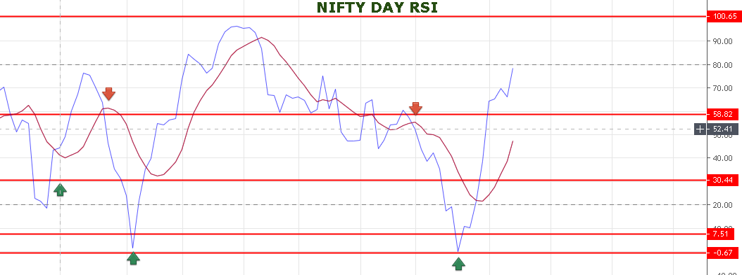
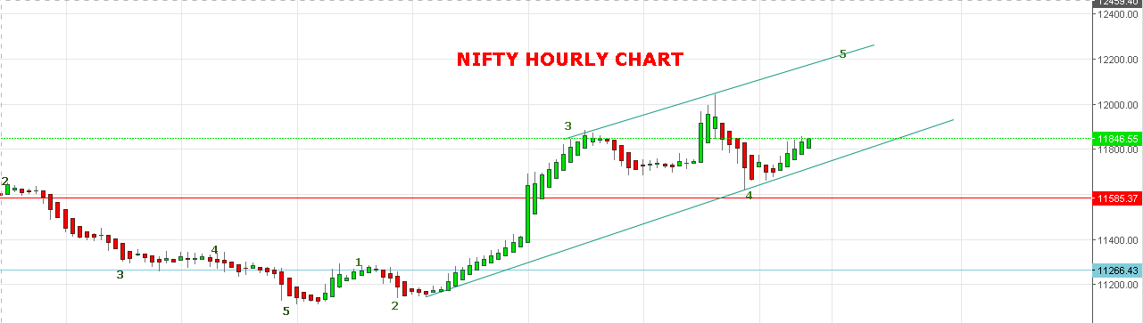
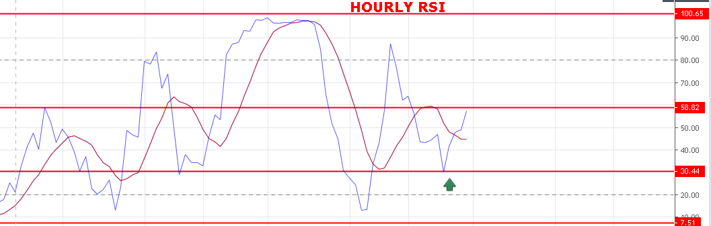
STRONG ABOVE 11800.
WEAK BELOW 11770 NS.
BULLISH ABOVE 11899 NS.
SUPPORT: 11805-11780-11750-11714-11666.
RESISTANCE: 11898-11940-11991-12041-12110.
NIFTY OPTION FOR 27/05/2019:
HOLDING 12000 CE 30 MAY STOP 26 TGT 53-62-70-81-92.
BUY 11900 CE 30 MAY @90+ STOP 80 TGT 101-117-137-153.
BUY 11900 PE 30 MAY@139+ STOP 127 TGT 161-180-192-205.
BUY PE BELOW 11800 NS, CE WILL REWARD ABOVE 11907 NS.
http://prntscr.com/nthu6p

