**BANK NIFTY PREDICTION FOR 30/05/2019:**

**BANK NIFTY HOLDING 31170 CAN BOUNCE TOWARDS 31500 TO 32200 TILL FRIDAY.BEARISH BELOW 31100 LEVELS FOR 30850 LEVELS.**

**SAR: 30797 BNS.**

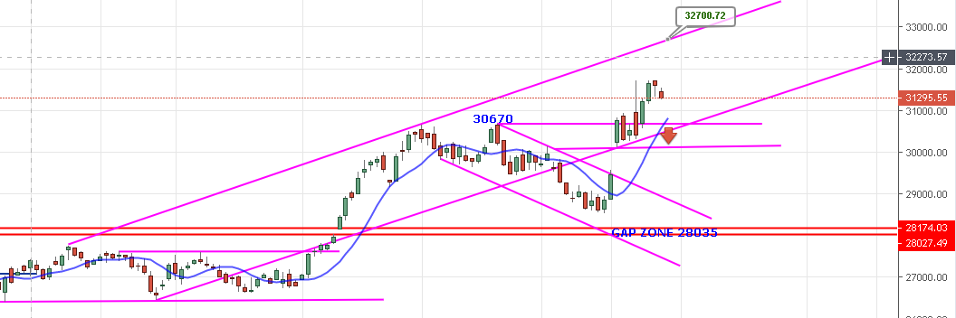

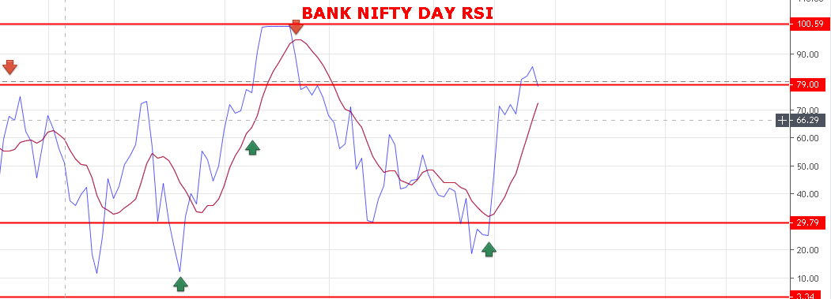

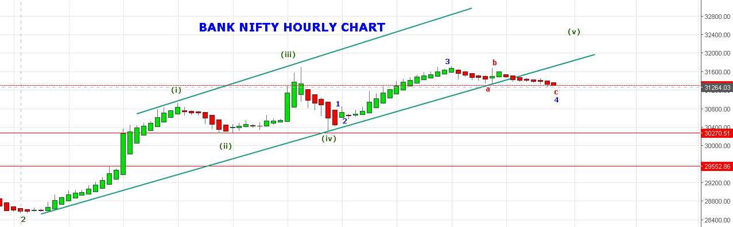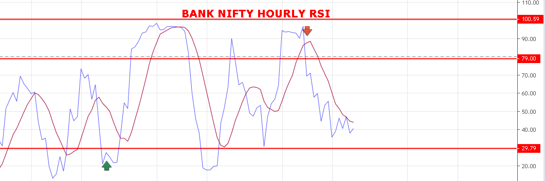

**BUY ABOVE 31420, SELL BELOW 31170 BNS.**

**WEAKNESS REMAIN BELOW 31370 BNS.**

**STRONG ABOVE 31420 BNS.**

**BULLISH ABOVE 31500 BNS.**

**SUPPORT: 31220-31171-31130-31100-31050-30975-30900-30850.**

**RESISTANCE: 31367-31400-31440-31495-31550-31620-31710-31800-31940.**

**EXPIRY LOWER CASE: 31000. UPPER CASE: 31940.**

**BANK NIFTY OPTION FOR 30/05/2019:**

**HOLDING 32000 CE 06 JUNE STOP 50.**

**BUY 32000 CE 06 JUNE @122 STOP 101 TGT 185-230-260-300.**

**BUY 31300 PE 30 MAY@155+ STOP 95 TGT 190-235-250-285-300.**

**BUY PE BELOW 31170 BNS, CE WILL GAIN ABOVE 31420 BNS.**

**FOLLOW ABOVE CALLS. DON’T WAIT FOR MY INSTRUCTIONS.**