BANK NIFTY PREDICTION FOR 27/05/2019:
BANK NIFTY HOLDING 31028 LEVELS CAN SEE 31700 TO 32000+ LEVELS. TRADING BELOW 30910 CAN SEE 30500 TO 30300 LEVELS.
SAR: 29748 BNS.
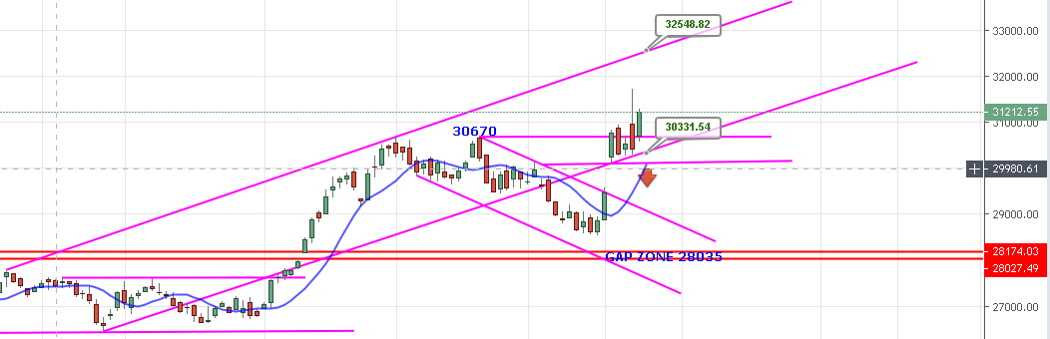
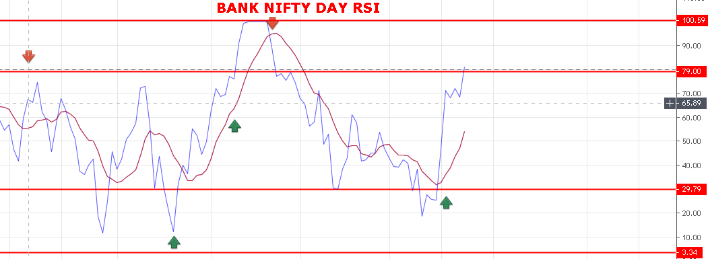
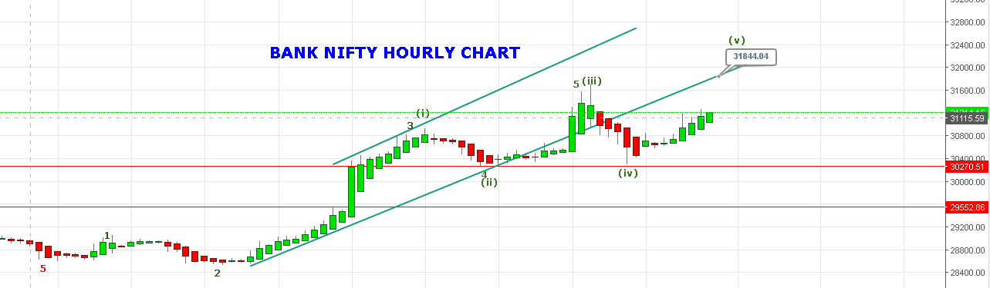
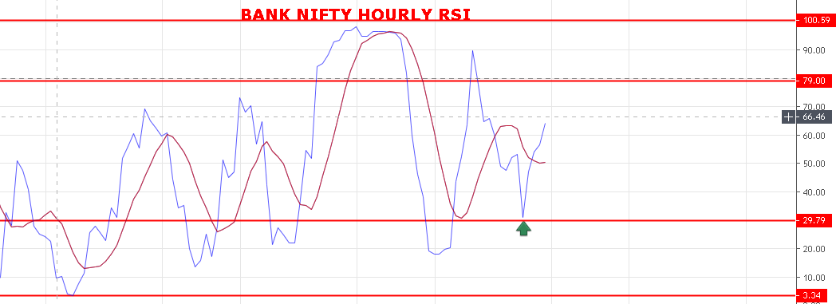
STRONG ABOVE 31000 BNS.
WEAK BELOW 30910 BNS.
BEARISH BELOW 30300 LEVELS.
PRICE HOLDING ABOVE 31300 CAN BREAK 23RD MAY HIGH 31705 LEVELS.
SUPPORT: 31090-31000-30910-30850-30740.
RESISTANCE: 31340-31421-31550-31705-31890-32100.
BANK NIFTY OPTION FOR 27/05/2019:
HOLDING 32100 CE 30 MAY STOP 21. TGT 60-98-120-150-190.
BUY 31400 CE 30 MAY@240+ STOP 200 TGT 270-291-322-350-400-435.
BUY 31200 PE 30 MAY@305+ STOP 270 TGT 345-405-460-499-525-570.
BUY PE BELOW 31050 BNS, CE WILL REWARD ABOVE 31350 BNS.

http://prntscr.com/nthks4

