NIFTY PREDICTION FOR 08/04/2019:
NIFTY HOLDING ABOVE 11640 WILL SEE 11740-55. HOLDING BELOW 11618 CAN SEE 11570-11529 & BELOW.
SAR: 11618 NS.
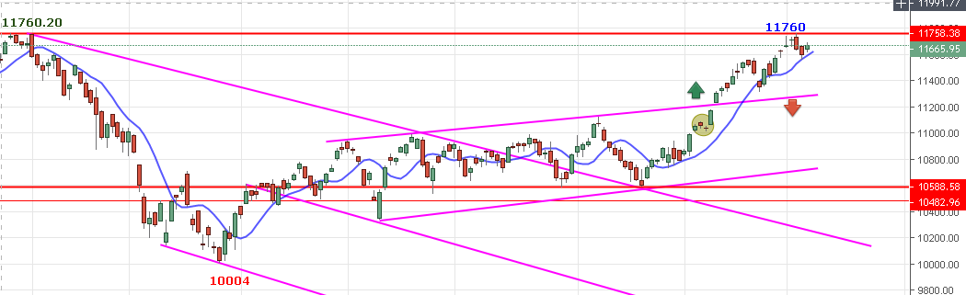
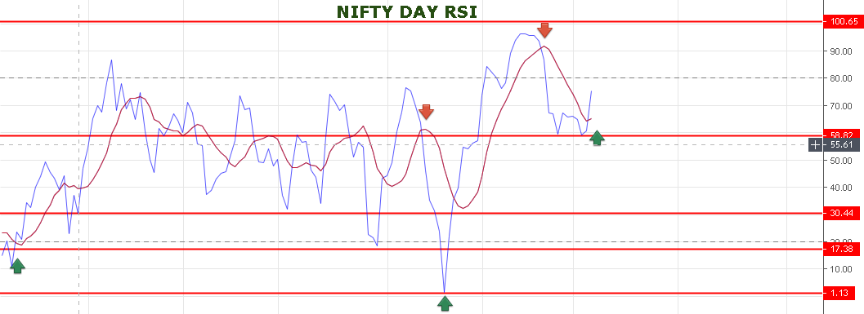
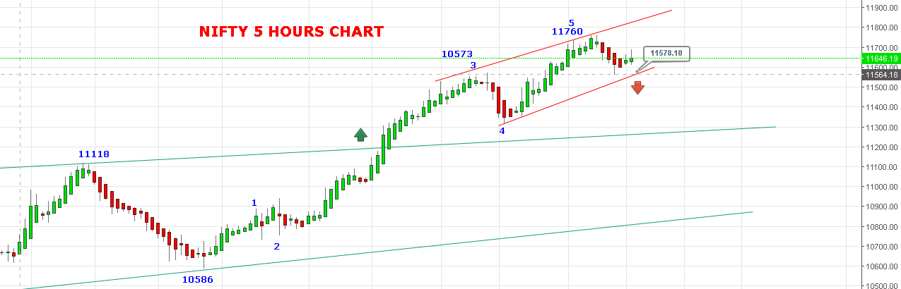
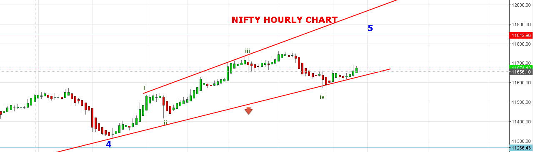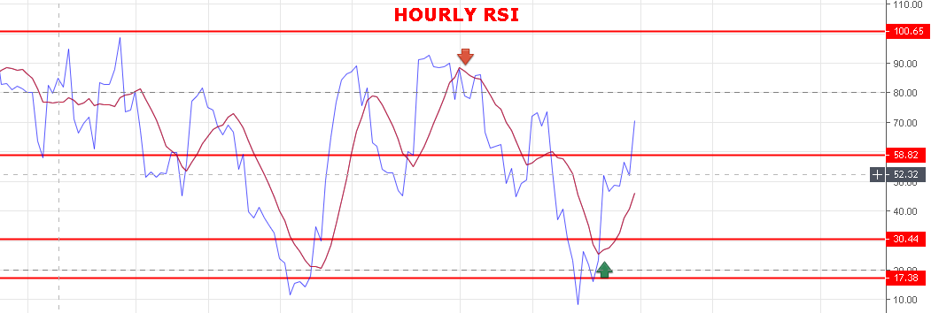
WEAK BELOW 11618 NS.
BEARISH BELOW 11550 NS.
BULLISH ABOVE 11761 NS.
SUPPORT: 11640-11620-11578-11555-11529-11515.
RESISTANCE: 11715-11740-11757-11777.
NIFTY FUTURE INTRADAY LEVELS:
BUY NF@11705+ STOP 11685 TGT 11730-11755-11791-11810.
SHORT NF@11645 STOP 11675 TGT 11630-11615-11570-11520.
NIFTY OPTION FOR 08/04/19:
BUY 11600 CE 11 APRIL @137+ STOP 103 TGT 144-162-175-192-205-220.
BUY 11800 PE 11 APRIL @160 STOP 150 TGT 180-204-225-244-260-300.
BUY CE ABOVE 11670 NS. BUY PE BELOW 11630 NS.

