NIFTY PREDICTION FOR 02/04/2019:
NIFTY TRADING BELOW 11600 CAN SEE 11575-11520 LEVELS. STRONG ONLY ABOVE 11711 NS.
SAR: 11489 NS.
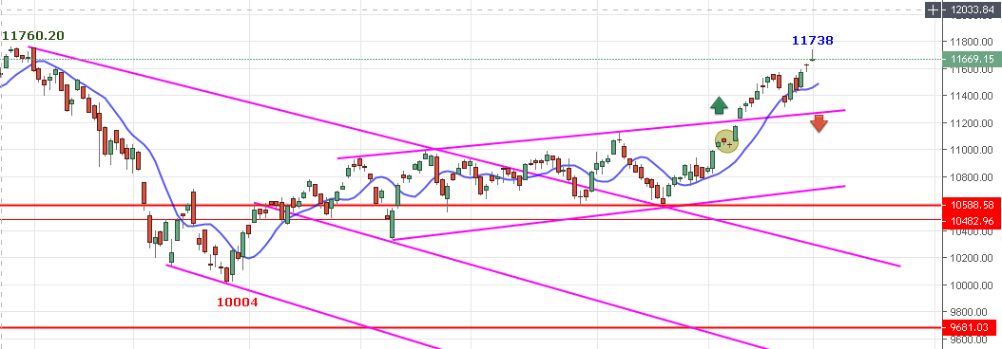
GRAVESTONE DOJI FORMATION OR SHOOTING STAR INDICATING PAUSE IN UP MOVE NOW.
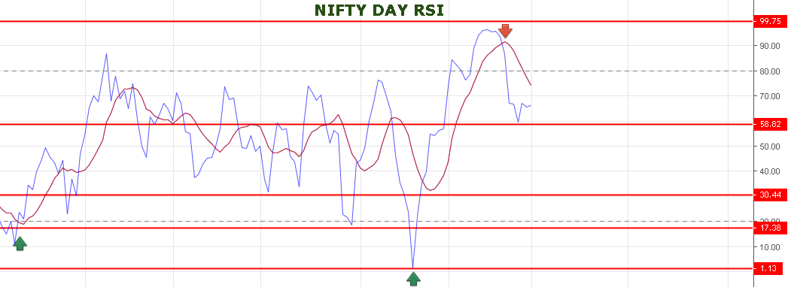
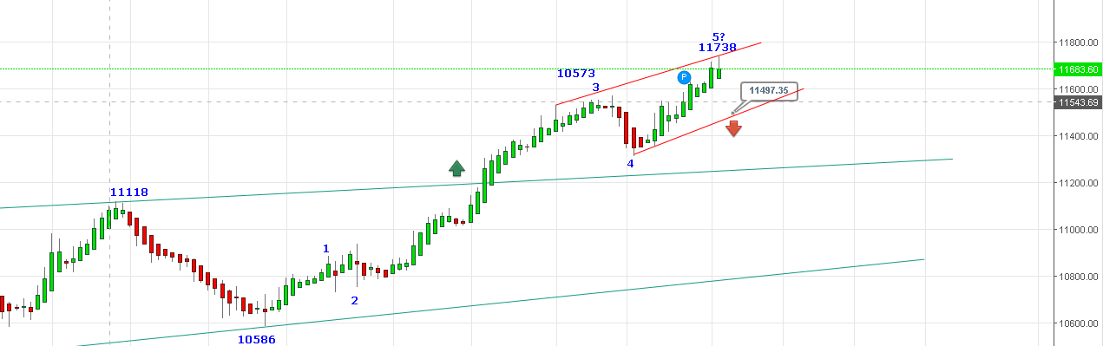
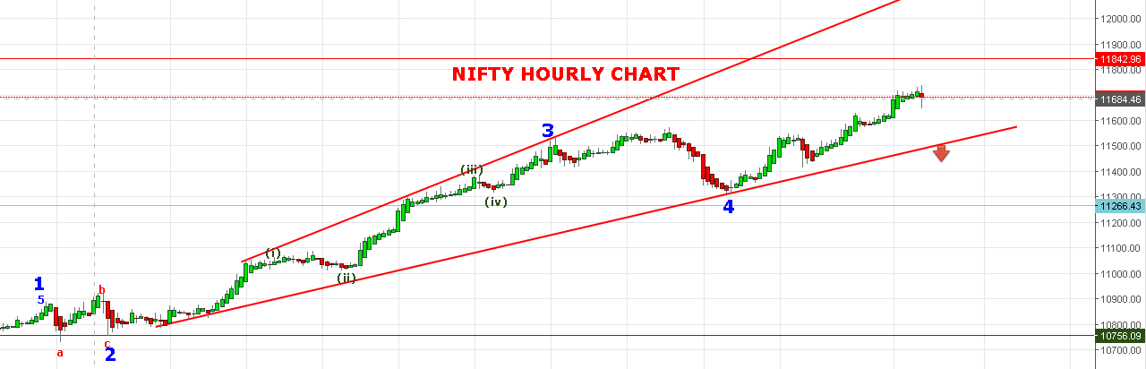
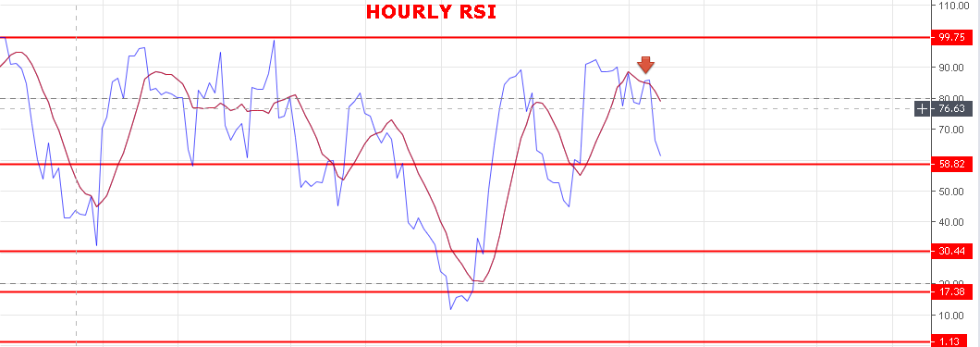
WEAK BELOW 11681 NS.
STRONG ABOVE 11711 NS.
BEARISH BELOW 11515 NS.
SUPPORT: 11608-11573-11550-11536-11520.
RESISTANCE: 11680-11711-11760-11810.

NIFTY FUTURE INTRADAY LEVELS:
BUY NF @11782 STOP 11752 TGT 11802-11816-11835-11855-11868.
SHORT NF@11725 STOP 11755 TGT 11695-11650-11630-11618-11575-11527.

NIFTY OPTION FOR 02/04/2019:
BUY 11600 CE 04 APRIL @140+ STOP 113 TGT 152-170-185-200.
BUY 11700 PE 04 APRIL @84 STOP 61 TGT 95-103-112-123-132-142.
HOLDING 11800 PE 04 APRIL @130 STOP NOW 110 TGT 158-180-195-205.

