BANK NIFTY PREDICTION FOR 09/04/2019:
BANK NIFTY DID 29850 NEXT TARGET 29650 TO 29400 LEVELS NOW IF HODLING BELOW 29900.
SAR: 30152 BNS. SAR= STOP AND REVERSE. TREND=DOWN.
http://prntscr.com/n94zlr
http://prntscr.com/n950n0
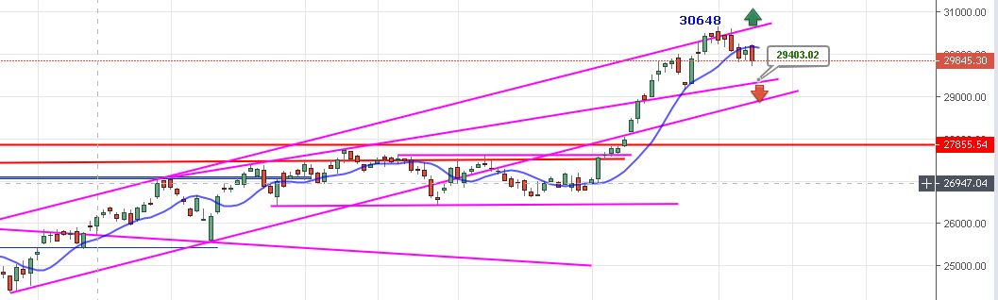
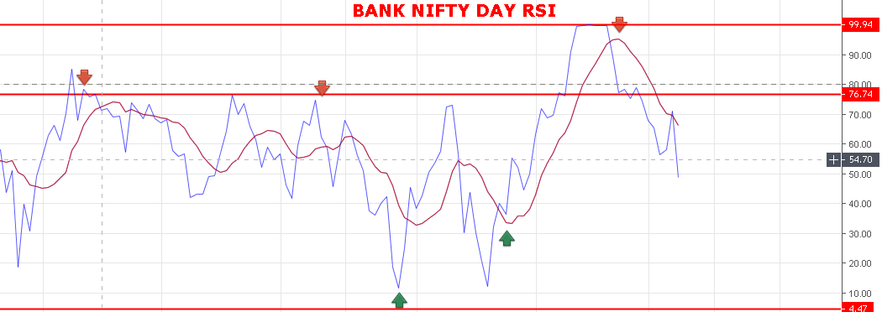
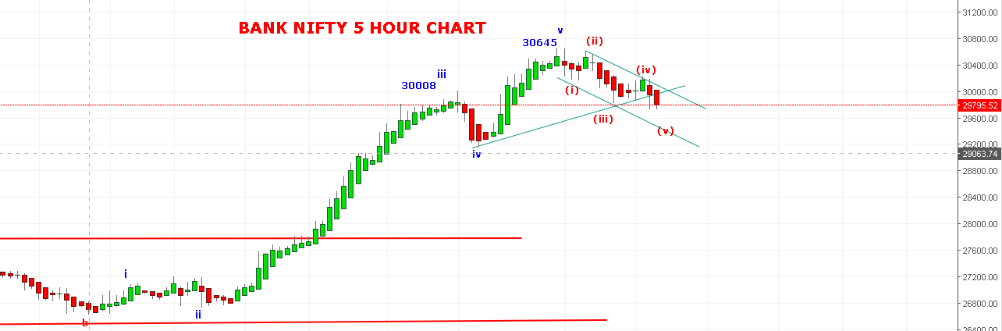
WAVE (v) IS ON TARGET 29680 TO 29400/29200. VIEW NEGATED IF TRADE ABOVE 30030 BNS.
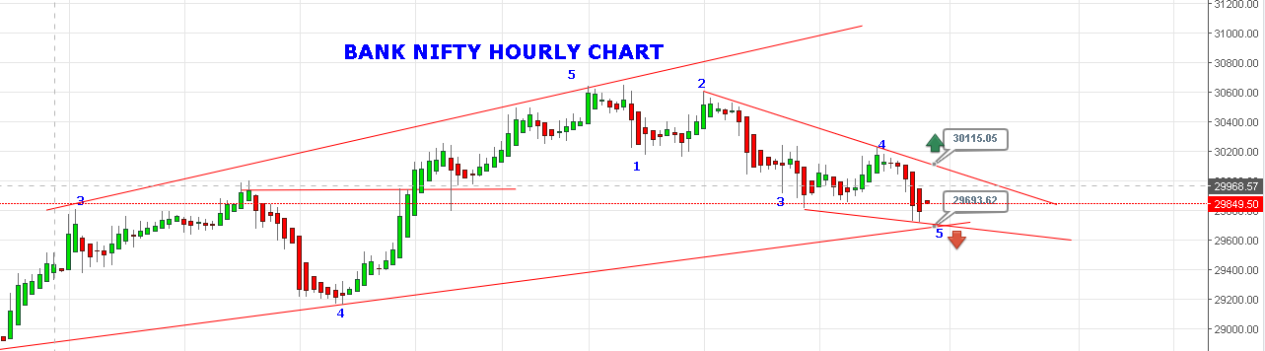
IF ABLE TO HOLD TOMORROW 29845 & TRADED ABOVE 30030 THEN GO LONG ABOVE 30115 FOR TARGETS 30500+
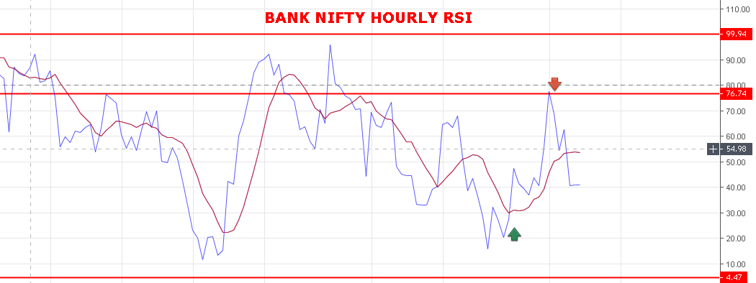
WEAKNESS REMAINS BELOW 30013 BNS.
STRONG ABOVE 30030 BNS.
BULLISH ABOVE 30115 BNS.
SUPPORT: 29790-29740-29680-29640-29550-29430.
RESISTANCE: 29908-29950-30010-30055-30082-30175.

BANK NIFTY FUTURE INTRADAY LEVELS:
BUY BNF @30111+ STOP 30050 TGT 30170-30210-30255-30300-30350-30425.
SHORT BNF @29940 STOP 30050 TGT 29850-29770-29660-29595-29490-29350.
BANK NIFTY OPTION FOR 09/04/2019:
BUY 29900 CE 11 APRIL @236+ STOP 180 TGT 250-272-300-320-350-370-392.
HOLDING 29800 PE 11 APRIL @144 STOP NOW 120 TRADING ABOVE 189 TGT 200-225-250-275-310-350-370.
FRESH ENTRY 190+ STOP 150 .

