BANK NIFTY PREDICTION FOR 08/04/2019:
BANK NIFTY TRADING ABOVE 30108 CAN SEE 30250>30410.TRADING BELOW 29990 CAN SEE 29840 BELOW 29800 CAN SEE 29700-29650.

SAR: 30175 BNS. TREND: DOWN TO NEUTRAL.

PRICE STILL CLOSED BELOW SAR THIRD DAY. NOW GO LONG POSITIONAL ABOVE 30250 ONLY.

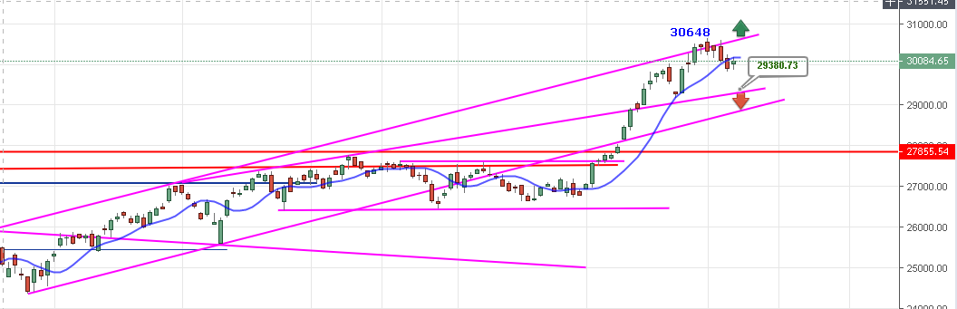
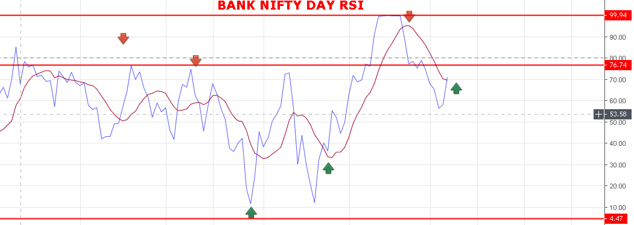
SELL ON RISE AS LONG HOLDING BELOW 30250 BNS.

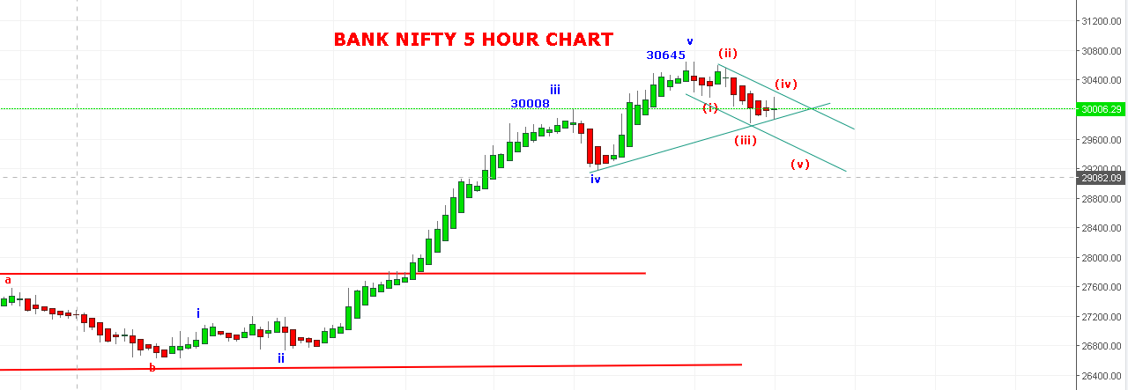
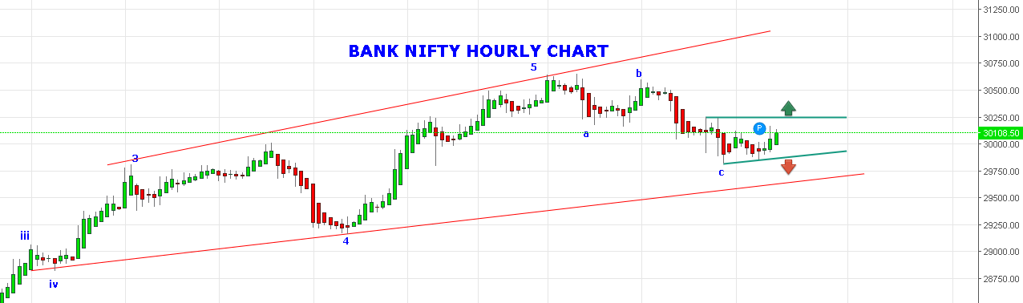

SIDEWAYS TRADING RANGE 29880 TO 30250.

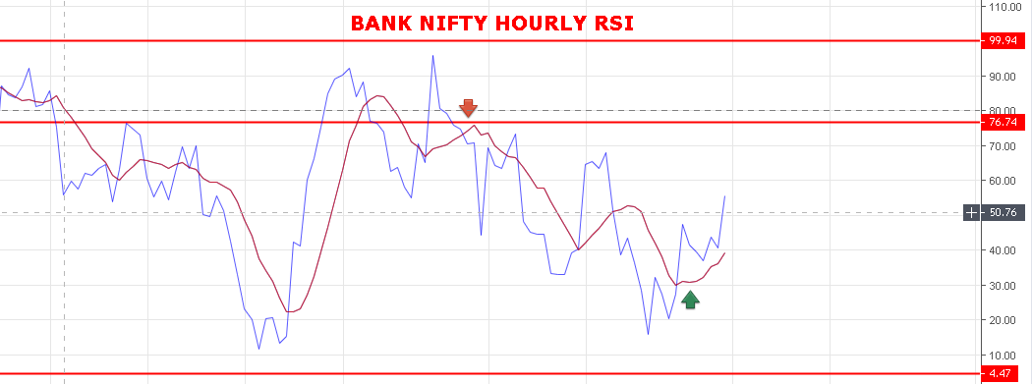

WEAK BELOW 30090 NS.

STRONG ABOVE 30108.

BULLISH ABOVE 30475 BNS.

BEARISH BELOW 29800 BNS.

SUPPORT: 30000-29950-29900-29850-29800-29680.

RESISTANCE: 30190-30250-30330-30400-30470.

BANK NIFTY FUTURE INTRADAY LEVELS:

BUY BNF @30390 STOP 30300 TGT 30450-30510-30550-30630-30710.

SHORT BNF@30215 STOP 30300 TGT 30152-30108-30060-29950-29860-29640.

BANK NIFTY OPTION FOR 08/04/2019:

BUY 30200 CE 11 APRIL @205+ STOP 184 TGT 240-260-299-325-350-370-400-430-450.

BUY 30300 PE 11 APRIL @275+ STOP 240 TGT 330-360-410-450-505-545-600.

