NIFTY PREDICTION FOR 13/03/2019:
NIFTY HOLDING 11170 CAN SEE 11450 LEVELS.
DAY SAR: 10954 NS.
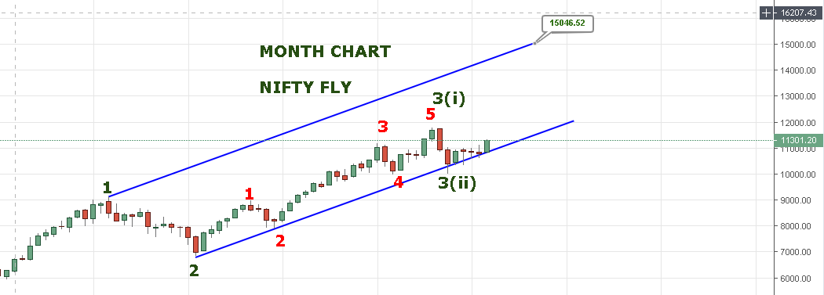
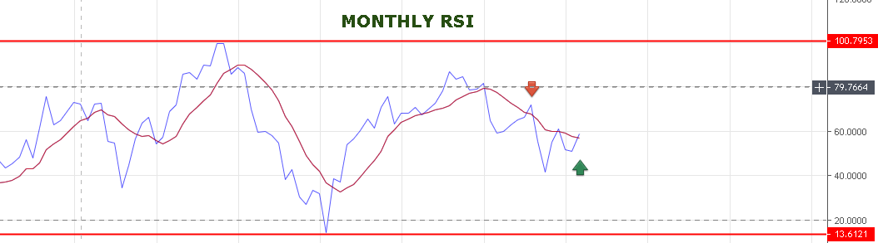
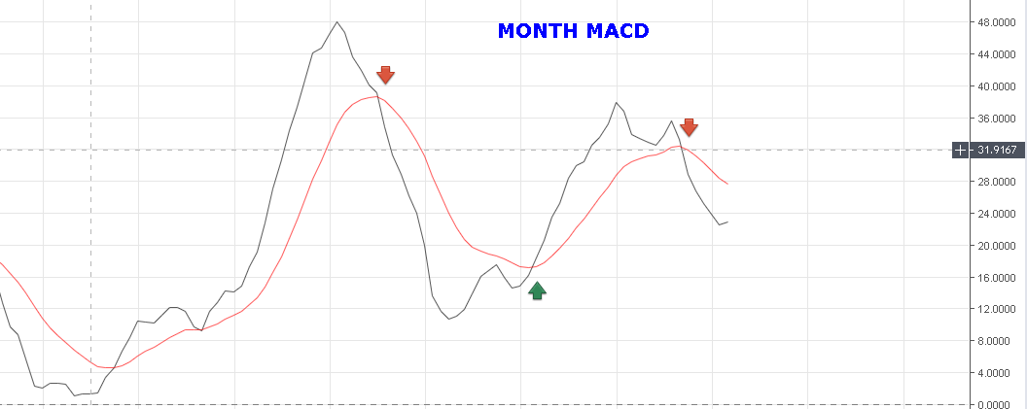
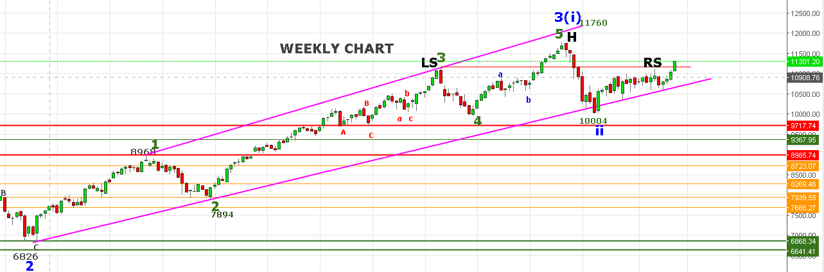
H& S PATTERN REJECTED TODAY.
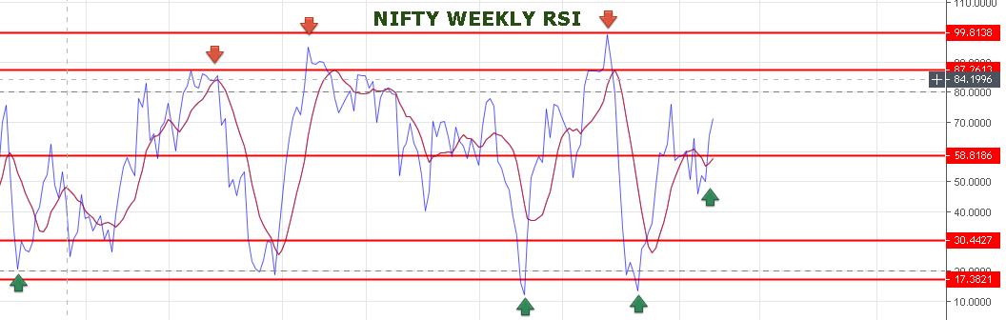
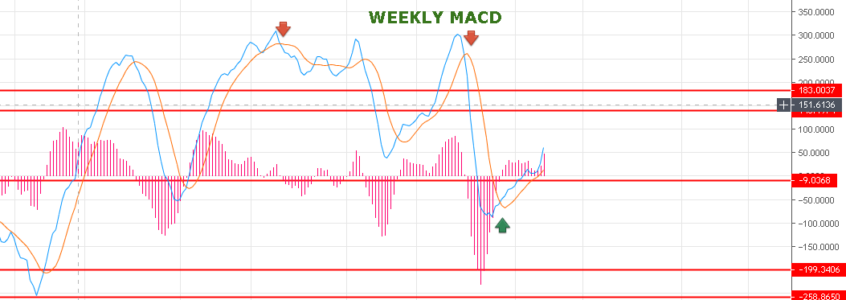
WEEKLY MACD TELLING US UPSIDE LEFT 75% ONLY 25% DONE.
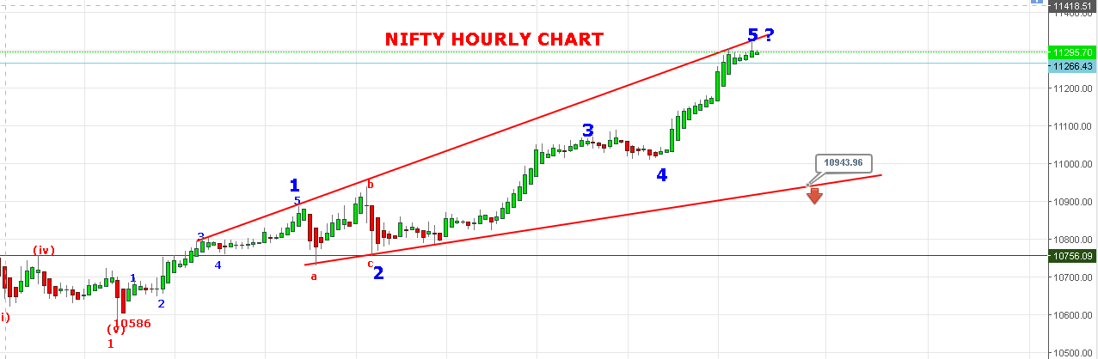
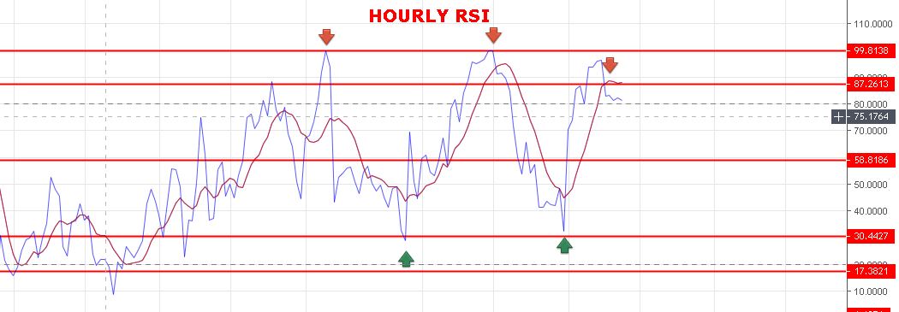
SUMMARY:
FOR LONGER POINT FROM BULLS EYE: AS LONG NIFTY HOLDING 10817 MONTH LOW WE CAN SEE 11700-12800 LEVELS.
BREAK OF MONTH LOW 10817 WE CAN SEE 10100 AGAIN. BUT POSSIBLITY IS LOW NOW. AS BOTH MONTHLY & WEEKLY CHART ARE STRONG.
NIFTY IS BUY ON DECLINE TILL 11000 LEVELS AS STRONG SUPPORT AS PER OPEN INTEREST DATA.
TODAY NIFTY DONE 73.6% RETRACEMENT LEVEL FROM 11760 TO 10005=10297.
80% COMES @10409 LEVELS.
SO IF NIFTY CLOSED ABOVE 10409 THEN MASSIVE UPSIDE WILL BE.
FROM BEARS EYE: AS LONG NIFTY HOLDING BELOW 10409 POSSIBILITY TO COME 10940 LEVELS. ONLY CLOSING BELOW 10940 WE CANN SEE 10500 -10100 LEVELS.
FOR TOMORROW IF NIFTY TRADE BELOW 11320 LEVELS THEN WE CAN SEE 11250-11170 AS SUPPORT.

