NIFTY PREDICTION FOR 26/02/2019:
NIFTY ABLE TO HOLD 200 DMA(10861) NOW HEADING TOWARDS 10900-10923>10950-10990.
SAR: 10740 NS.
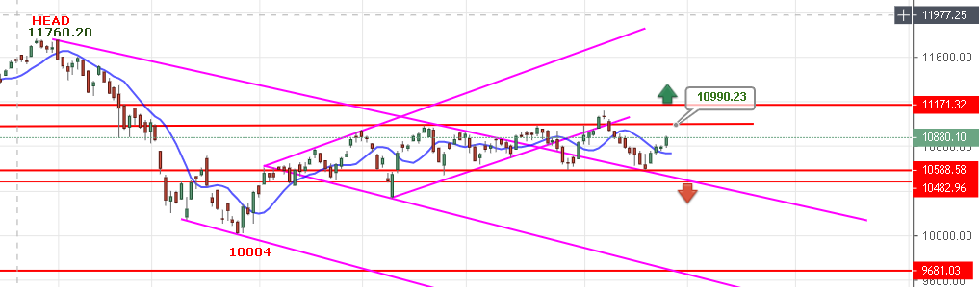
LONG POSITION IN NF CAN BE HOLD WITH STOP 10788 NS FOR 10920-10990NS.
TREND WILL REVERSE IF CLOSED BELOW 10740 NS FOR 10500 & BELOW.
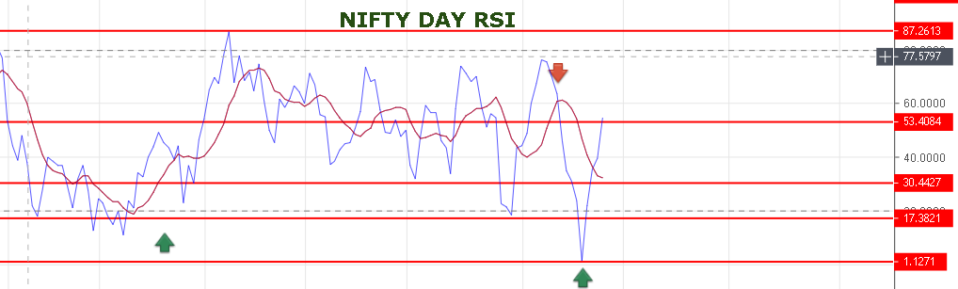
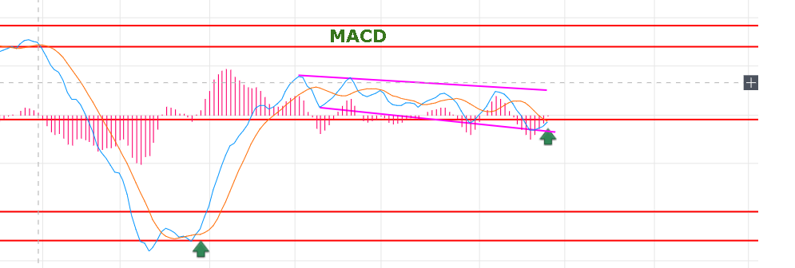
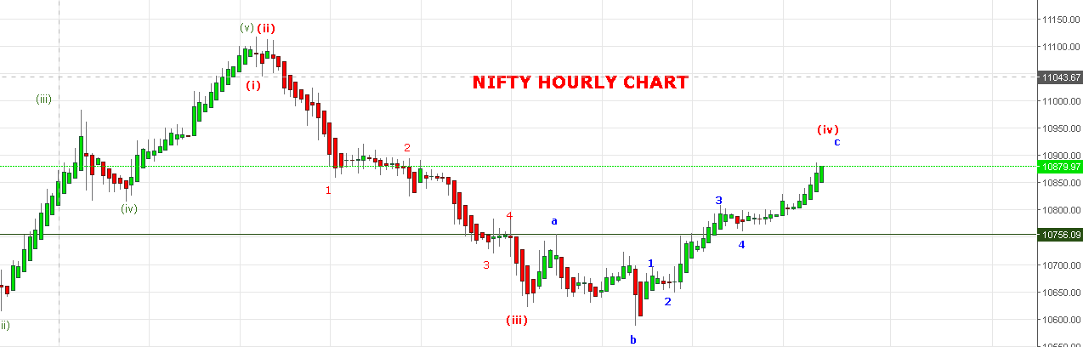
WAVE (iv) EXTENDED FROM 10810 AND AS LONG HOLDING ABOVE 10828 NS WE CAN SEE 10900 TO 10923-10940 LEVELS . AFTER COMPLETING WAVE (iv) WAVE (v) WILL START FOR 10400 LEVELS.
IF NIFTY BREAK 10828 TOMORROW FIRST HOUR AND SUSTAIN BELOW 10806 NS THEN ASSUME END OF WAVE (iv).
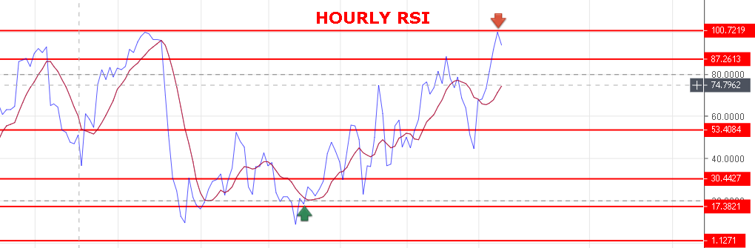
AS HOURLY RSI REACHED AT OVERBOUGHT ZONE SO ANY TIME WE CAN SEE CORRECTION.
WEAK BELOW 10825 NS.
BEARISH BELOW 10780 NS.
RESISTANCE: 10911-10923-10940-10980.
SUPPORT: 10828-10806-10780-10729-10670.
NIFTY FUTURE INTRADAY LEVELS:
BUY NF@10910+ STOP 10888 TGT 10932-10955-10981-10995.
SHORT NF@10860 STOP 10890 TGT 10825-10810-10782-10765.

NIFTY OPTION: FOR 26/02/2019:
HOLDING 4 LOTS OF 10900 PE @68 STOP 48.
KINDLY KEEP STOP LOSS. IF YOU DON’T KEEP STOP LOSS YOU CAN LOOSE CAPITAL AND MENTAL RESIST YOU TO BOOK LOSS AND FORCED YOU TO SEE CAPITAL ZERO.
TODAY’S TRADE REPORT:
http://prntscr.com/mpwi7i
INTRADAY:
BUY 10900 CE @54+ STOP 43 TGT 64-70-77-84.
BUY 10900 PE@71+ STOP 59 TGT 86-91-101-108>119-137.
PE WILL PREFER ONLY BELOW 10850 NS.

