NIFTY PREDICTION FOR 14/02/2019:
NIFTY CLOSED BELOW 50 DMA(10817) NOW NEED TO HOLD 100 DMA(10711) ELSE 10625.
SAR: 10936 NS.
POSITIONAL LONG ONLY ABOVE 10936 NS. TILL THEN SELL ON RISE TILL 10850 NS.
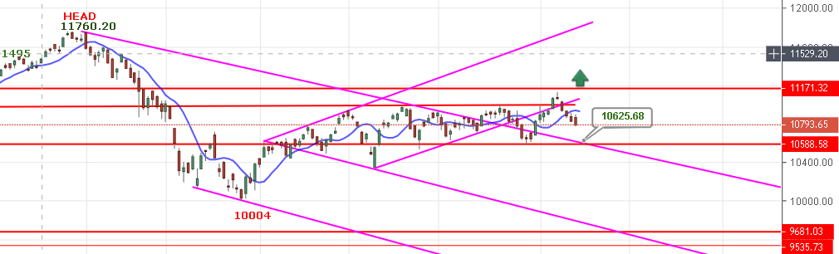
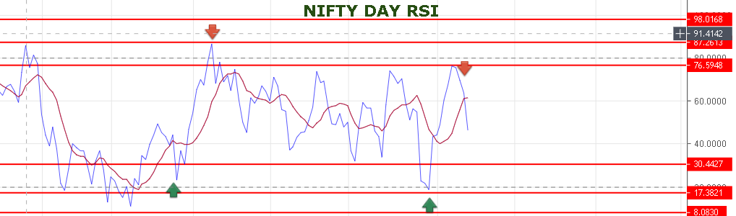
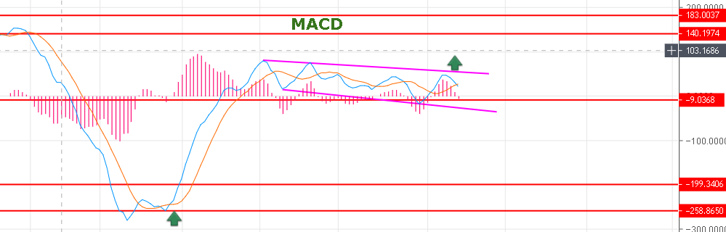
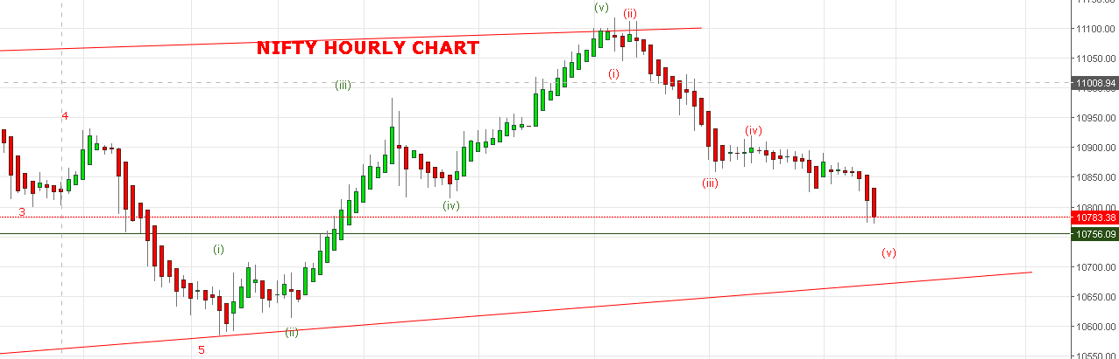
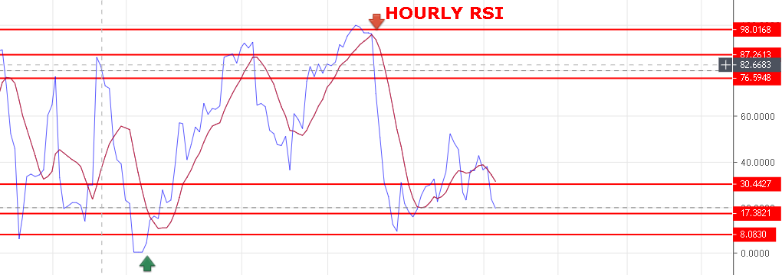
WEAKNESS REMAINS AS LONG HOLDING BELOW 10815 NS.
STRONG ABOVE 10850 NS.
NIFTY HOLDING 10717 WILL BOUNCE TOWARDS 10850-10900 LEVELS.
RESISTANCE: 10820-10840-10862-10885-10900.
SUPPORT: 10761-10730-10711-10675-10650-10625.
NIFTY FUTURE INTRADAY LEVELS:
BUY NF@10855+ STOP 10825 TGT 10885-10905-10920-10935.
SHORT NF@10800 STOP 10840 TGT 10775-10760-10742-10722-10693.
NIFTY OPTION:
BUY 10700 CE 14 FEB @139 STOP 127 TGT 148-161-175-190.

BUY 10900 PE 14 FEB @97 STOP 67 TGT 108-113-121-127>138-150

