NIFTY PREDICTION FOR 04/02/2019:
NIFTY HEADING TOWARDS 11090 IF CROSS 10990 NS ELSE 10750 AGAIN.
SAR: 10761 NS.
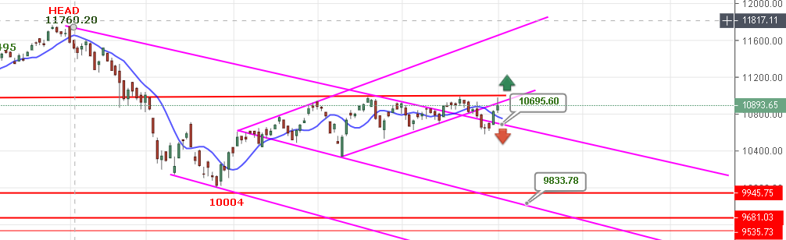
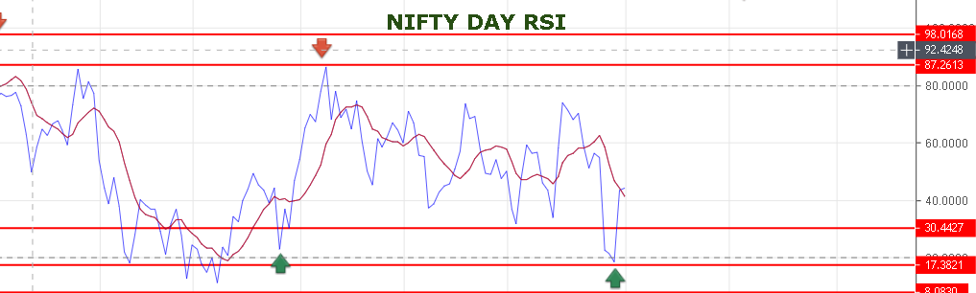
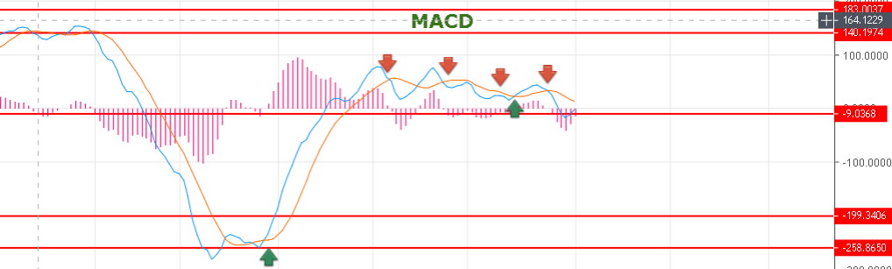
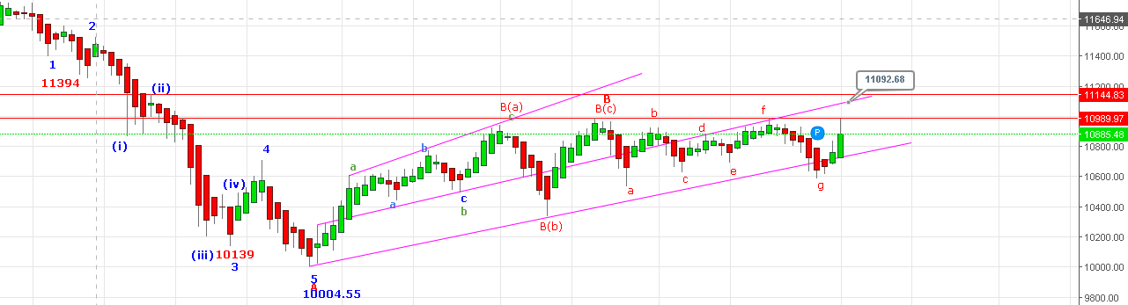
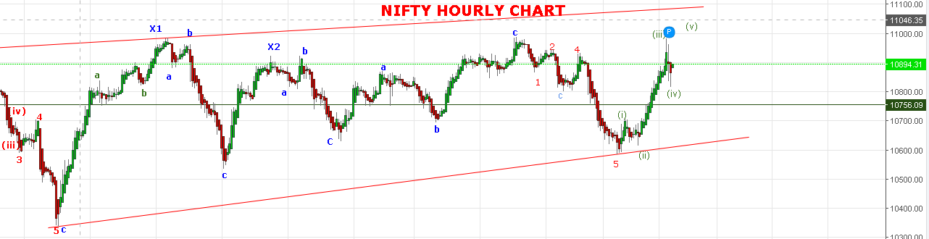
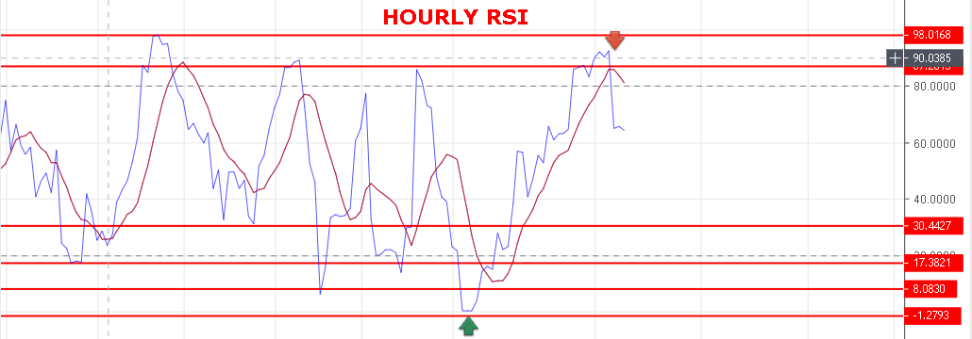
WEAKNESS BELOW 10850 NS.
BEARISH BELOW 10790 NS.
RESISTANCE: 10940-10991-11029-11050-11090.
SUPPORT: 10840-10800-10760-10710.
AS PER OPEN INTEREST TABLE NIFTY RESISTANCE STILL @11000 AND SUPPORT @10700 NS. SO RANGE BOUND 11000-10700.

NIFTY FUTURE INTRADAY LEVELS:
BUY NF@10938+ STOP 10915 TGT 10947-10966-10980-11030-11045.
SHORT NF@10900 STOP 10932 TGT10885-10855-10829-10798-10775.
NIFTY OPTION:
BUY 11100 CE @96+ STOP 82 TGT 111-116-124-139.
BUY 10800 PE@140+ STOP 122 TGT 155-165-190-202.

