BANK NIFTY PREDICTION FOR 26/02/2019:
BANK NIFTY HOLDING 26960 WILL SEE 27300-27400 LEVELS. WEAK BELOW 26960.
SAR: 26906 BNS.
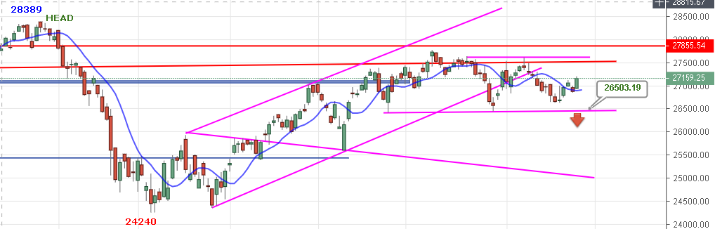
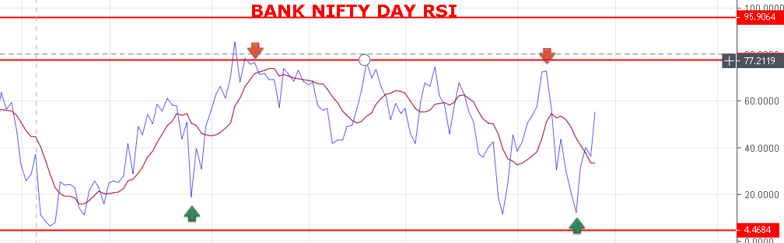
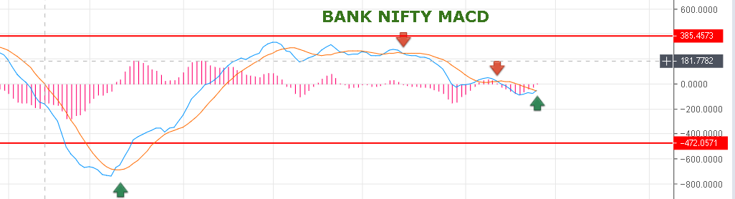
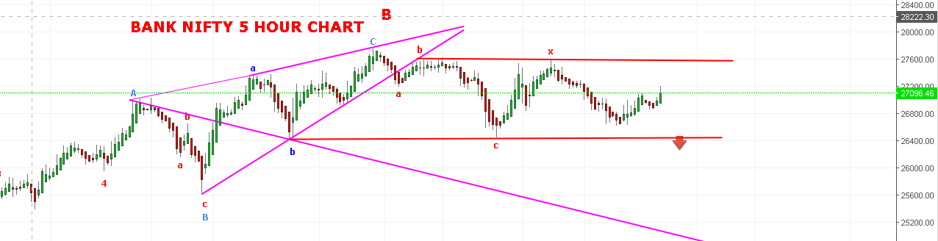
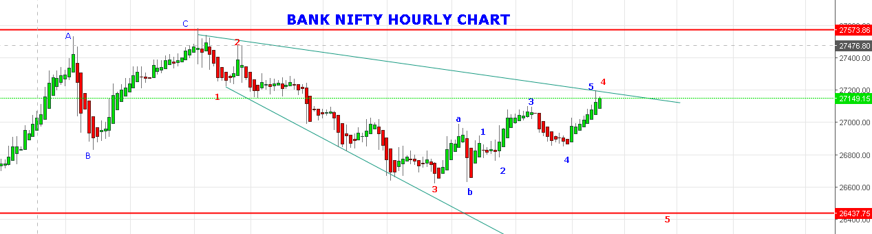
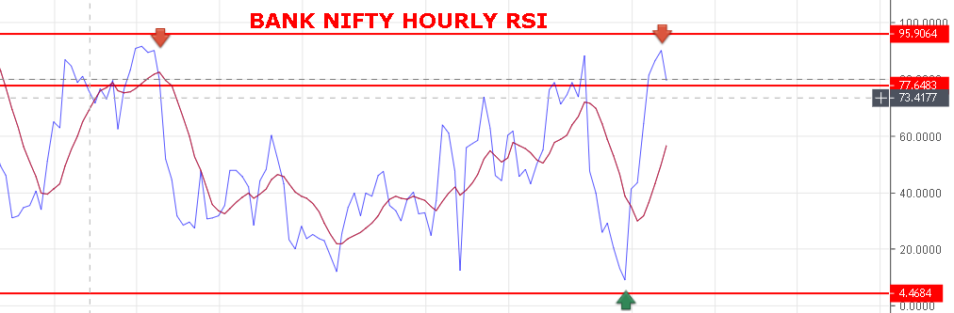
HOURLY RSI REACHED AT OVERBOUGHT ZONE.
WEAK BELOW 26960 NS.
BEARISH BELOW 26850 BNS.
RESISTANCE: 27200-27330-27400-27540.
SUPPORT: 26960-26860-26740-26660-26500.

BANK NIFTY FUTURE INRADAY LEVELS:
BUY BNF@27230+ STOP 27170 TGT 27290-27315-27395-27455-27489.
SHORT BNF@27100 STOP 27160 TGT 27020-26940-26870-26790.
BANK NIFTY OPTION INTRADAY:
BUY 27200 CE@120+ STOP 101 TGT 150-171-185-201.
BUY 27100 PE@128+ STOP 101 TGT 152-165-183-198-230.
PE WILL PRFER ONLY BELOW 26960 BNS.
http://prntscr.com/mpx31z

