NIFTY PREDICTION FOR 31/12/2018:
NIFTY NEED TO CROSS @100 DMA(10922) AND PREVIOUS WEEK HIGH @10985 NS FOR 11090>11234 NS.
SAR: 10801 NS.
POSITIONAL LONG STOP 10801-30=10771 NS.
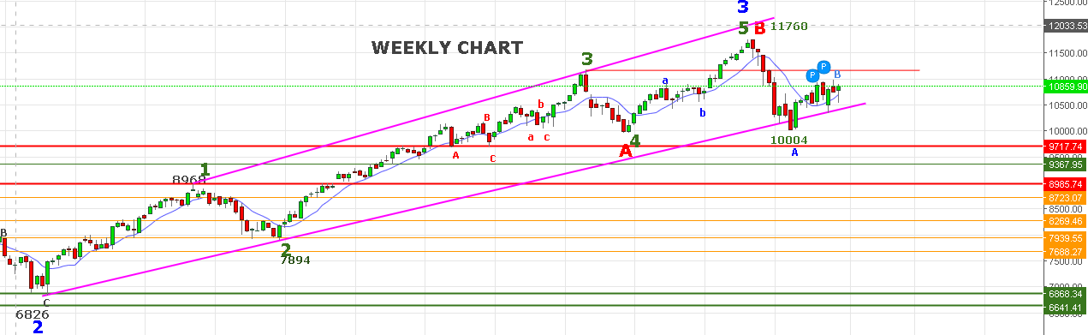
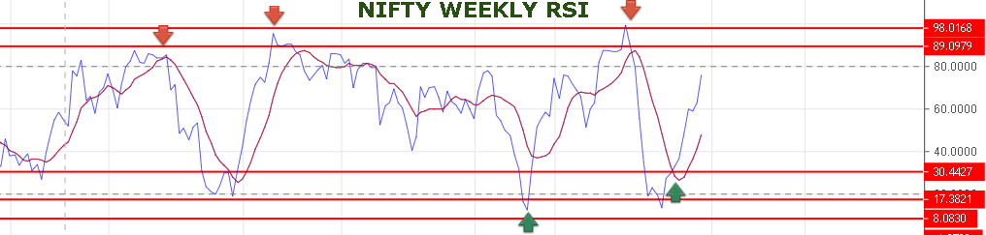
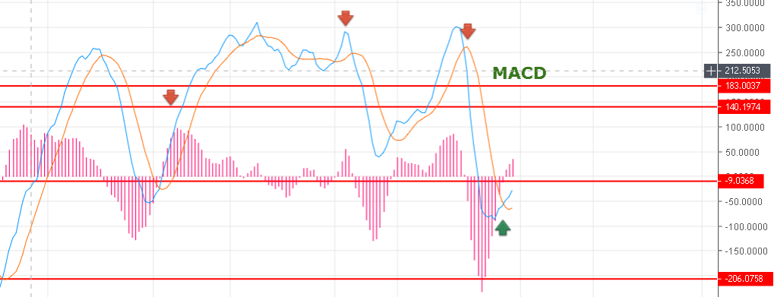
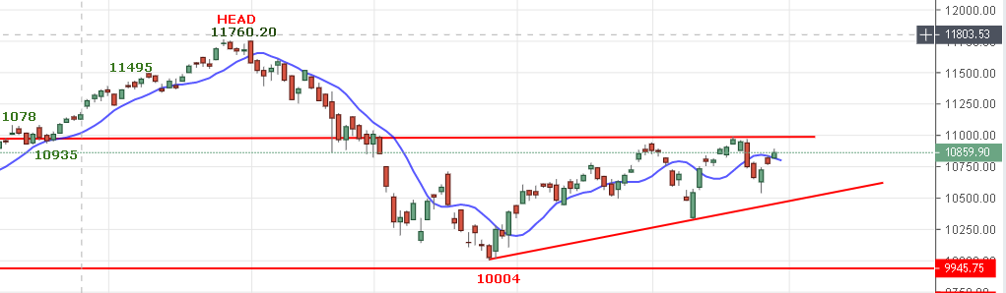
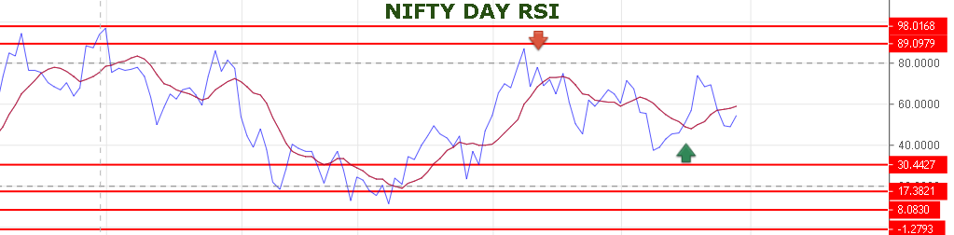
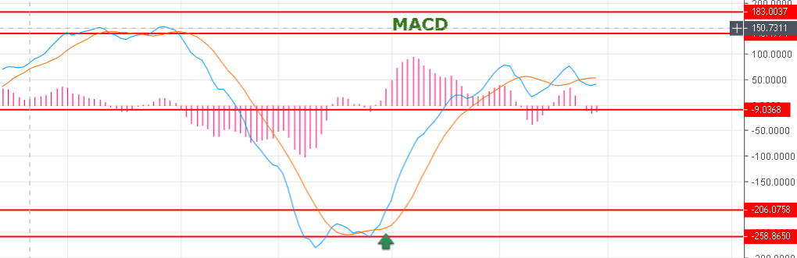
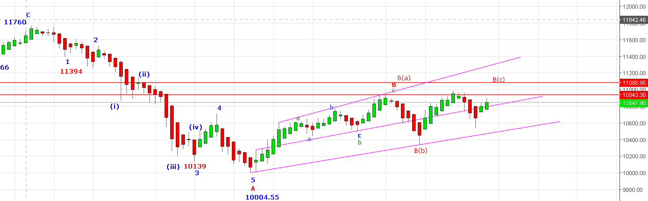
REVERSAL BELOW 10760 NS.
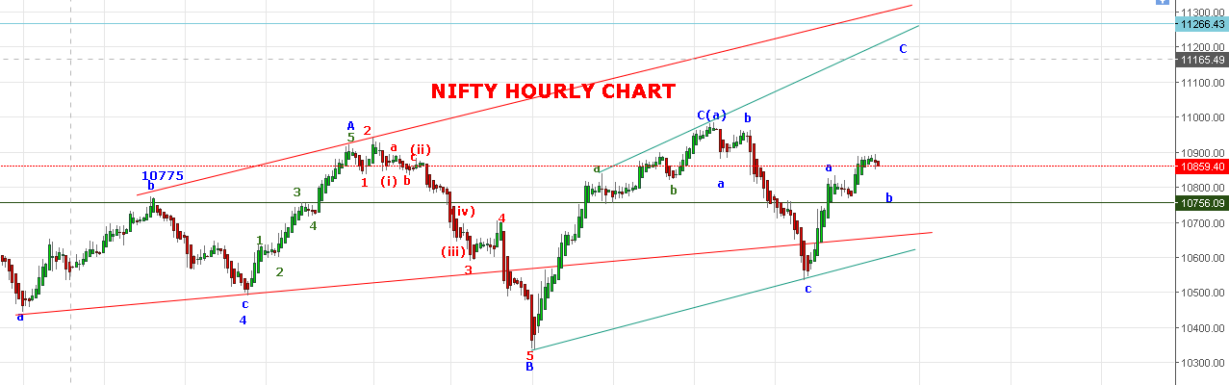
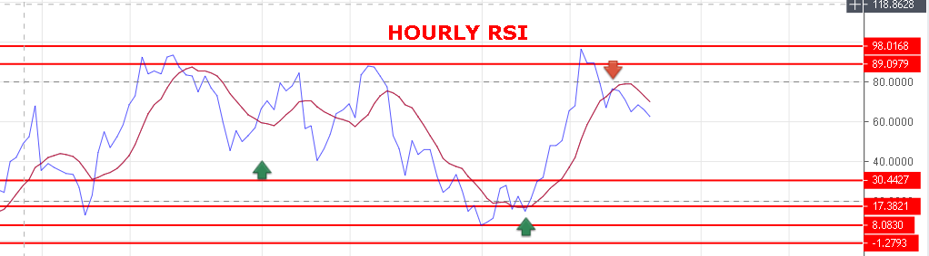
NIFTY TRADING BELOW 10850 CAN SEE FALL UP TO 10800<10760 LEVELS. TRADING ABOVE 10894 CAN SEE 10922-10940>10985>11030-11090>11108 LEVELS.
WEAK BELOW 10831 NS.
BEARISH BELOW 10740 NS.
RESISTANCE: 10922-10940-10985-11030-11086.
SUPPORT: 10850-10830-10817-10800-10783-10760.
BUY NS ABOVE 10894, SELL BELOW 10828 NS.
NIFTY FUTURE INTRADAY LEVELS:
BUY NF@10944+ STOP 10914 TGT 10990-11015-11052-11081-11121.
SHORT NF@10875 STOP 10905 TGT 10855-10842-10827-10800-10780.
NIFTY OPTION:
BUY 11100 CE @104+ STOP 93 TGT 114-119-127-138-151-166-185.
BUY 10700 PE@121+ STOP 111 TGT 142-153-180-198.
HOLDING 11100 CE STOP 83.

