NIFTY PREDICTION FOR 28/12/2018:
NIFTY TRADING ABOVE 10820 AGAIN WE CAN SEE 10940 TO 11090 LEVELS.
SAR: 10817 NS.
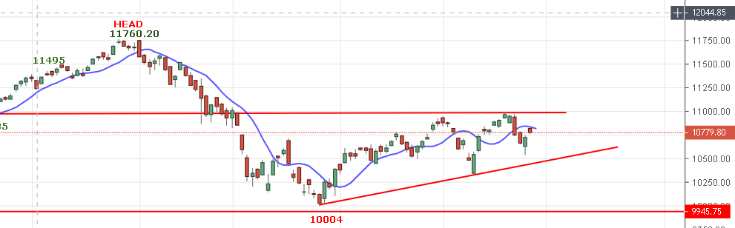
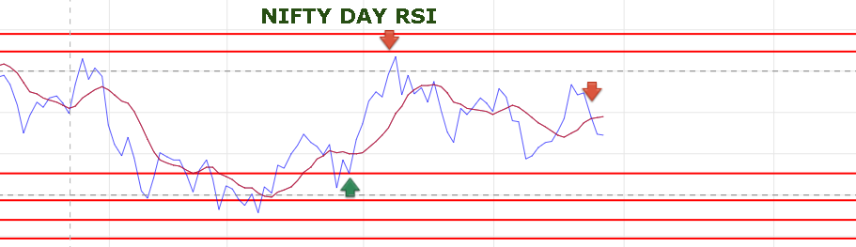
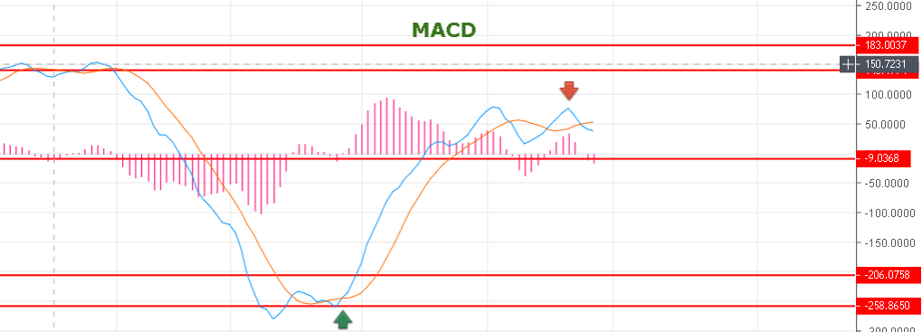
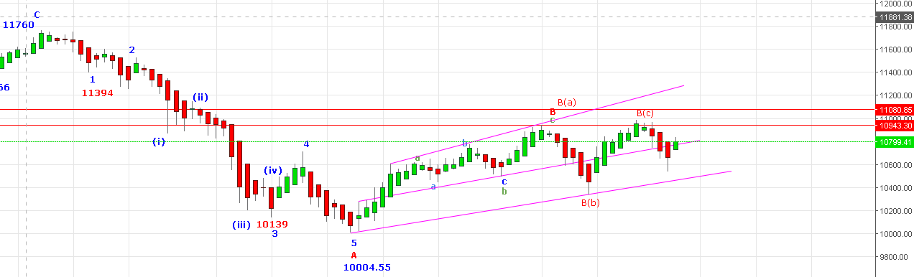
HOLDING ABOVE 10826 WILL SEE 10234 NS. REVERSAL BELOW 10730 NS FOR 10450 & BELOW.
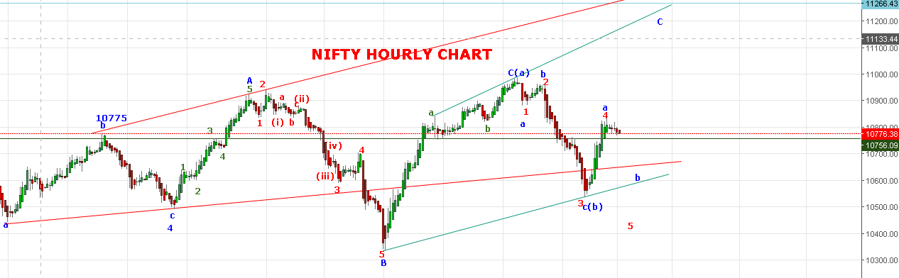
PULL BACK RALLY FROM 10534 TO 10834 JUST IN TWO DAYS CHANGE THE WAVE COUNT INSTEAD OF 12345 IT SHOULD BE abc NOW . LOOK LIKE WAVE B( C) (c ) STILL IN PROGRESS SUB DIVIDED INTO abc AS SHOWN IN ABOVE CHART. IF 10580 BROKEN WE ASSUME WAVE 5 IN PROGRESS. IF PRICE HOLD 10650 LEVEL WE WILL ASSUME INNER WAVE OF SMALL (b) IN PROGRESS.IF PRICE HOLD ABOVE 10826 THEN WAVE SAMLL (c) OF B( C) IN PROGRESS FOR TARGETS 11090 TO 11234 NS.
HUGE VOLATILITY AND COMPLEX NATURE FRUSTRATED TRADERS.
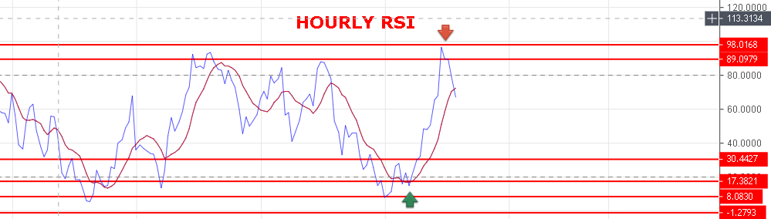
HOURLY RSI WAS OVERBOUGHT NOW ITS FALLING AND TOMORROW CORRECTION LIKELY TO BE TILL 10700 LEVELS & BELOW.
WEAK BELOW 10760 NS.
BEARISH BELOW 10700 NS.
BULLISH ABOVE 10826 NS.
BUY NS ABOVE 10811 NS, SELL BELOW 10760 NS.
NIFTY FUTURE INTRADAY LEVELS:
BUY NF @10840 + STOP 10810 TGT 10870-10891-10910-10938-10955-10980.
SHORT NF@10770 STOP 10832 TGT 10729-10705-10670-10640-10598.
NIFTY OPTION:
BUY 10900 CE@166 STOP 146 TGT 188-200-230-250.
BUY 10500 PE @108 STOP 93 TGT 121-138-160-178>199-230.

