NIFTY PREDICTION FOR 27/12/2018:
NIFTY DID 10540 AND BOUNCE. DID 50% RETRACEMENT @10750. MUST PAUSE HERE FOR 10450 LEVELS & BELOW.
SAR: 10834 NS.
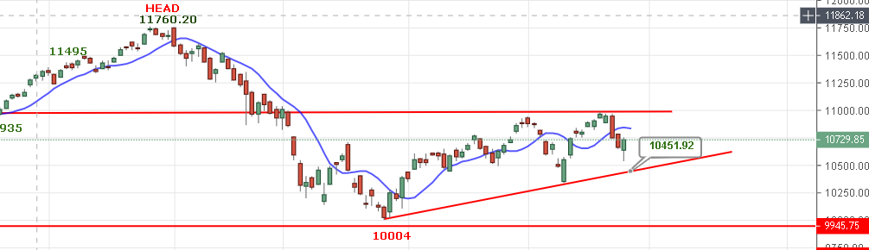
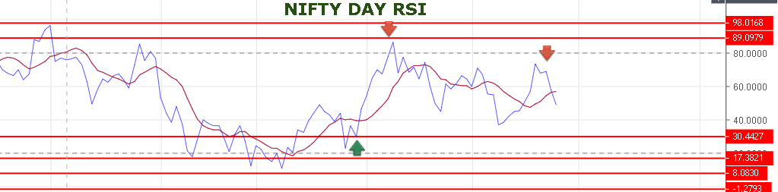
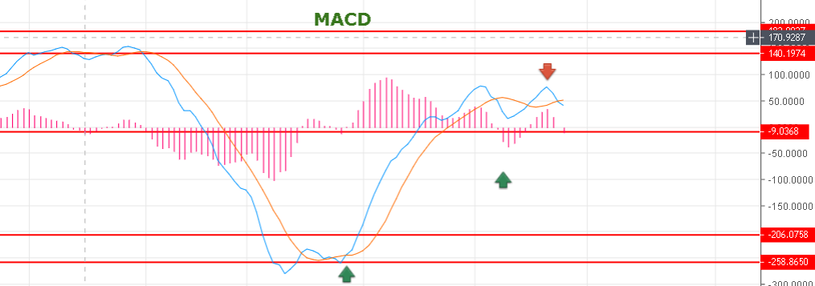

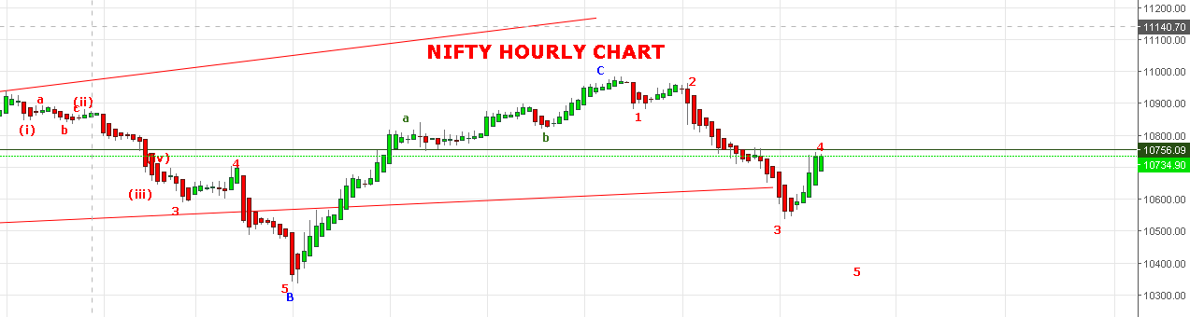
WAVE 3 DONE @10534 AND WAVE 4 SEEMS TO BE DONE @10748 AND WAVE 5 WILL START FOR 10470 MINIMUM TARGETS.
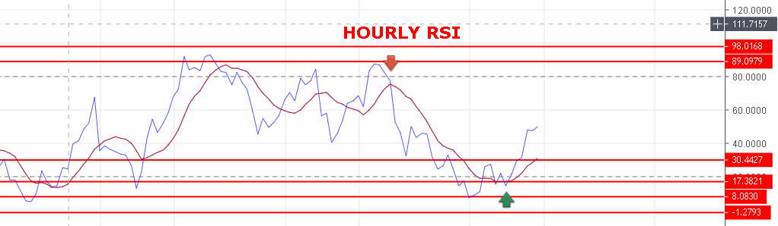
BULLISH ABOVE 10820 NS FOR 11234 NS.TILL THEN VIEW IS FOR 10469 & BELOW.
RESISTANCE: 10751-10763-10770-10777-10813.
SUPPORT: 10700-10655-10591-10530-10507-10469.
BUY NS ABOVE 10770, SELL BELOW 10707 NS.
NIFTY FUTURE INTRADAY LEVELS:
BUY NF JAN@10833 STOP 10800 TGT 10858-10870-10900-10940.
SHORT NF JAN @10750 STOP 10790 TGT 10705-10660-10630-10619-10575.
NIFTY OPTION:
BUY 10900 CE JAN @150 STOP 142 TGT 179-194-225.
BUY 10500 PE JAN @119+ STOP 105 TGT 130-142-169-190.

