NIFTY PREDICTION FOR 25/01/2019:
NIFTY ABLE TO HOLD 10800 LEVELS TODAY BUT HOLDING BELOW 10870 WILL BREAK 10800 ABOVE CAN SEE 10915+
SAR: 10885 NS.
HOLDING SHORTS STOP NOW 10877 NS.TARGETS 10700.
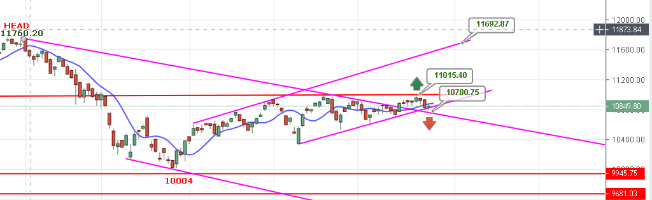
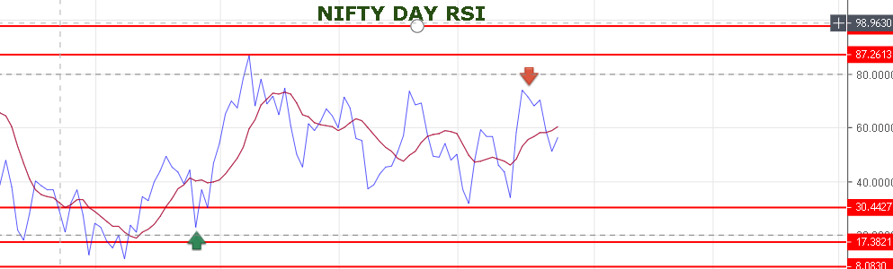
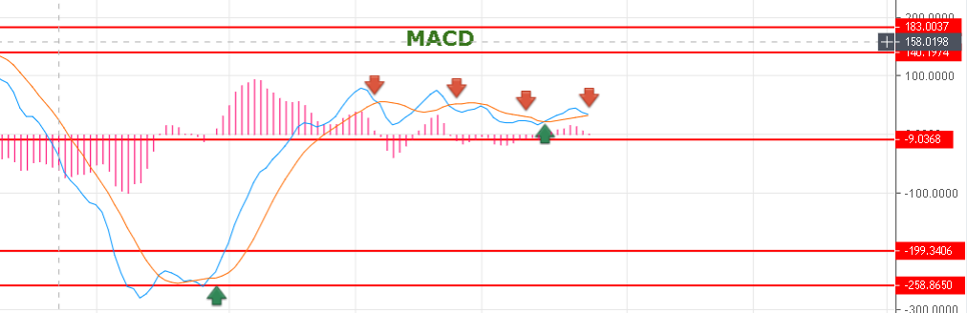
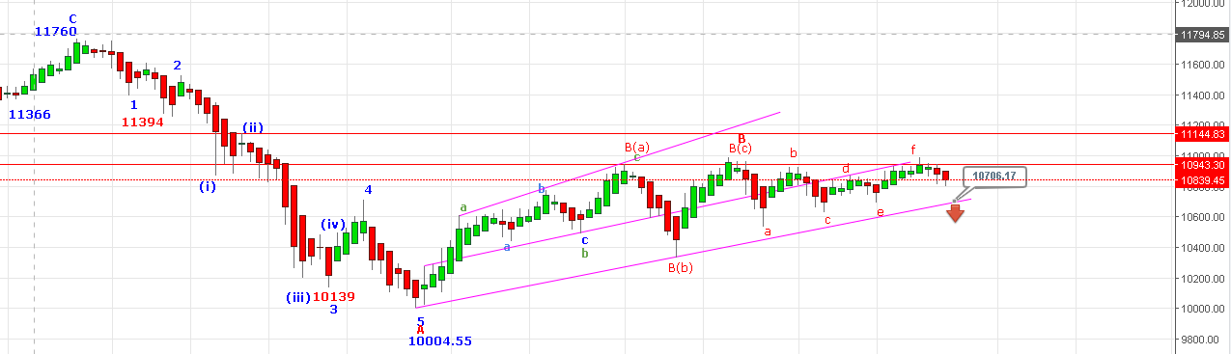
HOLDING BELOW 10875 TARGETS 10700 LEVEL. ABOVE 10898 TARGETS 11050 .
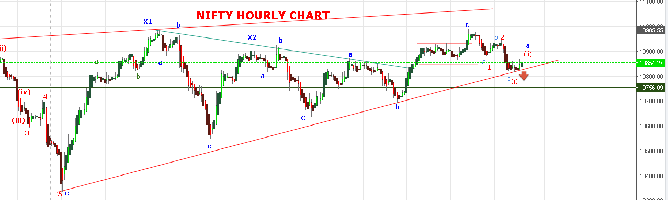
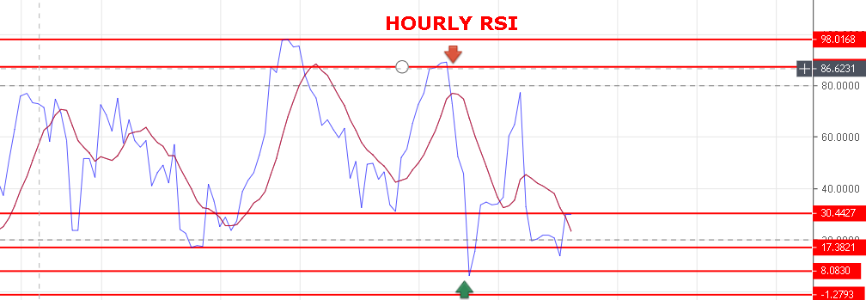
FOR BULLS MUST CROSS 10879 FOR BEARS MUST CROSS BELOW 10780 NS.
RESISTANCE: 10869-10873-10887-10916.
SUPPORT: 10810-10782-10774-10705.

NIFTY INTRADAY FUTURE LEVELS:
BUY NF@10898 STOP 10868 TGT 10930-10945-10970.
SHORT NF@10840 STOP 10820-10807-10790-10761.
NIFTY OPTION:
BUY 10900 CE@85+ STOP 61 TGT 95-101-110-119.
BUY 10800 PE @77+ STOP 68 TGT 90-97-106-118-127.

