NIFTY PREDICTION FOR 24/12/2018:
NIFTY FALL AS PER EXPECTATION. CLOSED BELOW 200 DMA(10767) AND SAR(10808).
SAR: 10836 NS.
SHORT TRIGGER AS PER SAR METHOD.POSITIONAL HOLDER KEEP STOP NOW 10836+40=10876 NS.
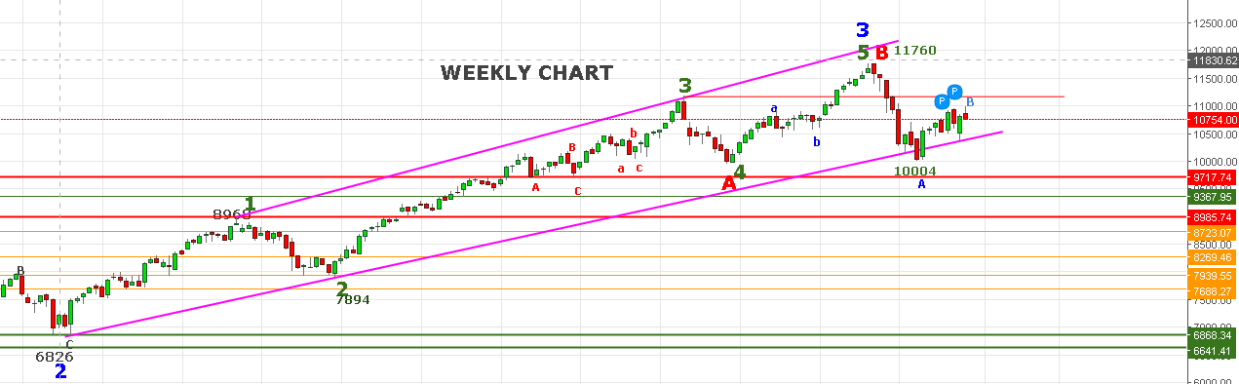
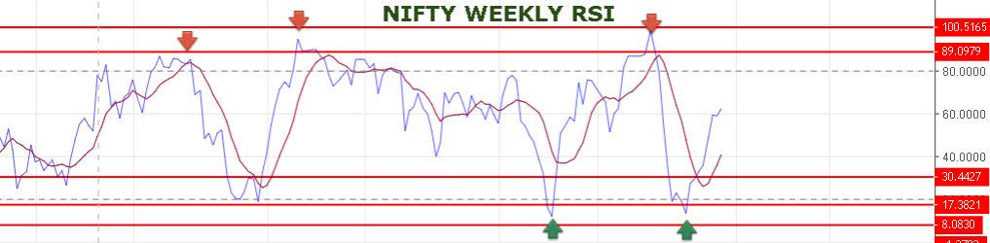
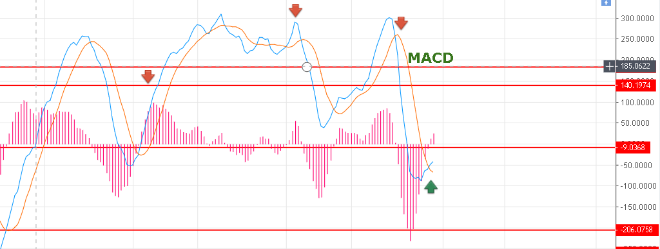
WEEKLY SUPPORT @10722 IF BROKEN THEN 10611-10536-10443 LIKELY TO HIT. HOLDING 10722NS WILL BOUNCE UP TO 10802-10830 LEVELS.

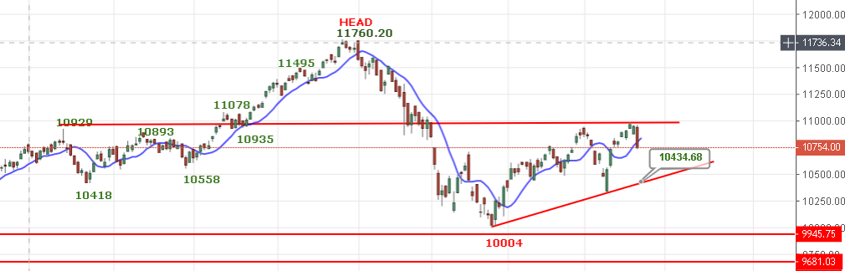
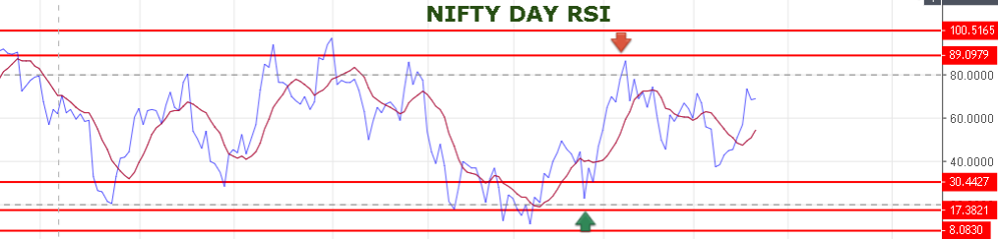
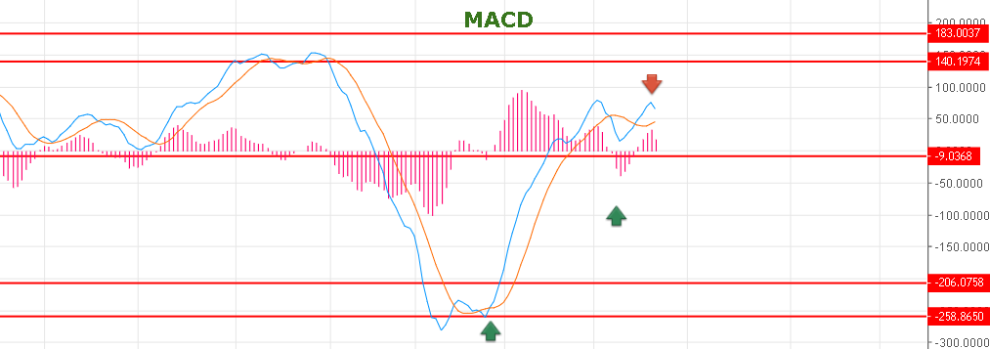
DAY MACD BENDING NOW.
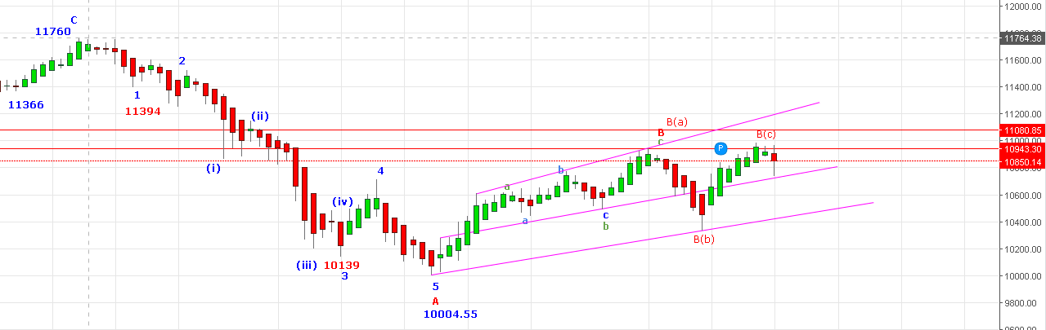
AS PER ABOVE CHART B WAVE COMPLETED AND PRICE MUST CLOSE BELOW 10729 NS TO ACHIEVE TARGETS 10450-10420 LEVELS.
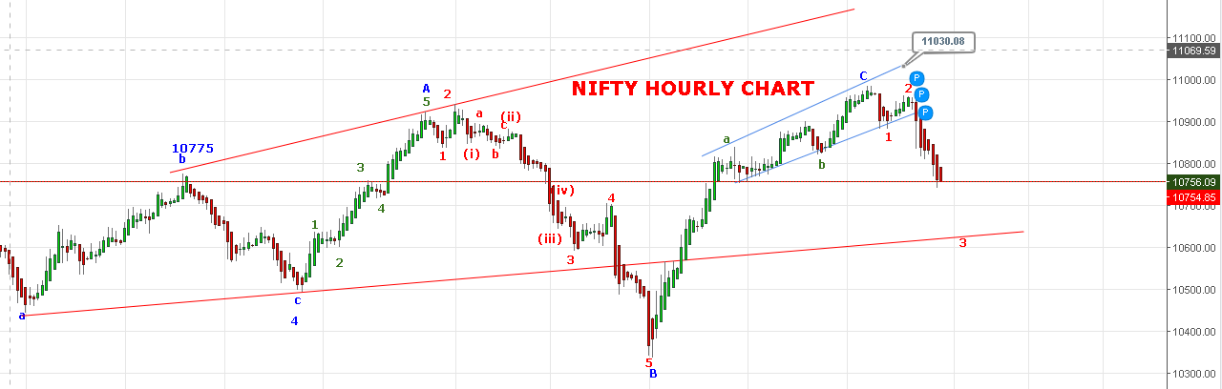
3RD WAVE TARGETS COMING NEAR 10640 TO 10590>10536 LEVELS.IT CAN FURTHER EXTEND TO 10440 LEVELS.
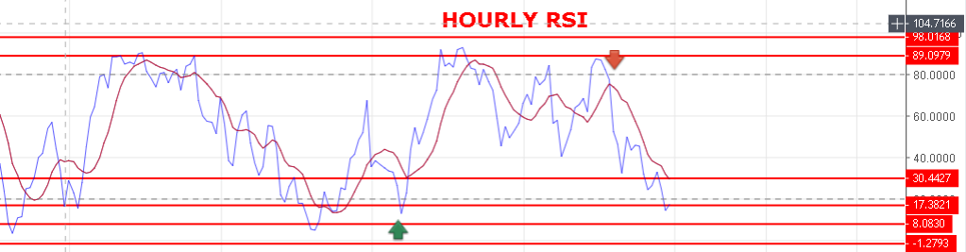
IF NIFTY BOUNCE ABOVE 10875 NS THEN GO LONG FOR TARGETS 11090-11234 NS.
WEAKNESS REMAINS AS LONG HOLDING BELOW 10802 NS.
STRONG ABOVE 10841 NS.
BULLISH ABOVE 10894 NS.
RESISTANCE: 10784-10802-10819-10830>10860-10891.
SUPPORT: 10721-10655-10590-10555-10536.
BUY NS ABOVE 10781 NS( INTRADAY TRADERS), SELL BELOW 10727 NS.
NIFTY FUTURE INTRADAY LEVELS:
BUY NF@10811 STOP 10781 TGT 10837-10855-10872-10900-10922-10940.
SHORT NF@10730 STOP 10760 TGT 10685-10660-10619-10590-10548.
NIFTY OPTION:
BUY 10700 CE@139+ STOP 122 TGT 150-162-191-208.
BUY 10700 PE @68+ STOP 54 TGT 86-94-107-119-127-140.
HOLDING 10500 PE@18 STOP 9( PRICE MUST HOLD BELOW FOR 5 MINT) TARGETS 50-70.
CE WILL PREFER ABOVE 10828 NS, PE BELOW 10753 NS.

