NIFTY PREDICTION FOR 24/01/2019:
NIFTY HOLDING BELOW 10812 WILL SEE 10750-10650 LEVELS.HOLDING ABOVE 10885 NS CAN SEE 11015 NS.
SAR: 10882 NS.
NIFTY CLOSED BELOW SAR, POSITIONAL SHORT TRIGGER STOP 10915 NS TGT 10760 & BELOW(9950).
AS ALREADY MENTIONED THAT AFTER 21 ST JANUARY 10500 WILL BREAK LET SEE. ON 21-01-2019 HIGH MADE 10987 NOW LOW MADE TILL NOW 10812. FALL TILL 175 POINTS SO FAR.

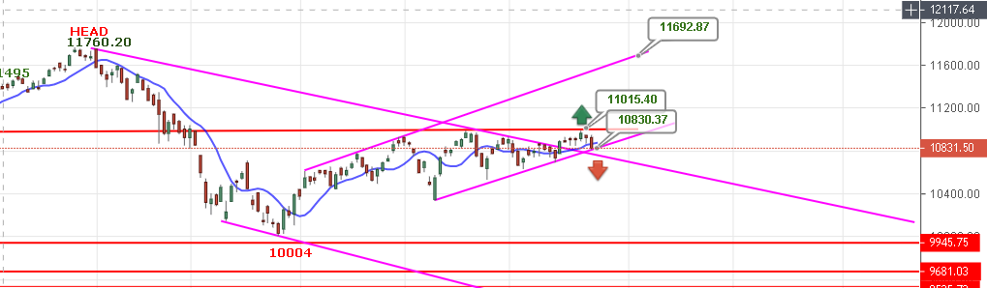
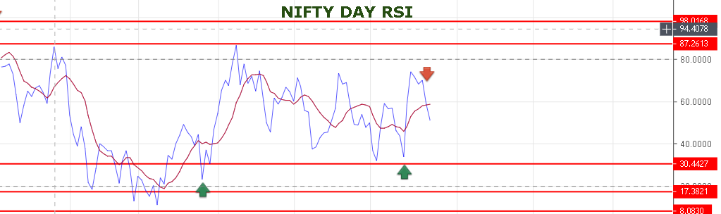
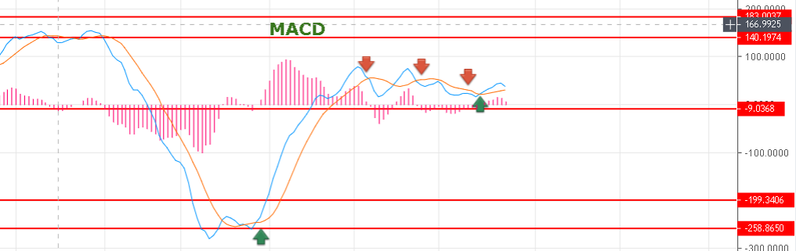
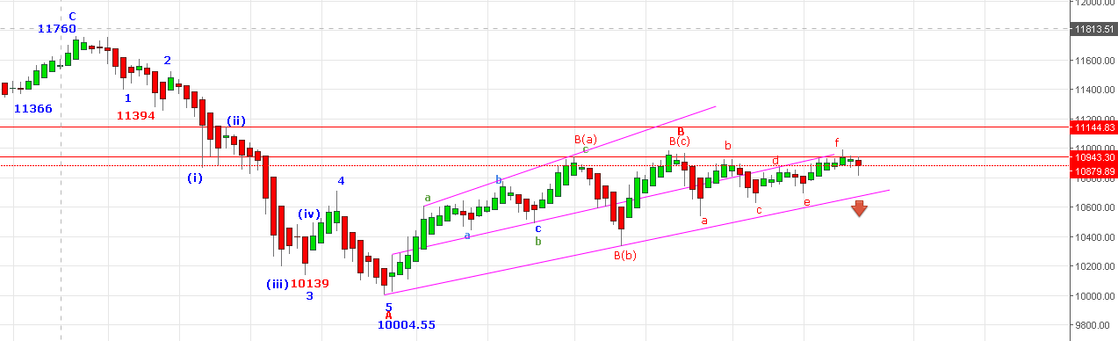
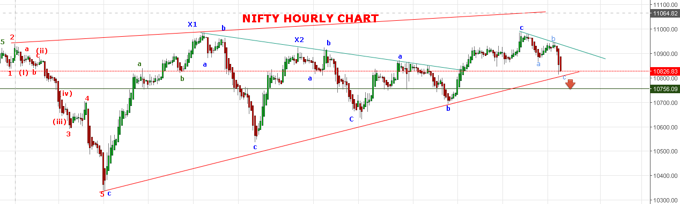
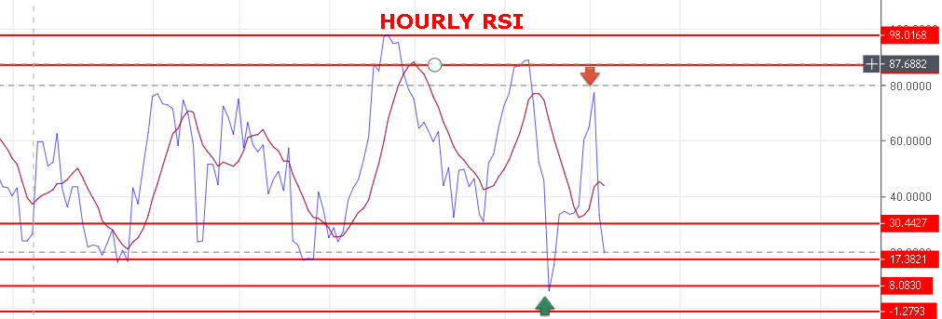
STRONG ONLY ABOVE 10892 NS.
BULLISH ABOVE 10932 NS.
RESISTANCE: 10866-10885-10915-10925.
SUPPORT: 10805-10788-10760-10698.IF SUPPORT TAKEN NEAR 10800 THEN IT WILL BOUNCE AGAIN TOWARDS 10915.

NIFTY FUTURE INTRADAY TARGETS:
BUY NF@10886 STOP 10850 TGT 10919-10955-10967-10980.
SHORT NF@10840 STOP 10870 TGT 10805-10792-10758-10745.
NIFTY OPTION:
BUY 10900 CE@107+ STOP 92 TGT 116-127-139-148.
BUY 10800 PE@82+ STOP 64 TGT 105-119-130-143.

