NIFTY PREDICTION FOR 22/01/2019:
NIFTY HOLDING 10927 WILL MOVE TOWARDS OUR TARGETS 11015 TO 11050 LEVELS.
SAR: 10853 NS.
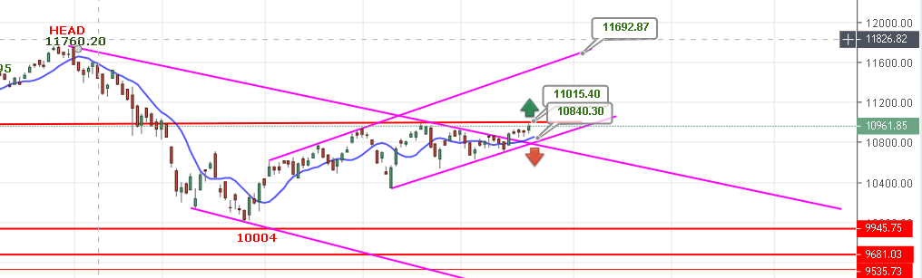
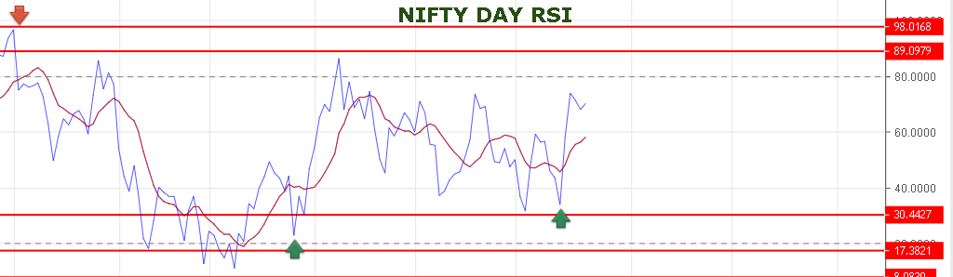
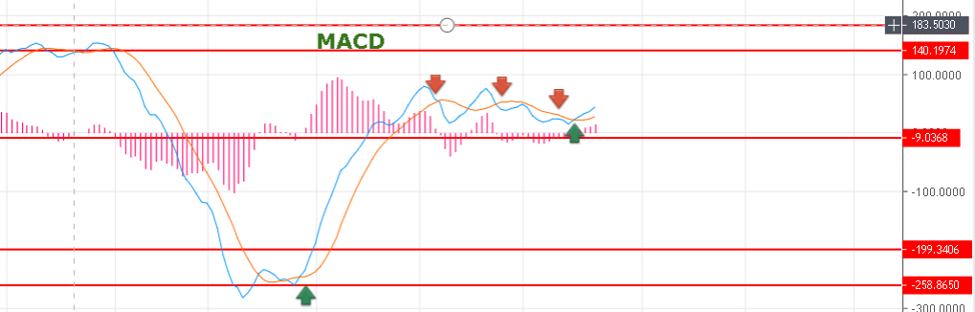
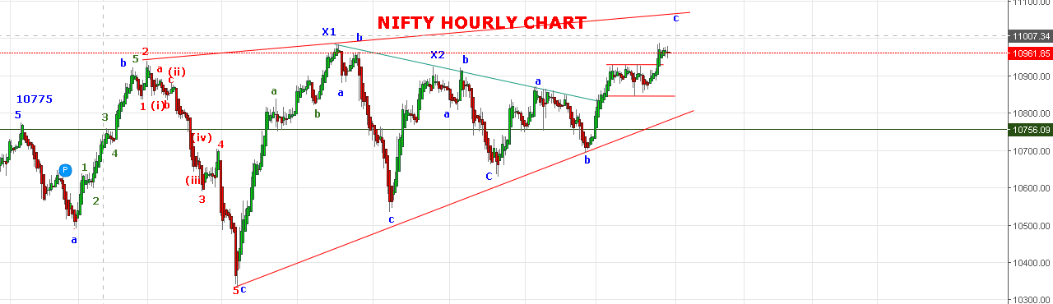
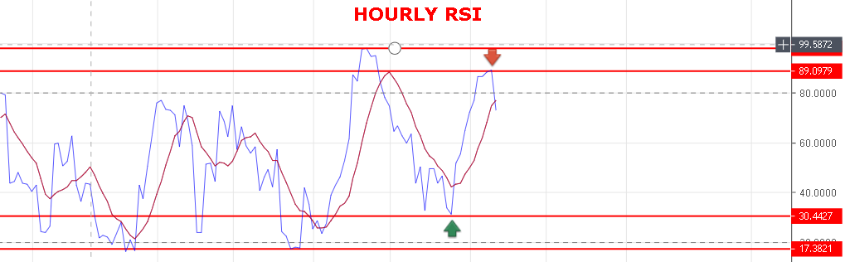
WEAK ONLY BELOW 10927 NS.
BEARISH BELOW 10850 NS.
RESISTANCE: 10990-11015-11040-11064-11087.
SUPPORT: 10934-10902-10881-10860-10841.
INTRA-DAY NIFTY FUTURE LEVELS:
BUY NF@11001+ STOP 11029-11050-11077-11091-11100.
SHORT NF@10947 STOP 10980 TGT 10924-10904-10890-10862.
NIFTY OPTION:
BUY 11000 CE@95+ STOP 87 TGT 110-119-135-148-161.
BUY 11000 PE@133 STOP 118 TGT 150-181-197-208.

