NIFTY PREDICTION FOR 21/12/2018:
NIFTY STILL HOLDING 10950 LEVELS, HOLDING SAME CAN TOUCH 11029-11090 LEVELS.ELSE 10740 IS COMING.
SAR: 10808 NS.
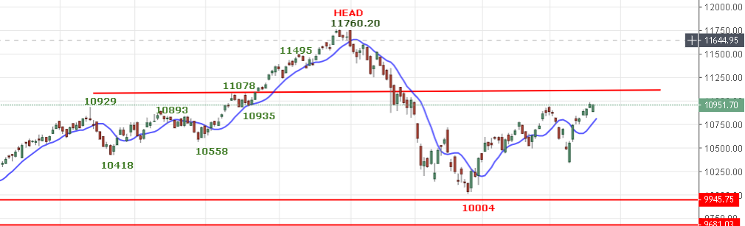
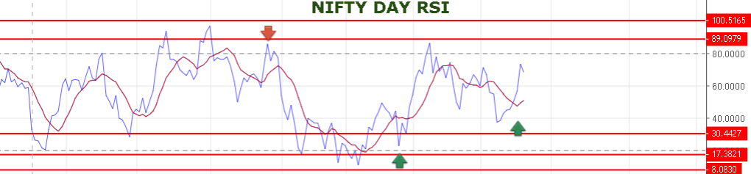
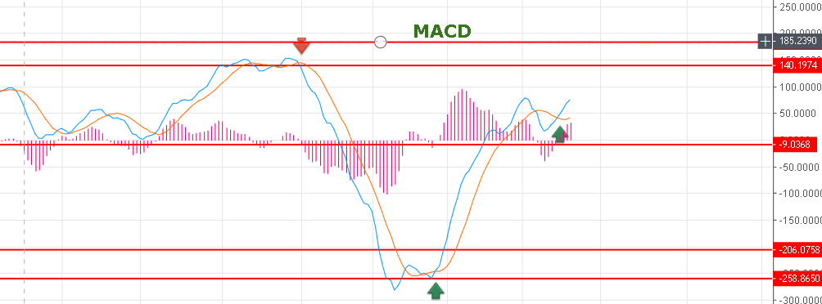
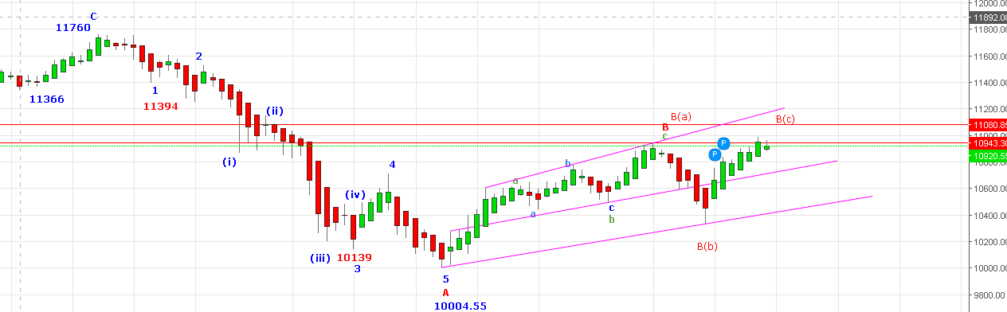
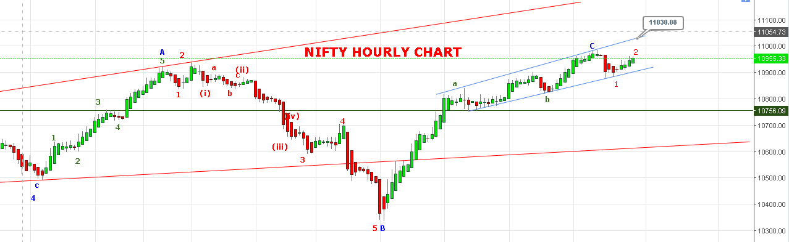
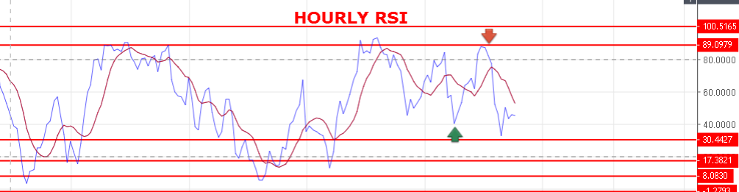
SO EITHER WAVE C COMPLETED AND DOWN WAVE START DONE 1 & 2 AND 3RD WILL START OR WAVE C (a) & (b) DONE AND LAST LEG C IS PENDING TO COMPLETE.
WEAK BELOW 10916 NS.
STRONG ONLY ABOVE 10978 NS.
BEARISH BELOW 10880 NS.

NIFTY FUTURE INTRADAY LEVELS:
BUY NF@11018 STOP 10990 TGT 11040-11060-11080-11106.
SHORT NF@10940 STOP 10970 TGT 10896-10874-10840-10810-10775.
NIFTY OPTION:
BUY 10900 CE@127+ STOP 115 TGT 145-150-162-190.
BUY 11000 PE@96+ STOP 79 TGT 109-115-130-144-160-202.
PE WILL PREFER BELOW 10916 NS.

