NIFTY PREDICTION FOR 21/01/2019:

NIFTY READY TO MOVE EITHER TOWARDS 11050 OR TOWARDS 10835 NS.

SAR: 10830 NS.

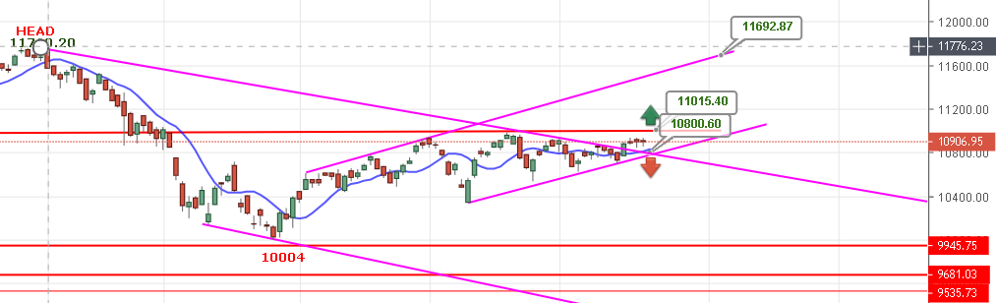
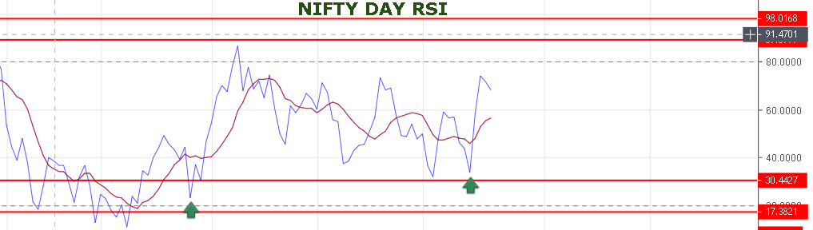
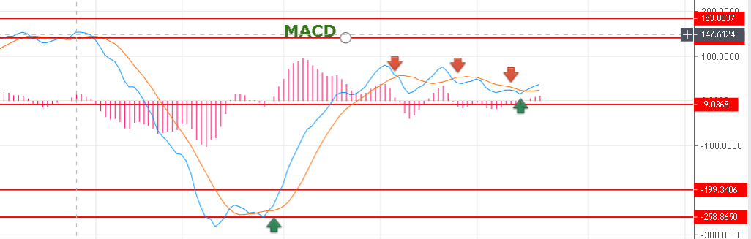

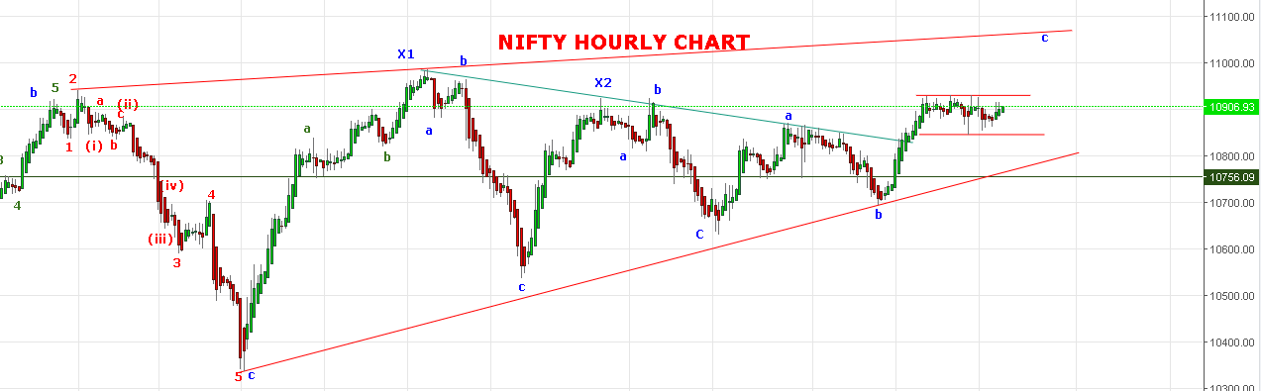
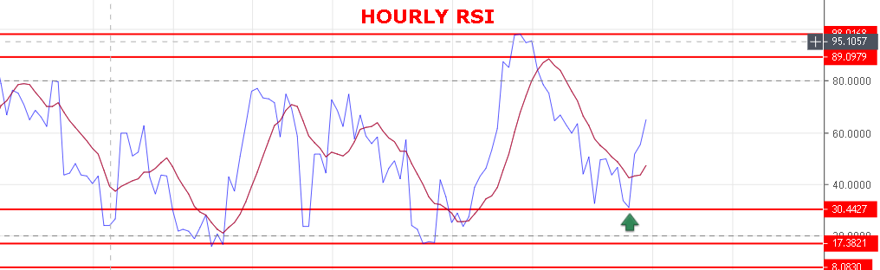

WEAK BELOW 10870 NS.

BEARISH BELOW 10815 NS .

RESISTANCE: 10930-10950-10985-10998-11016-11040.
SUPPORT: 10877-10845-10816-10774-10741-10723.
NIFTY FUTURE INTRADAY:
BUY NF@10960 STOP 10930 TGT 10991-11015-11035-11050-11065.
SHORT NF@10906 STOP 10936 TGT 10880-10845-10822-10810-10790.
NIFTY OPTION:
BUY 11000 CE@82+ STOP 70 TGT 96-108-118-131-161.
BUY 10800 PE@83 STOP 67 TGT 97-107-119-129-144-150.

