BANK NIFTY PREDICTION FOR 25/01/2019:
BANK NIFTY HOLDING 27150 CAN MOVE TO 27450+LEVELS AGAIN. HOLDING BELOW 27150 CAN SEE 26900 LEVELS.
SAR: 27441 BNS.
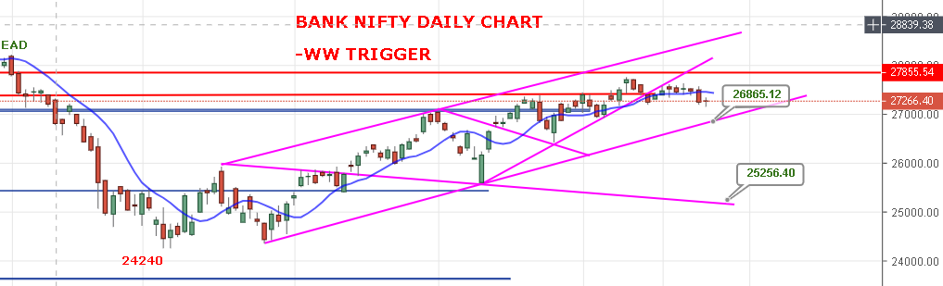
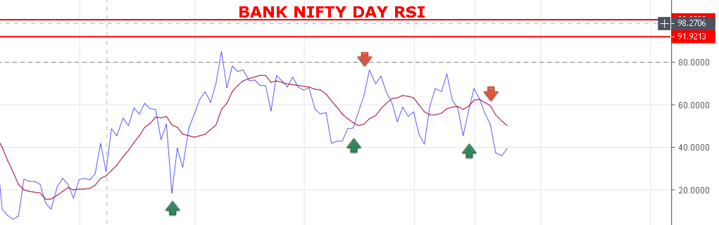
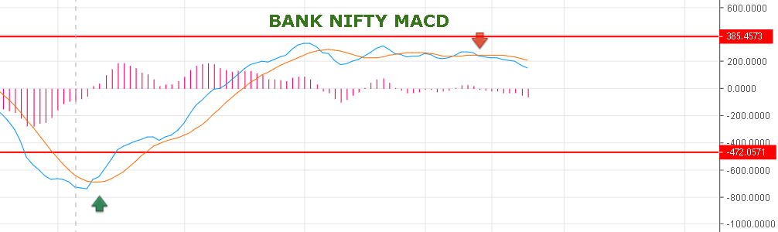
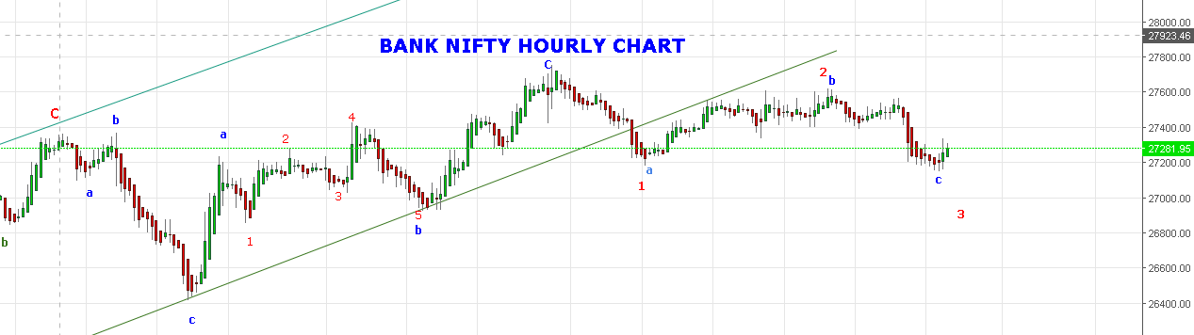
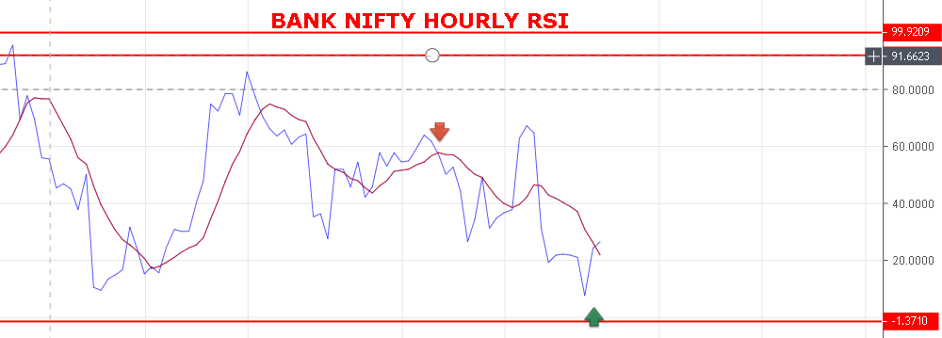
WEAKNESS REMAIN TILL 27330 BNS.
STRONG ABOVE 27355 BNS.
BULLISH ABOVE 27550 BNS.
RESISTANCE: 27330-27355-27410-27480-27550.
SUPPORT: 27140-27085-27005-26950-26888.

BANK NIFTY INTRADAY FUTURE LEVELS:
BUY BNF@27390+ STOP 27275 TGT 27468-27550-27610-27658.
SHORT BNF@27266 STOP 27317 TGT 27170-27089-27010-26977.
BANK NIFTY OPTION:
BUY 27400 CE 31ST JAN @182+ STOP 166 TGT 205-215-235-250.
BUY 27000 PE 31ST JAN @124+ STOP 97 TGT 140-161-185-202.

