BANK NIFTY PREDICTION FOR 24/01/2019:
BANK NIFTY NOW TRADING BELOW 27330 READY TO BREAK 27050 LEVELS. HOLDING ABOVE 27400 WILL BOUNCE AGAIN TOWARDS 27700 LEVELS.
SAR: 27457 BNS.
POSITIONAL SHORT TRIGGER STOP 27457 TGT 26900 BNS.
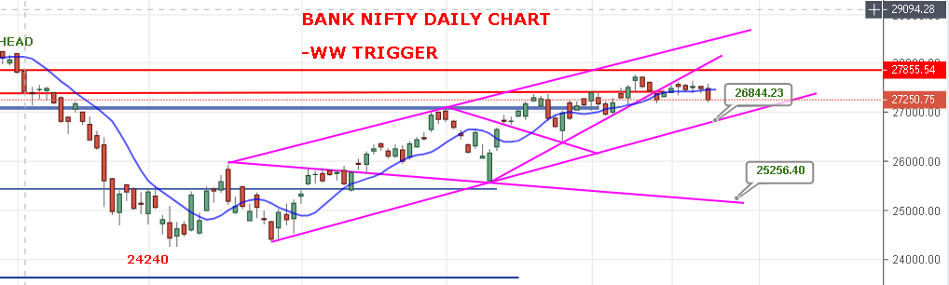
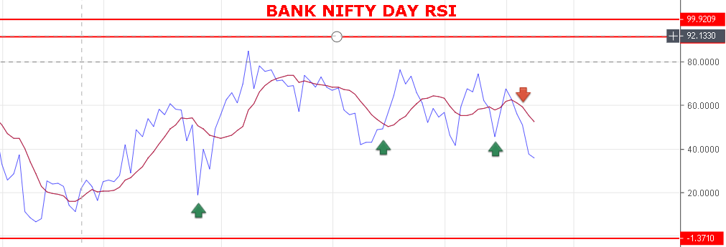
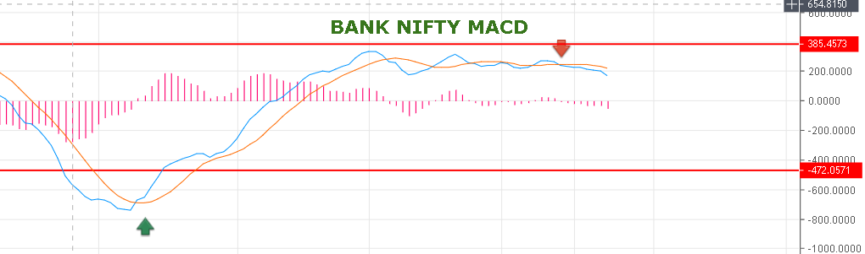

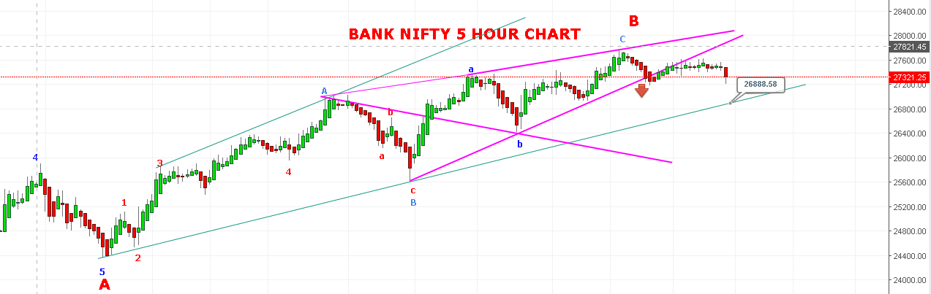
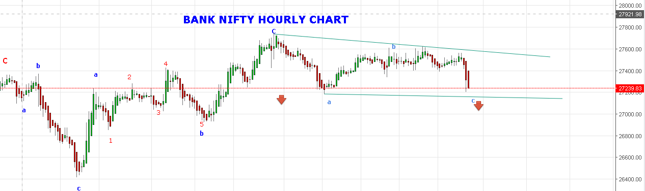
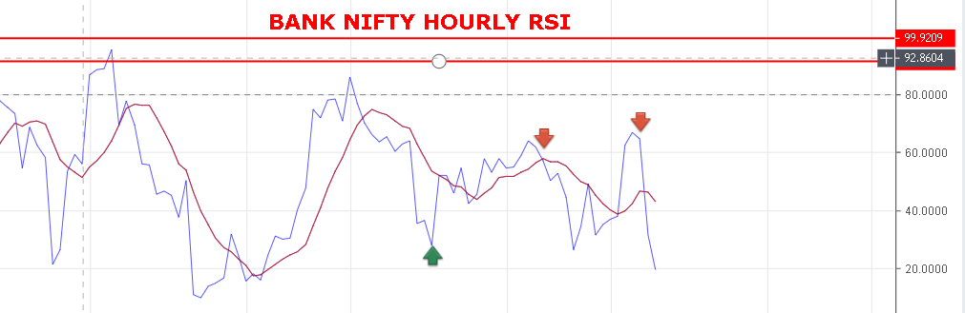
STRONG ABOVE 27355 BNS.
BULLISH ABOVE 27550 BNS.
RESISTANCE: 27320-27450-27540-27620-27750.
SUPPORT: 27140-27095-27020-26950-26890-26800-26770.

BANK NIFTY FUTURE INTRADAY LEVELS:
BUY BNF @27395+ STOP 27320 TGT 27455-27517-27585-27630.
SHORT BNF@27300 STOP 27360 TGT 27199-27090-27005-26940.
BANK NIFTY OPTION:
BUY 27200 CE 24 JAN @194+ STOP 180 TGT 220-240-270-305.
BUY 27400 PE 24 JAN @148+ STOP 120 TGT 188-214-230-250-310.

