SMALL & MID-CAP STOCKS PREDICTION: 30.06.2018:
AS ON 30.06.2018 MANY MID & SMALL CAP AVAILABLE @50% DISCOUNTS, TIME TO INVEST SPECIFIC CLASSIC STOCKS:
MIRC ELECTRONICS LTD: CMP 27.75. LOW MADE 23.95. FALL FROM RECENT @64.7. CORRECTED MORE THAN 50% .DOWN SIDE LIMITED 23-19. BUY NOW WITH STOP 19 ON CLOSING BASIS FOR 38-41 IN SHORT TERM LONG TERM TARGETS 60-100.
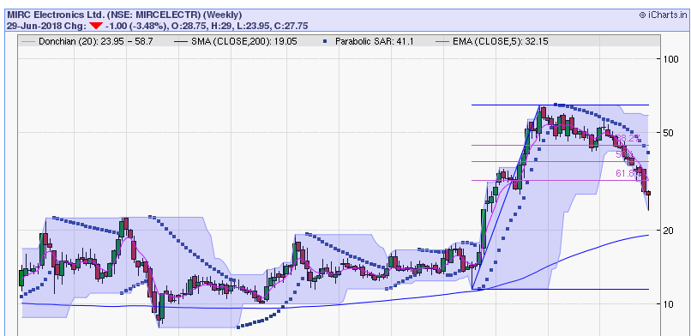
BUY WITH STOP 19.
KOLTEPATIL DEV.LTD: HIGH MADE 405 IN JAN 2018 LOW MADE 222 ON 29TH JUNE 2018. ALMOST 50% CORRECTED. BUY WITH STOP 200 FOR 310 IN SHORT TERM LONG TERM 400-600 LEVELS.
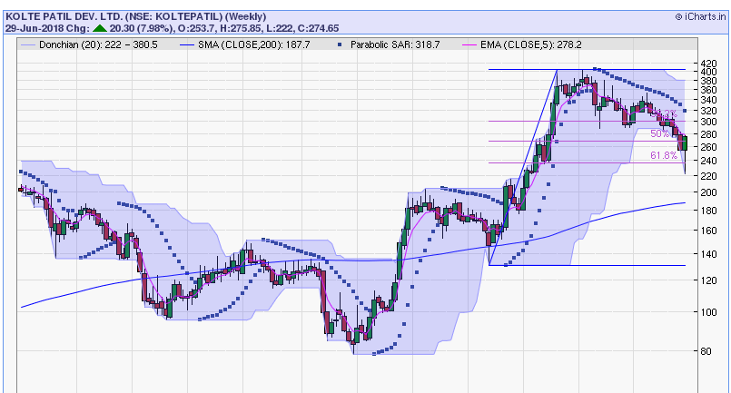
BUY WITH STOP 200 ON CLOSING BASIS.
JK TYRE & JK PAPER: JK TYRE HIGH MADE 193 IN FEB2018 LOW MADE 118 ON 29TH JUNE 2018.
BUY WITH STOP 110 ON CLOSING BASIS SHORT TERM TARGETS 140-150. LONG TERM TARGETS 180-250.BEARISH BELOW 100 FOR 80-70.
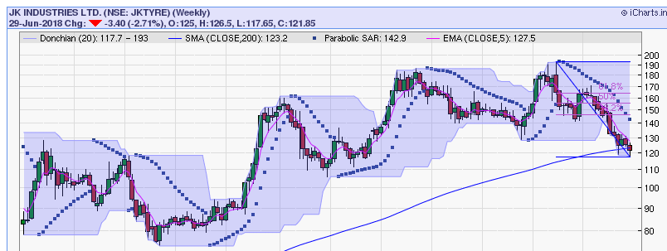

JK PAPER HIGH MADE IN JAN @170 LOW MADE 103 ON 29TH JUNE. BUY WITH STOP 99 ON CLOSING BASIS FOR SHORT TERM TARGETS 130-145. LON TERM TARGETS 170-220. BEARISH BELOW 90 FOR 75.
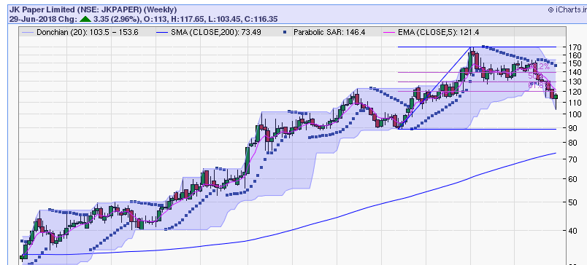
BUY STOP 99.
HCL-INSYS: HIGH MADE 70 IN FEB 2018 LOW MADE 32.5 ON 29TH JUNE. CORRECTED MORE THAN 50%.
BUY WITH STOP 29 ON CLOSING BASIS FOR SHORT TERM TARGETS 44-48. LONG TERM TARGETS 70-120. BEARISH BELOW 28 FOR 22-18.
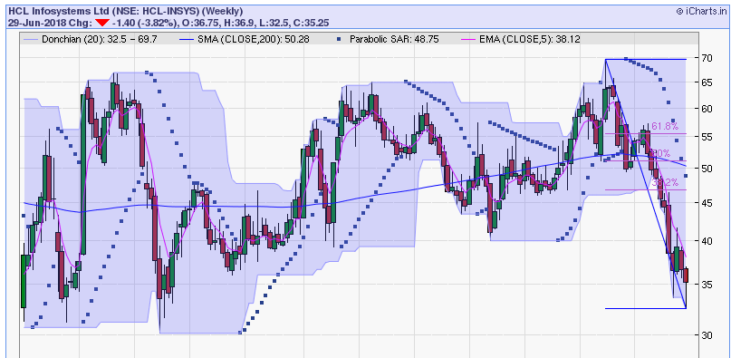
BUY WITH STOP 29.

