REVISED STOCK UPDATE: 30/06/2018.
FOCUS ON LARGE CAP STOCKS:
LARSEN & TOUBRO: SUPPORT TAKEN @1200 AND BOUNCE. HOLDING ABOVE 1290 WILL RETEST 1400 LEVEL SOON. SHORT TERM TARGETS 1350-1400. LONG TERM TARGETS- 2100-3000. PRICE SUSTAINING BELOW 1250 WILL TEST 1175-1100 LEVELS. BEARISH IF CLOSED BELOW 1100 TARGETS 9998-750.
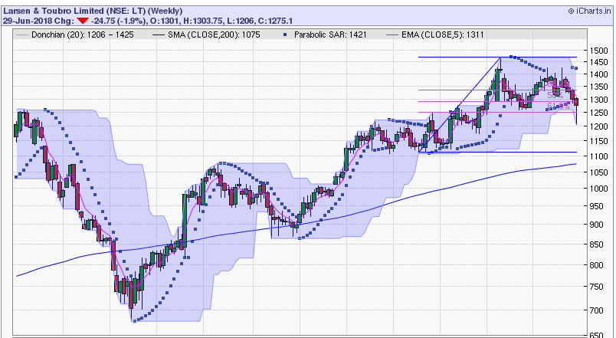
BUY STOP 1175 ON CLOSING BASIS.

ACC: SUPPORT @1250. CLOSING ABOVE 1370 WILL RETEST 1500 LEVELS. SHORT TERM TARGETS 1450-1500. LONG TERM TARGETS 1800-2100.DOWNSIDE IS LIMITED 1150-1100. BEARISH BELOW 1100 FOR 800-650 LEVELS.
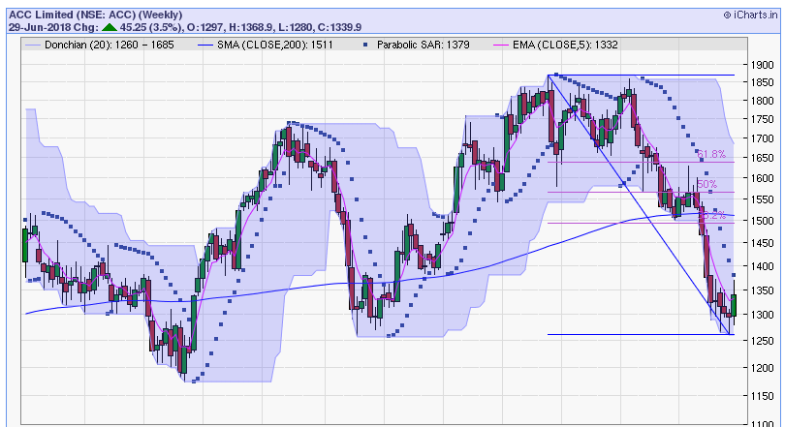
BUY STOP 1250 ON CLOSING BASIS.
ITC: STOCK STILL TO PERFORME. SUPPORT 245 SHORT TERM TARGETS 300-320. LONG TERM TARGETS 400-600.BEARISH BELOW 240 FOR 200-180.
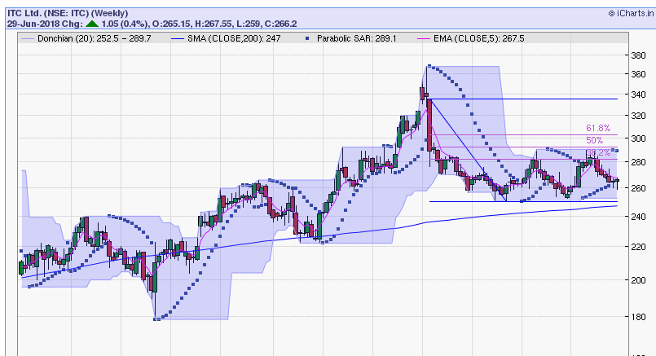
BUY WITH STOP 245 ON CLOSING BASIS.

SBI: CLOSED BELOW 200DSMA STONG SUPPORT @230. HOLD WITH STOP 230. IN SHORT TERM IF CLOSED ABOVE 266 TARGETS WILL BE 290-310. LONG TERM 380-500. BEARISH BELOW 225 FOR 200-180.
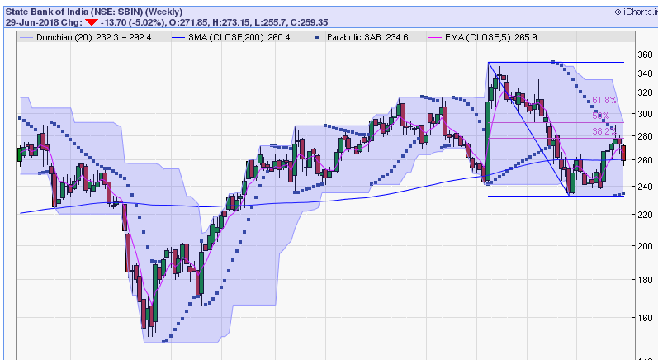
BUY ON DECLINE STOP 230.
TATASTEEL: AVAILABLE MORE THAN 25% DISCOUNT FROM RECENT FALL. BUY ON DECLINE WITH STOP 520. IN SHORT TERM CLOSING ABOVE 580 CAN MOVE UP TO 620-650 LEVELS.LONG TERM TARGETS 800-950. BEARISH BELOW 500 FOR 440-320.
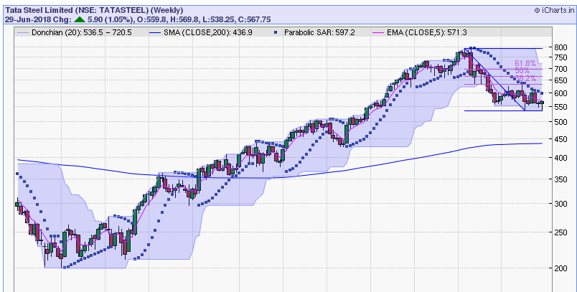
BUY WITH STOP 530 ON CLOSING BASIS.
ADANI PORTS: AS LONG HOLDING ABOVE 350 CAN MOVE TO 420-450 LEVELS IN SHORT TERM. LONG TERM TARGETS 600-750. BEARISH BELOW 340 FOR 300-280.
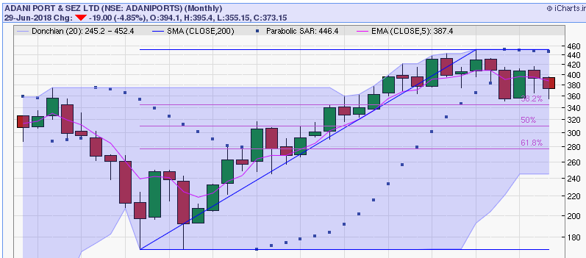
BUY WITH STOP 350 ON CLOSING BASIS.

