**NIFTY PREDICTION FOR 02/08/2018:**

**NIFTY DID OUR TARGET@11391 & FACE RESISTANCE FORMS DOJI AT EOD.**

**SAR: 11198 NS.**

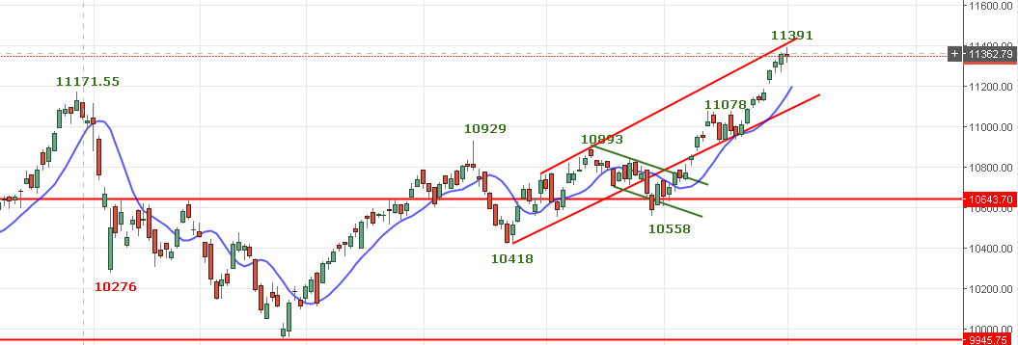

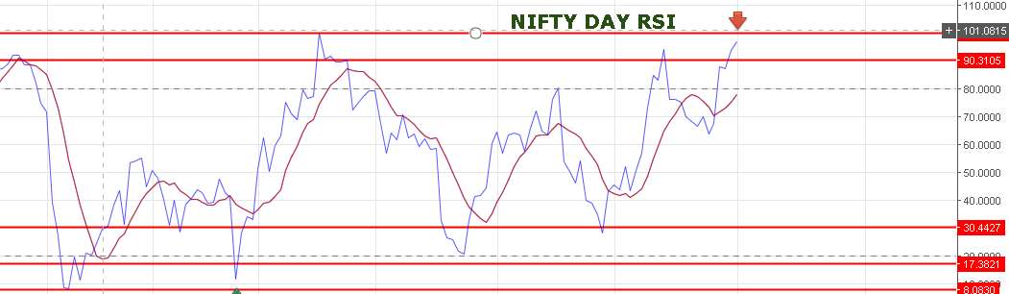

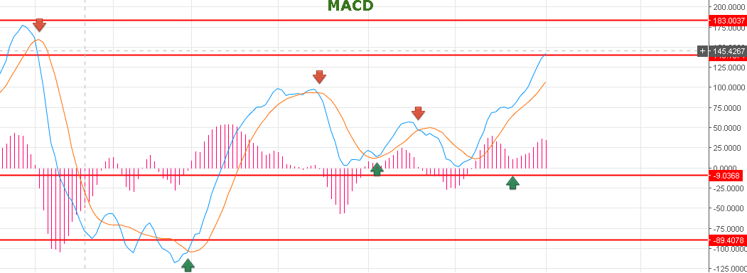

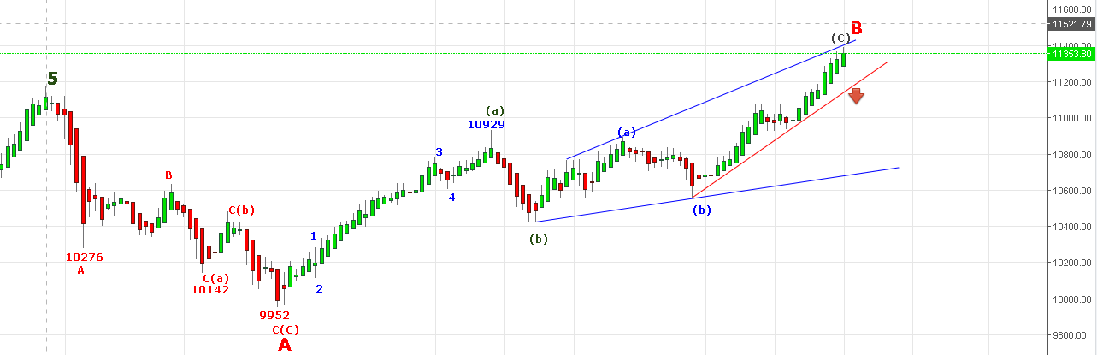

**REVERSAL BELOW 11285 NS.**

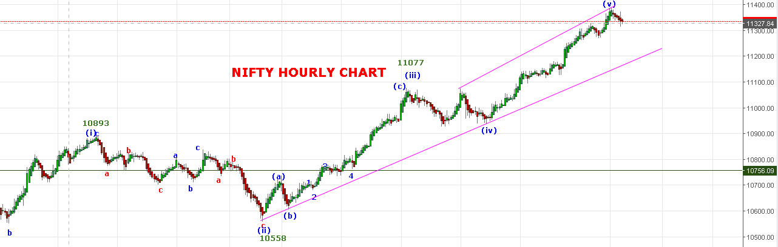

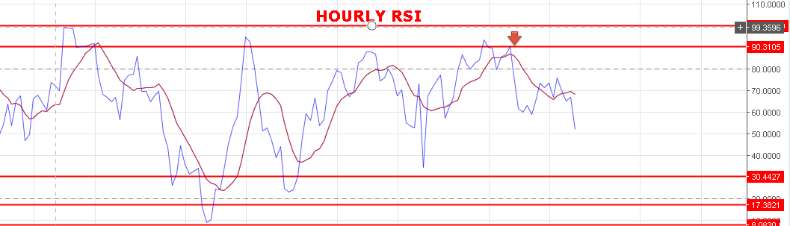

**A GAP DOWN OPENING EXPECTED TOMORROW NEAR 11300-11290 LEVEL.**

**SUPPORT: 11291-11232.**

**RESISTANCE: 11367-11388-11423.**

**WEAK BELOW 11350 NS.**

**STRONG ABOVE 11372 NS.**

**BUY NF@11397 STOP 11377 TGT 11422-11438.**

**SHORT NF@11355 STOP 11375 TGT 11296-11280-11250.**

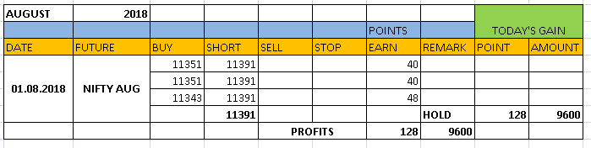

**NIFTY OPTIONS:**

**BUY 11400CE@130+ STOP 120 TGT 142-148-162.**

**BUY 11300PE@117+ STOP 107 TGT 127-134-148-159-172.**

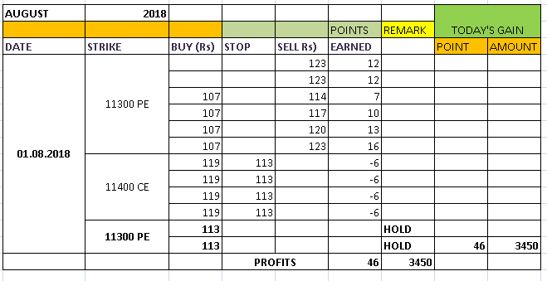

**NIFTY DAY PIVOT: 11350 NS.**

**NIFTY HOURLY PIVOT: 11347 NS.**

**NIFTY WEEKLY PIVOT: 11333 NS.**

**NIFTY MONTH PIVOT: 11350 NS.**

**SO ENJOY PE RIDE BELOW 11330 NS.**