**NIFTY PREDICTION FOR FRIDAY THE 13TH JULY 2018.**

**NIFTY DID OUR TARGETS 11034 AND FORMS SHOOTING STAR AT EOD.HEADING TOWARDS 10930.**

**SAR: 10824 NS.**

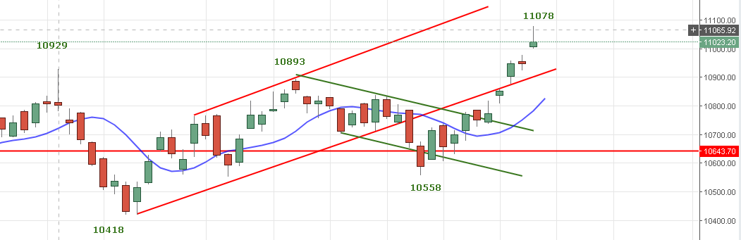

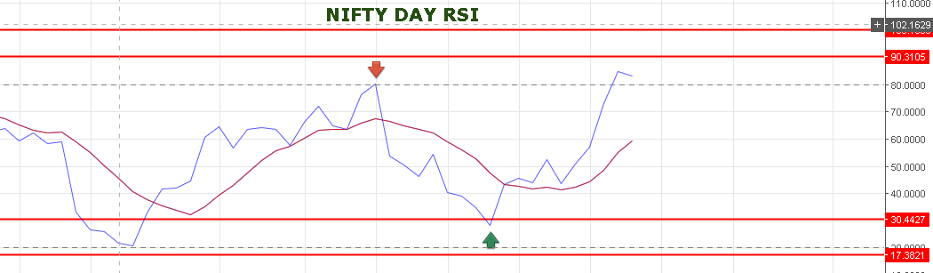

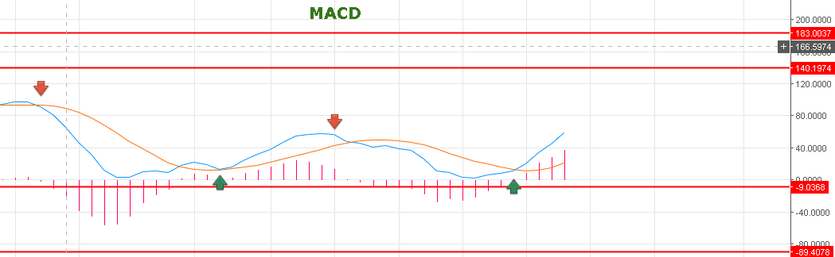

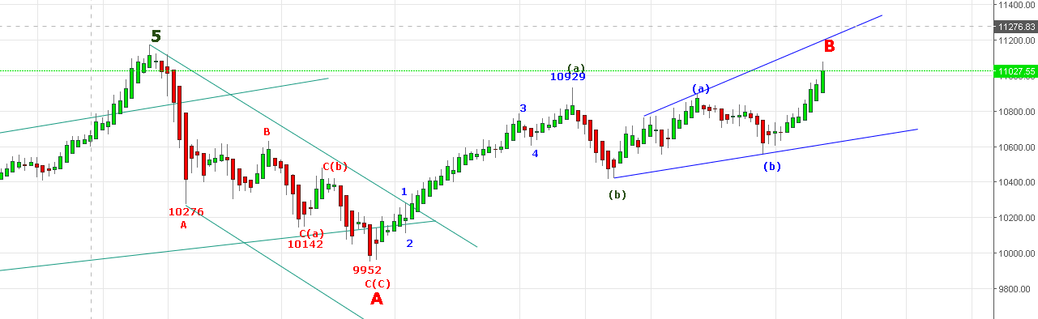

**TREND REVERSAL ONLY CLOSING BELOW 10900 NS.**

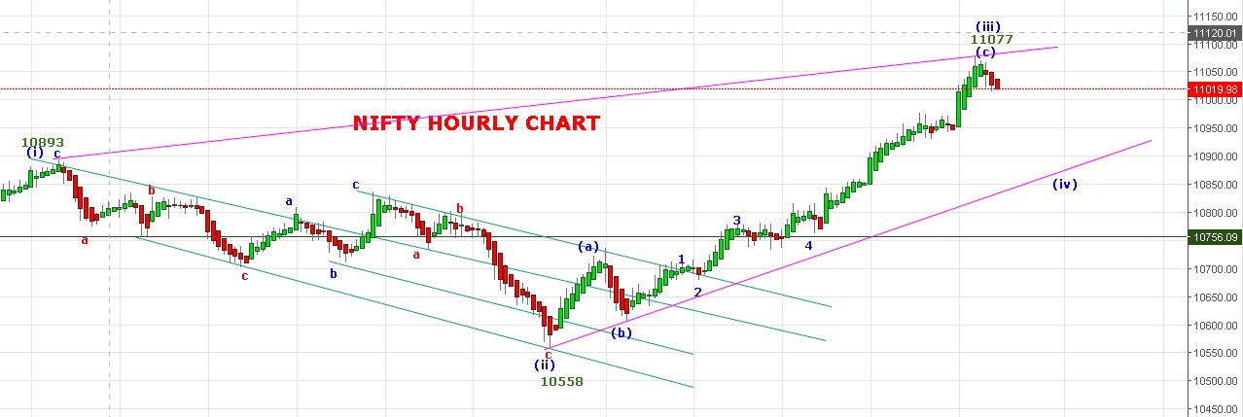

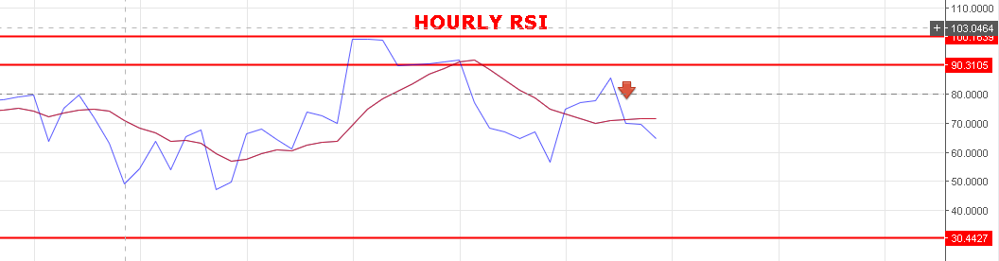

**WEAK BELOW 11010 NS.**

**BEARISH BELOW 10900 NS.**

**RESISTANCE: 11066-11102.**

**SUPPORT: 10950-10920-10900-10885.**

**BREAK OF 10880 CAN SEE UP TO 10786 <10730 LEVELS.**

**NIFTY STILL BUY ON DECLINE MODE TILL 10880 NS FOR TARGETS 11160>11500 EVELS.**

**INTRA-DAY TRADE IN NIFTY FUTURE FOR 13/07/2018:**

**BUY NF @11040 STOP 11020 TGT 11065-11099-11109.**

**SHORT NF@10992 STOP 11032 TGT 10966-10950-10930-10908-10885.**

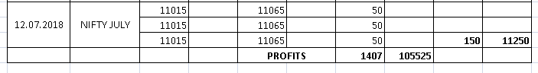

**NIFTY OPTIONS:**

**BUY 11000CE@110+ STOP 103 TGT 119-127-138-145.**

**BUY 11000PE @96+ STOP 86 TGT 106-116-125-137>161-170.**

**BUY CE ABOVE 11040 NS AND BUY PE BELOW 11015 NS.**

