NIFTY PREDICTION FOR 28/06/2018:
NIFTY BROKE AND CLOSED BELOW THE CHANNEL.
SAR: 10770 NS.
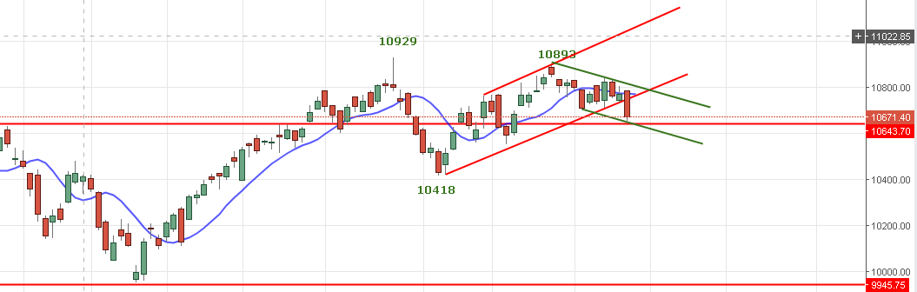
PRICE CLOSED BELOW RED CHANNEL AND BELOW 10700 LEVEL BUT HOLDING 10650 LEVELS. PRICE IF HOLD GREEN CHANNEL @10640NS EXPECTED TO BOUNCE TOWARDS 10740 LEVELS AS HOURLY RSI INDICATING OVERSOLD ZONE.
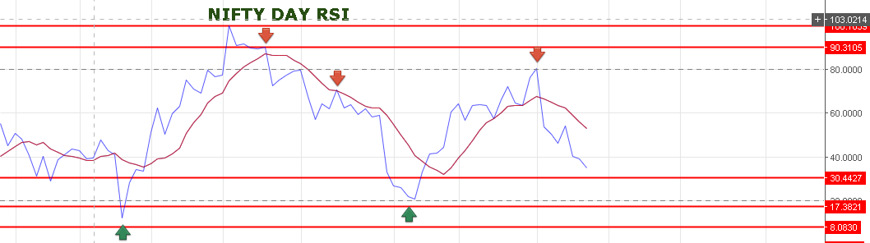
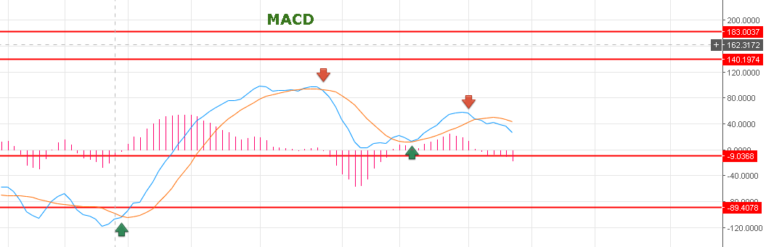
MACD IS IN SELL MODE. SO SELL ON RISE STARTEGY SHOULD BE ADOPTED DURING TRADING.
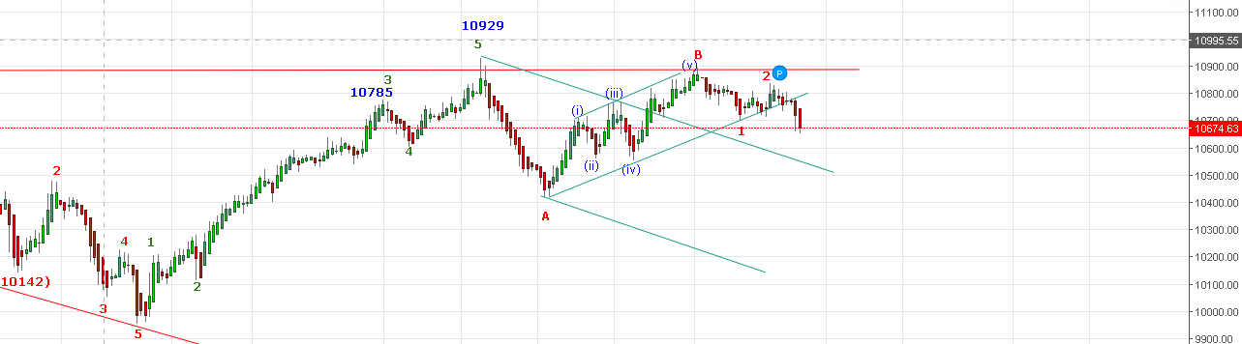
PRICE WILL FIND DIFFICULT TO CROSS 10745 LEVELS. WAVE 3 IN PROGRESS AS PER ABOVE CHART TAKING TO PRICE @10500 LEVELS.
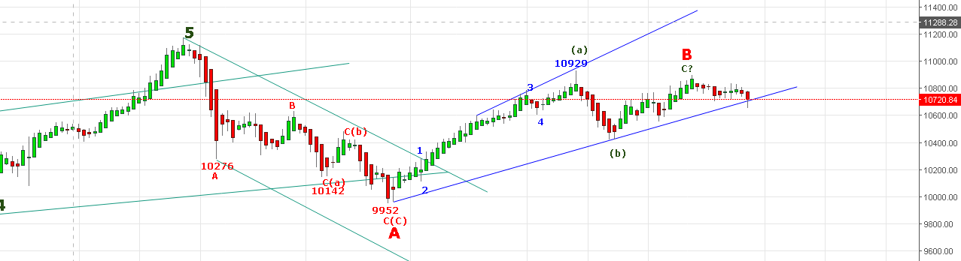
PRICE ABLE TO CLOSE WITHIN THE CHANNEL. IF WAVE B(C) (b) OVER THEN C OF C WILL START SOON.CLOSING BELOW THE CHANNEL EW COUNT WILL CHANGE AND WILL ASSUME WAVE B OVER @10893 LEVELS.
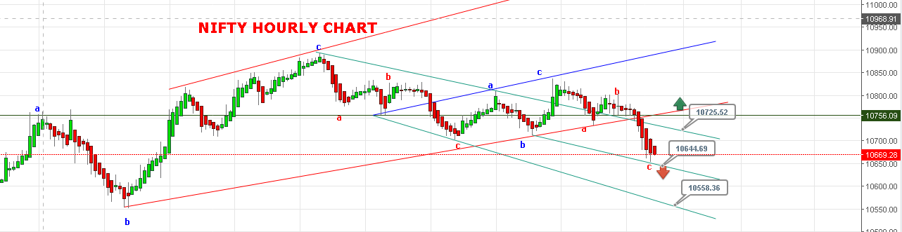
SUPPORT: 10640-10630-10600.
RESISTANCE: 10708-10744.
BULLISH ONLY ABOVE 10806NS.
WEAKNESS REMAINS AS LONG BELOW 10708 NS.

BUY NF 10695 STOP 10675 TGT 10714-10738-10763.
SHORT NF@10650 STOP 10670 TGT 10633-10622-10608-10588.
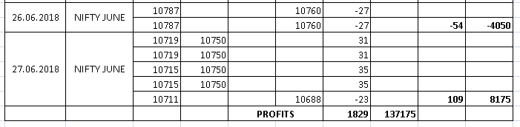
NIFTY OPTIONS:
BUY 10600CE@99 STOP 85 TGT 115-126-137.
BUY 10800PE@138+ STOP 122 TGT 151-168-181-197.
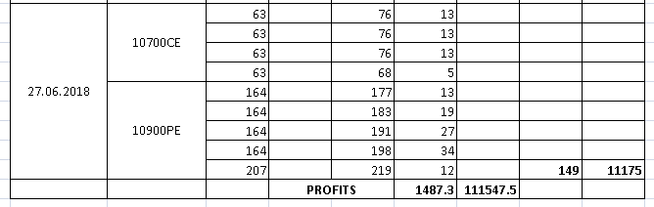
NIFTY DAY PIVOT: 10703 NS.
NIFTY HOURLY PIVOT: 10677 NS.
NIFTY WEEKLY PIVOT: 10718 NS.
NIFTY MONTH PIVOT: 10705 NS.

