NIFTY PREDICTION FOR 28/05/2018:
NIFTY HEADING TOWARDS SUPPLY ZONE 10640 TO 10675.
SAR: 10584NS.
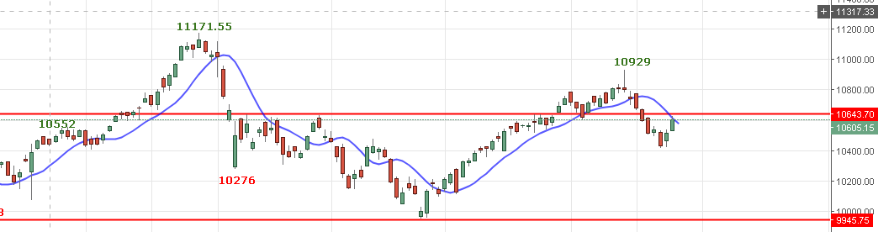
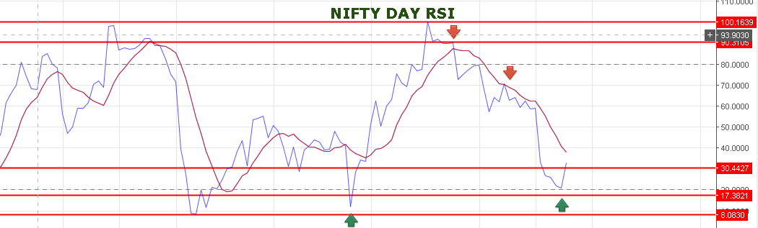
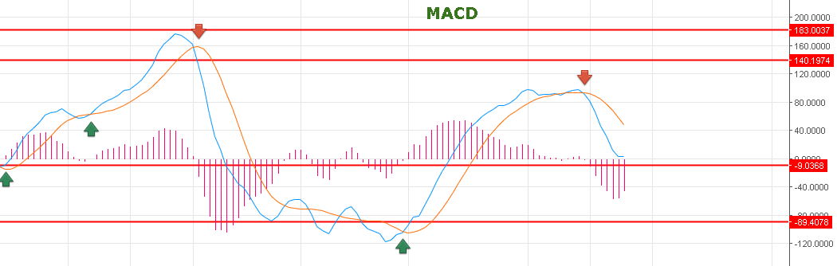
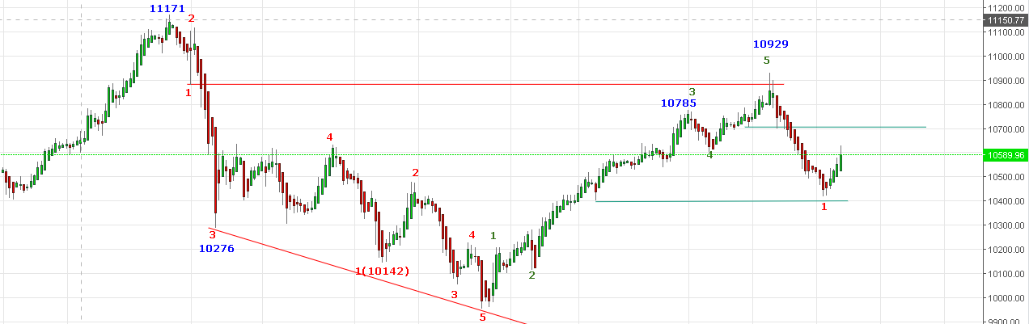
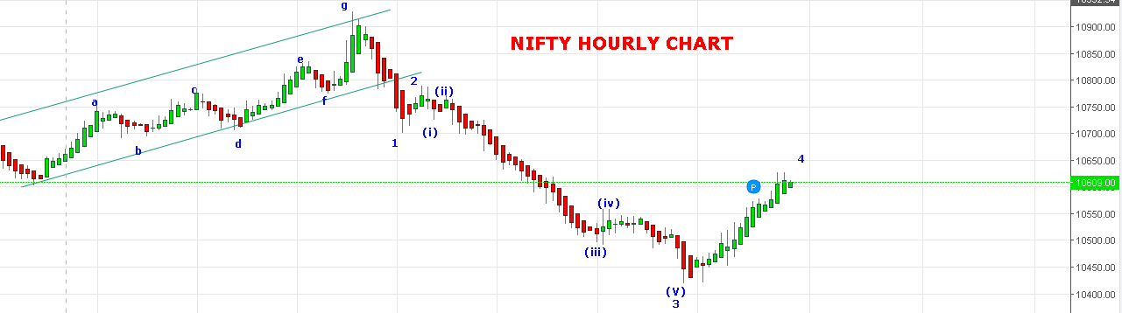
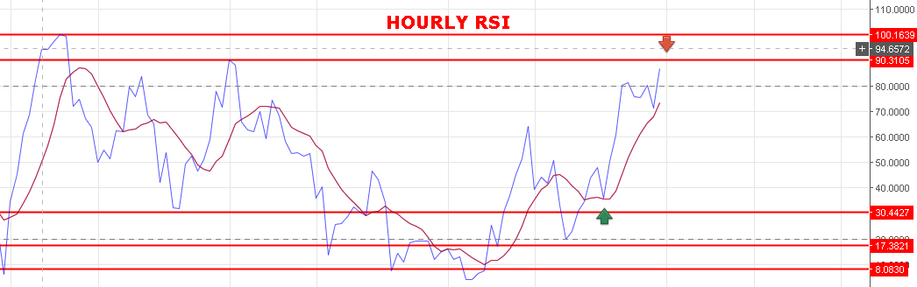
10669 IS A STRONG SUPPLY ZONE. FAILING TO CROSS OR CLOSE ABOVE IT BEAR WILL TAKE TOWARDS 10450 LEVELS.
SUPPORT: 10575-10552-10500.
RESISTANCE: 10643-10669.
WEAK BELOW 10580NS.
BEARISH BELOW 10499NS.
BUY NF@10625 STOP 10605 TGT 10647-10670-10702-10720.
SHORT NF@10580 STOP 10605 TGT 10550-10515-10495-10480.
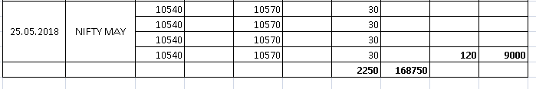
NIFTY OPTIONS:
BUY 10700PE@120 STOP 108 TGT 130-138-156-169.
BUY 10500CE@121+ STOP 108 TGT 138-148-167-180.
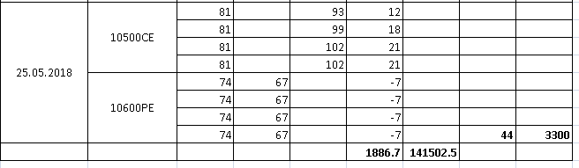
NIFTY DAY PIVOT: 10586NS.
NIFTY HOURLY PIVOT: 10605NS.
NIFTY MONTHLY PIVOT: 10651NS.

