NIFTY PREDICTION FOR 24/05/2018:
NIFTY HEADING TOWARDS OUR TARGET 10325NS.
SAR: 10657NS.
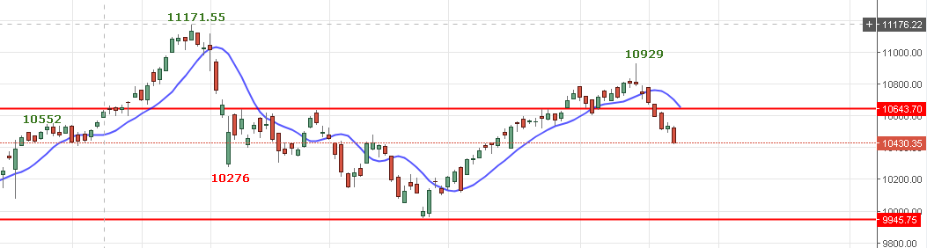
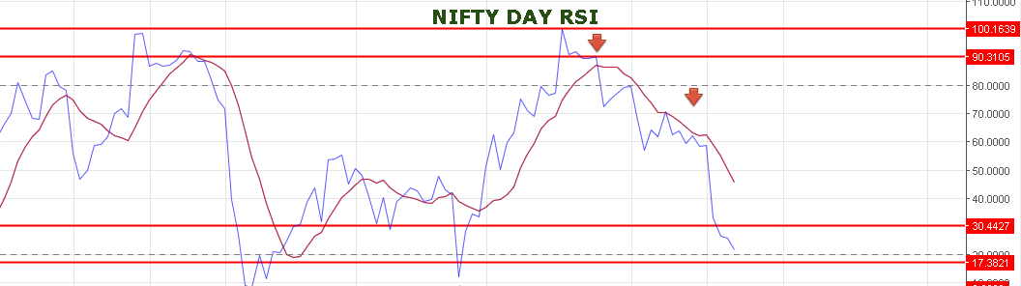
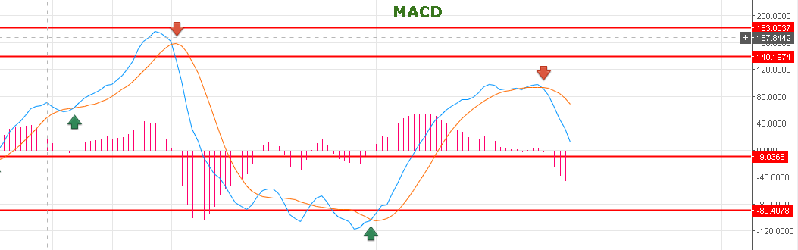
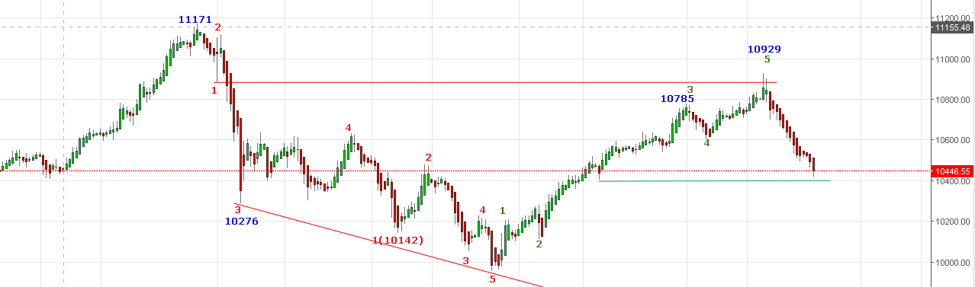
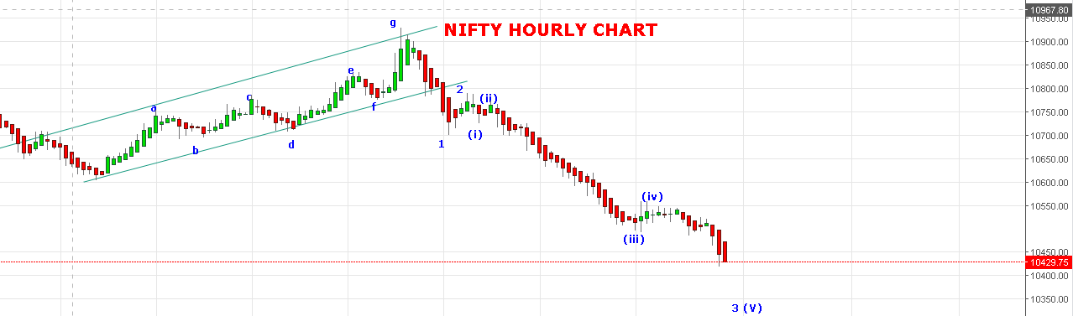
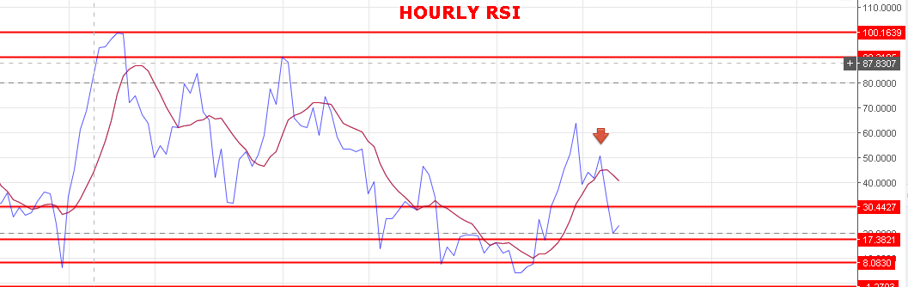

WEAKNESS REMAIN AS LONG HOLDING BELOW 10521NS.
SUPPORT: 10400NS-10385NS.
BULLISH ONLY ABOVE 10650NS.
POSITIONAL:
HOLD SHORT IN NF TARGETS 10385-10333-10320. STOP NOW 10550NF.

INTRADAY:
BUY NF@10470+ STOP 10440 TGT 10510-10520-10536.
SHORT NF@10405 STOP 10430 TGT 10380-10350-10333-10325-10320.

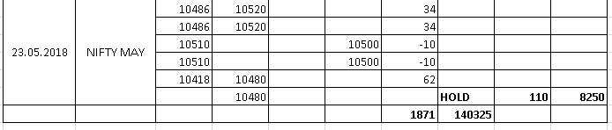
NIFTY OPTIONS:
BUY 10400CE @95+ STOP 85 TGT 102-112-122-132.
BUY 10400PE@68 STOP 58 TGT 80-88-96-118.
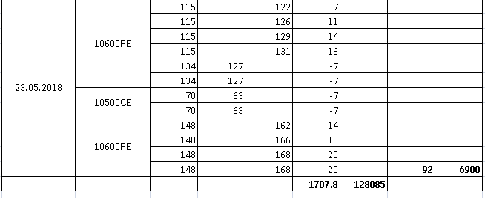
NIFTY DAY PIVOT: 10461NS.
NIFTY HOURLY PIVOT: 10433NS.

