NIFTY PREDICTION FOR 07/05/2018:
NIFTY CLOSED BELOW SAR BUT HOLDING 10600 LEVELS.
SAR: 10642NS.
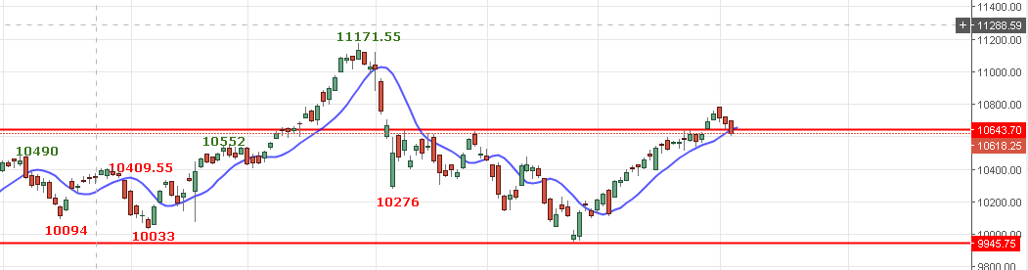
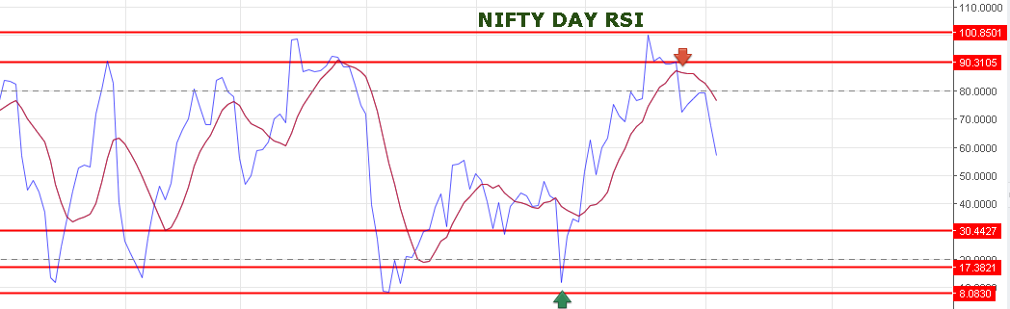
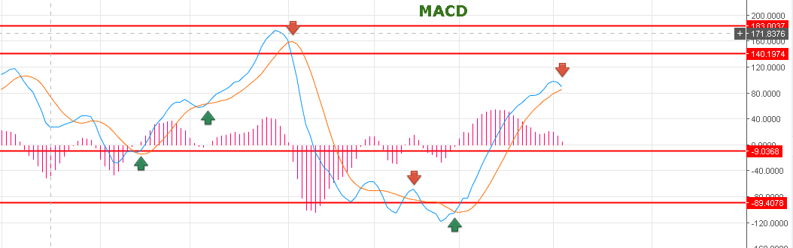
MACD READY TO BREAK?
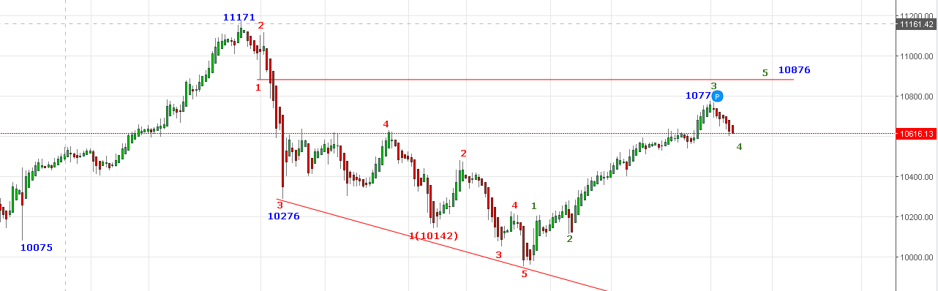
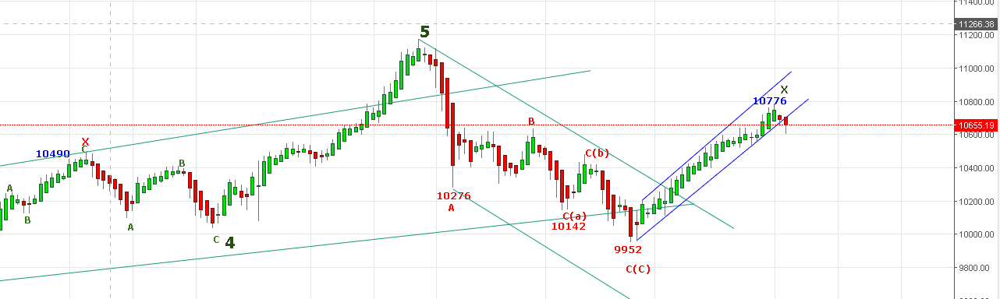
FROM ABOVE TWO CHARTS HAVE TWO POSSIBILITIES EITHER WILL BOUNCE FOR 10876 OR WILL BREAK DOWN FOR 9688NS.
TRADING ABOVE 10718NS WILL BE THE SIGNAL TOWARDS 10876 LEVELS. TRADING BELOW 10400 WILL BE THE SIGNAL TOWARDS 9688NS.
SIDEWAYS 10400 TO 10700NS.
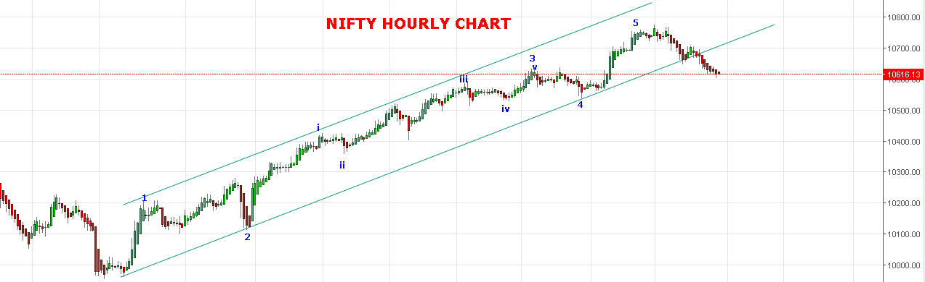
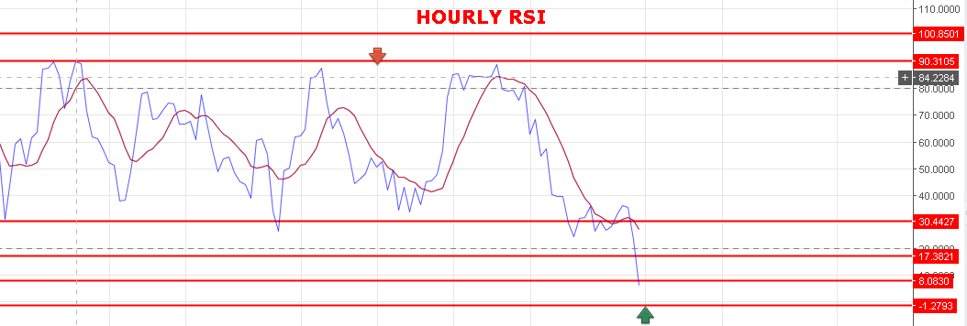
HOURLY RSI AT OS ZONE.
WEAKNESS REMAIN AS LONG HOLDING BELOW 10668NS.
BEARISH BELOW 10600NS.
SUPPORT: 10589-10538-10522.
RESISTANCE: 10641-10668-10718.
BUY NF@10680 STOP 10663 TGT 10702-10720-10750-10770-10780.
SHORT NF@10640 STOP 10660 TGT 10610-10570-10550-10521.
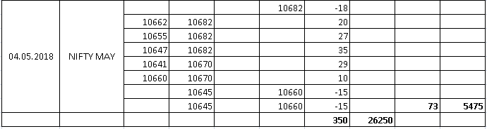

NIFTY OPTIONS:
BUY 10800CE@90 STOP 80 TGT 102-110-120-148.
BUY 10600PE@124 STOP 113 TGT 135-143-161-174-190.
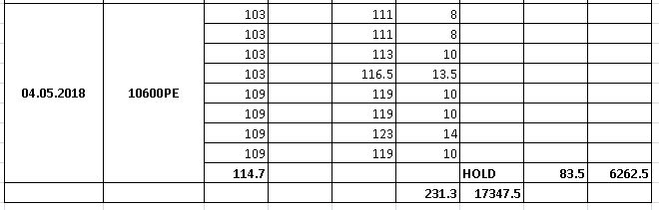
NIFTY DAY PIVOT: 10640NS.
NIFTY HOURLY PIVOT: 10619 NS.

