BANK NIFTY SPOT PREDICTION FOR 28/05/2018:
BANK NIFTY HEADING TOWARDS SUPPLY ZONE NEAR 26500 LEVELS.
SAR: 25955 BNS.
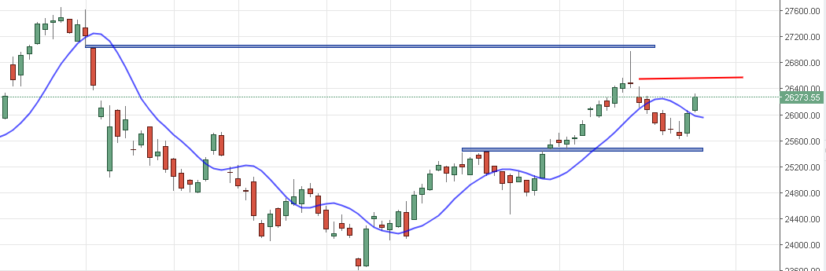
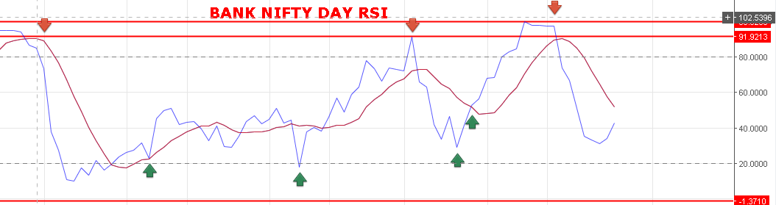
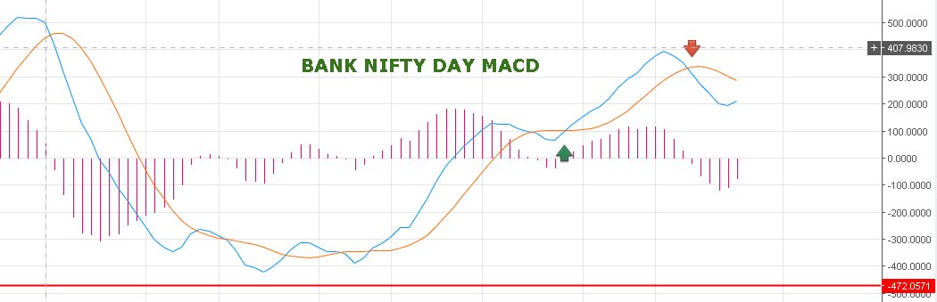
AFTER STEEP RISE, BANK NIFTY NOW WILL CONSOLIDATE FOR ANOTHER BIG MOVE. POSSIBLE GAP UP ON MONDAY BUT WILL FACE RESISTANCE NEAR 26500-26550 LEVELS. CONSOLIDATING TILL 26100 BNS CAN MOVE ABOVE 26775-27000 LEVELS.
CLOSING BELOW 26200 WILL MOVE DOWN TOWARDS 26080 TO 25980 LEVELS.

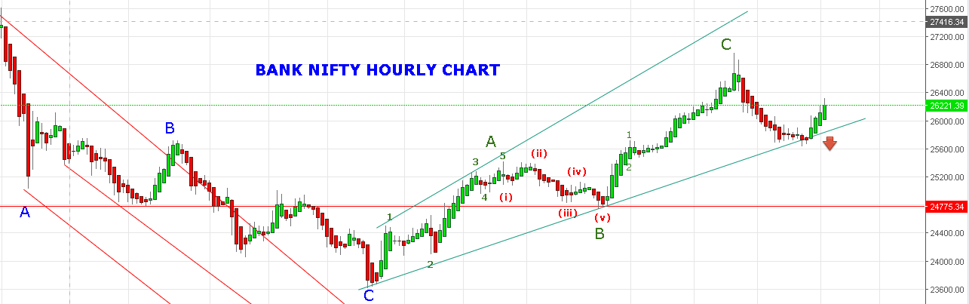
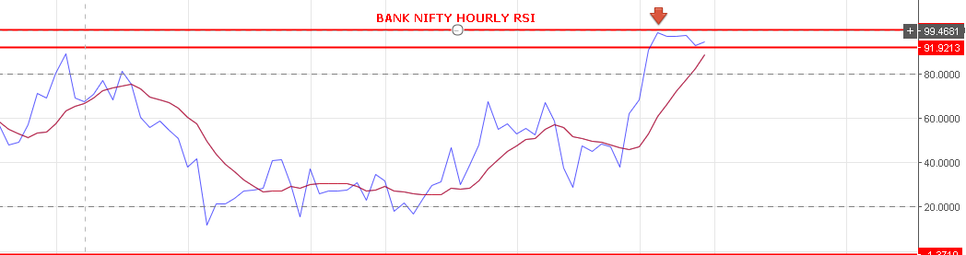

SINCE HOURLY RSI AT OVERBOUGHT ZONE BANK NIFTY WILL MOVE SIDE WAYS 26100 TO 26550 LEVELS.
BEARISH CLOSING BELOW 26000 BNS FOR 25550-25090 LEVELS.
INTRADAY:
BUY NF MAY @26302 STOP 26240 TGT 26370-26400-26510-26547-26599.
SHORT BNF@26150 STOP 26220 TGT 26106-26070-25975.
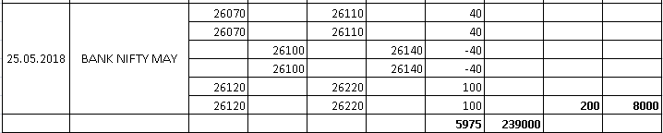
POSITIONAL:
POSITIONAL HOLDING LONG STOP 26050BNS. BOOK PROFIT 26490-26550.
POSITIONAL SHORT @25990 BNF JUNE MONTH FOR 25100 BNF.
DATE | DETAILS | RATE | AMOUNT
21.05.2018 | SHORT | 26050
 | BOOK PART | 25750
 | PROFIT | 300 | 12000
 | HOLDING | 26050
 | EXIT | 25870
22.05.2018 | PROFIT | 180 | 7200
23.05.2018 | LONG | 25730
 | BOOK PART | 25830
 | PROFIT | 100 | 4000
 |  | 25730
 | STOP OUT | 25650
 | LOSS | -80 | -3200
24.05.2018 | SHORT | 25670
 | ADDED | 25814
 | COVERED | 25712
 | PROFIT | 102 | 4080
 | ADDED | 25838
 | STOP OUT | 25890
 | LOSS | -188 | -7520
 | SHORT JUNE | 25880
 | COVERED | 25772
 | PROFIT | 108 | 4320
 | HOLDING | 25880
25.05.2018 | STOP OUT | 26100
 | LOSS | -220 | -10800
24.05.2018 | 26000CE | 98
25.05.2018 | SOLD | 199
24.05.2018 | 26000CE | 98
 | PROFIT | 101 | 4040
25.05.2018 | SOLD | 230
 | PROFIT | 132 | 5280
25.05.2018 | LONG JUNE | 26200
 | SOLD | 26320
 | PROFIT | 120 | 4800
25.05.2018 | LONG JUNE | 26200
TOTAL | PROFIT | TILL DT | 24200

