**NIFTY PREDICTION FOR 22/03/2018:**

**NIFTY HOLDING BELOW 200DSMA@10166. BULLISH ONLY ABOVE 10290NS.**

**SAR: 10272NS.**

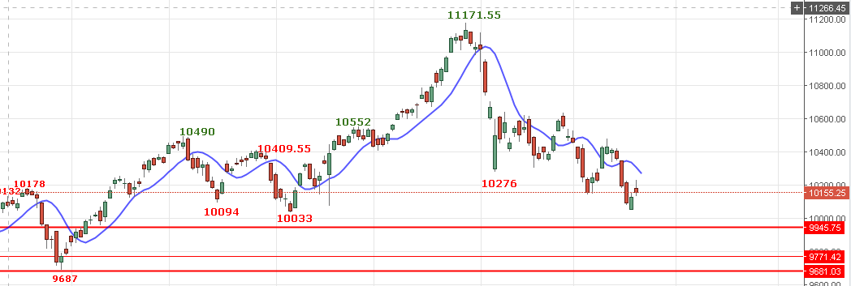

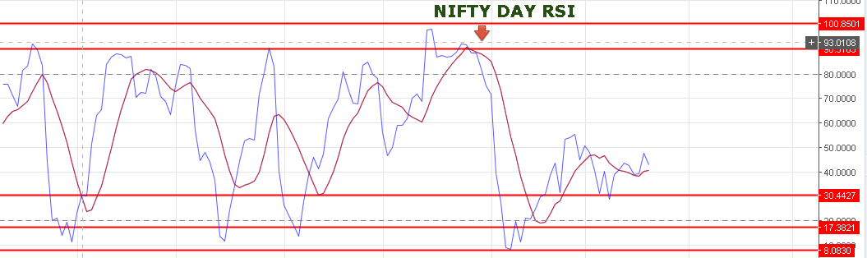

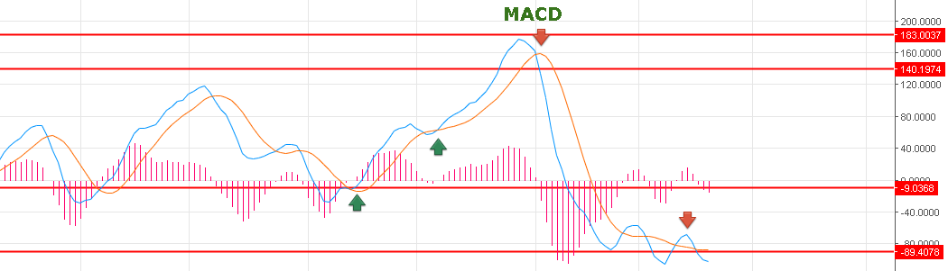

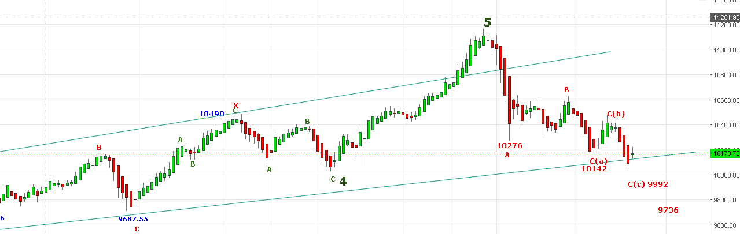

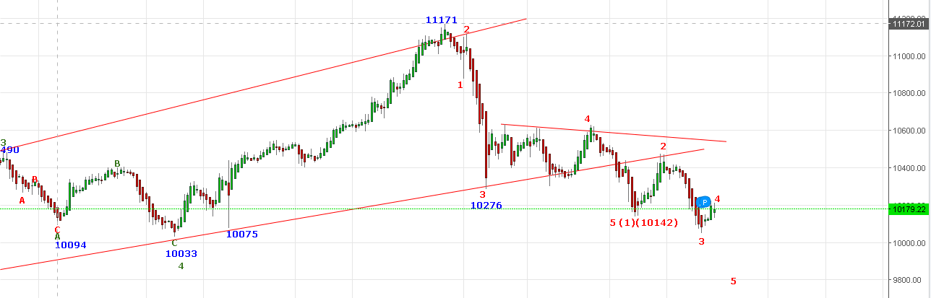

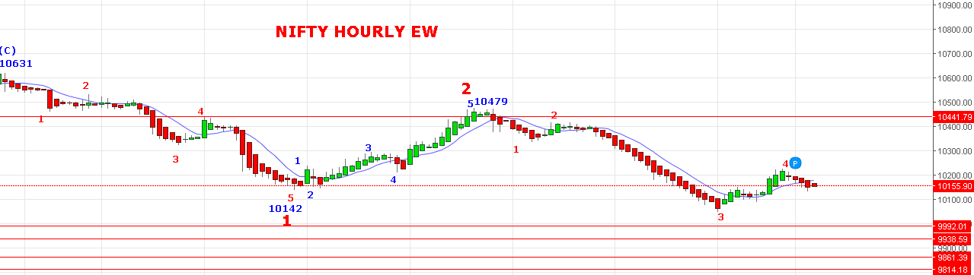

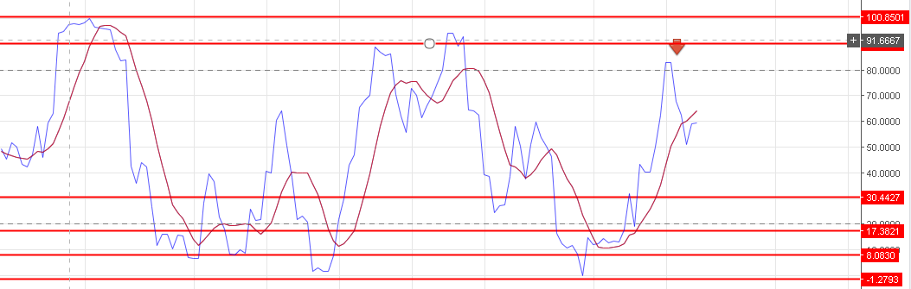

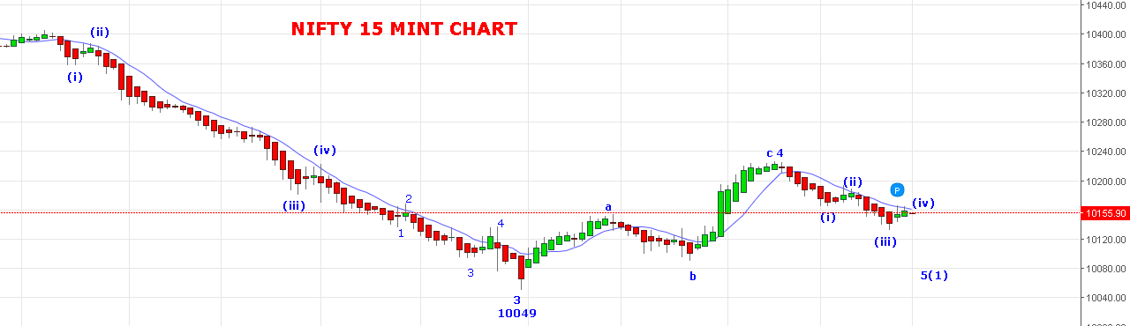

**WAVE 3(4) DONE @10227 AND 3(5)(1) IN PROGRESS.**

**RESISTANCE: 10178-10191-10215NS.**

**SUPPORT: 10133-10115-10104-10065NS.**

**BULLISH ABOVE 10292NS FOR 10500LEVELS.**

**HOLDING SHORTS IN NF STOP NOW 10233NF. LONG @10240+(IF SUSTAIN ABOVE FOR 5 MINTS)**

**BUY NF@10240 STOP 10200NF TGT 10266-10285-10298-10308-10318-10332.**

**NF TRADING BELOW 10148 TGT 10113-10095-10075-10055-10042.**

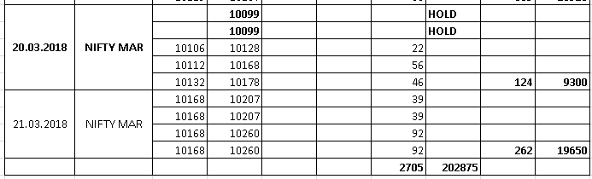

**NIFTY OPTIONS:**

**BUY 10200CE@86-92 STOP 72 TGT 107-117-129.**

**BUY 10200PE@108+ STOP 90 TGT 120-138-150-166-215.**

