**BANK NIFTY SPOT PREDICTION FOR 14/03/2018:**

**BANK NIFTY DID 25000 LEVELS BUT FAILED TO CLOSED ABOVE 24780BNS.**

**SAR: 24575BNS.**

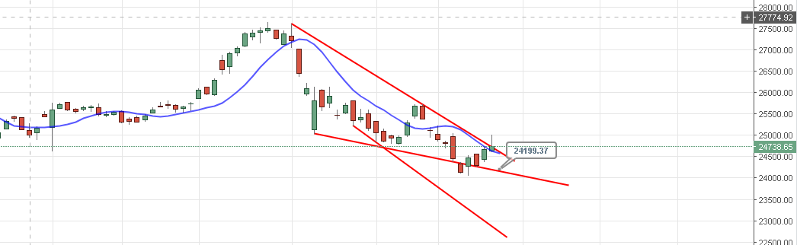

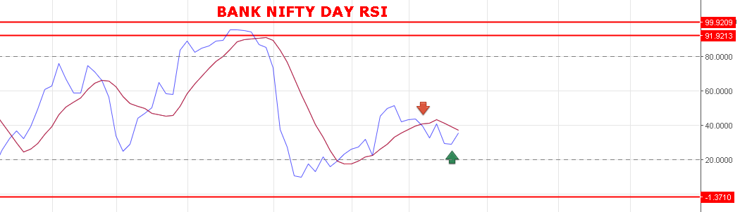

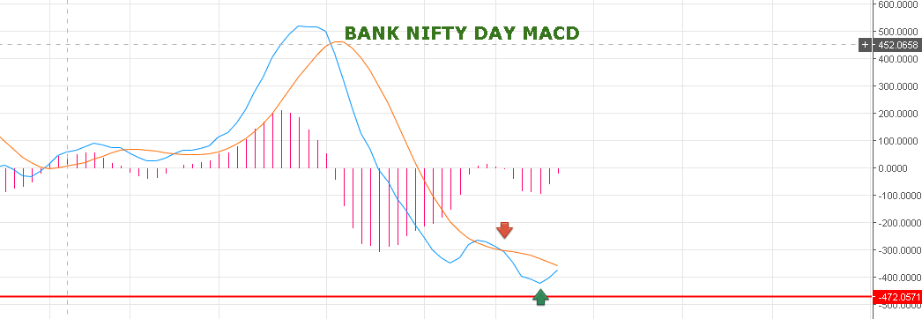

**BEARISH BELOW 24480BNS FOR 23800-23000 LEVELS.**

**BULLISH ABOVE 25100 BNS FOR 26100BNS.**

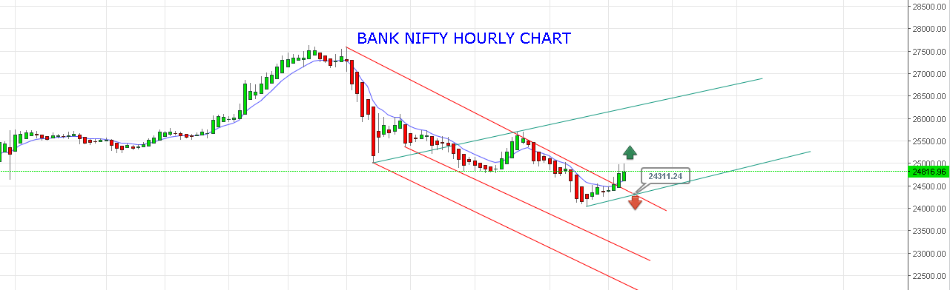

**WEAKNESS BELOW 24800& 24600BNS FOR 24490.**

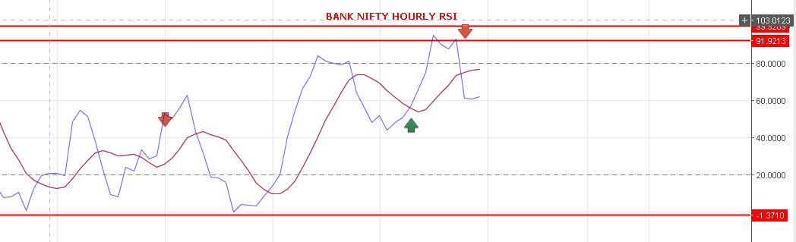

**BUY BNF@24900 STOP 24865 TGT 24970-25020-25075-25130-25170.**

**SHORT BNF@24745 STOP 24800 TGT 24670-24610-24560-24498.**

