**BANK NIFTY SPOT PREDICTION FOR 09/03/2018:**

**BANK NIFTY HOLDING 24450 CAN TOUCH 24800 LEVELS.WEEKLY CLOSING BE READY FOR SWING.**

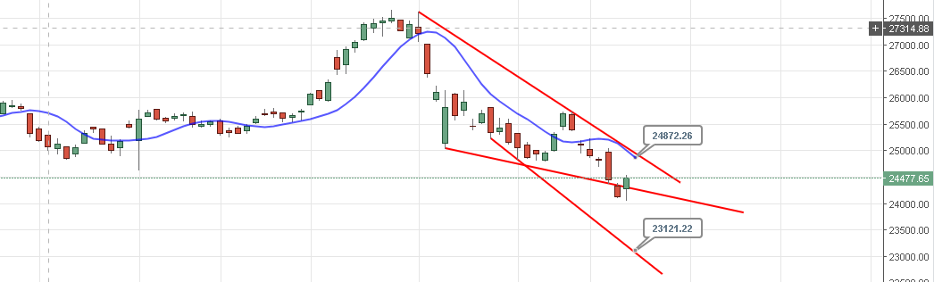

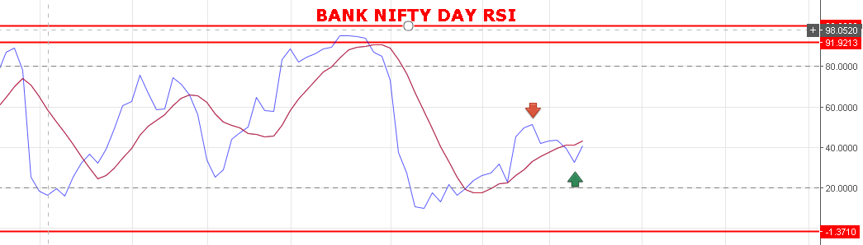

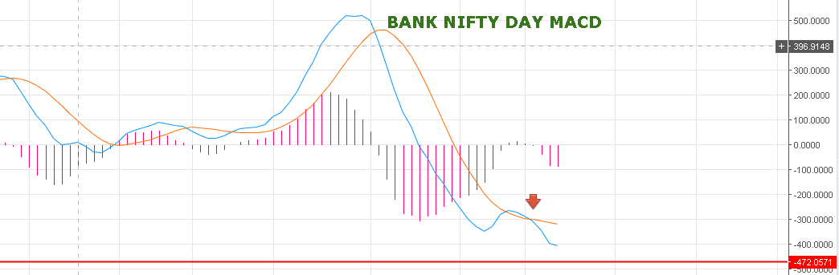

**IF WEEKLY CLOSING ABOVE 24870 LEVELS THEN IT WILL BE TREND REVERSAL SIGNAL.**

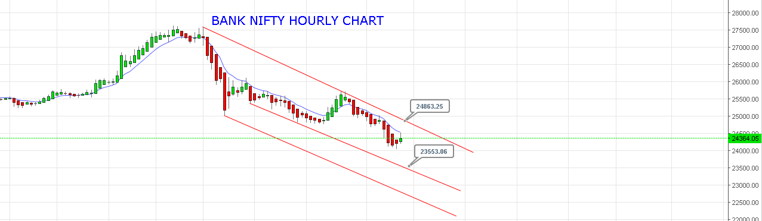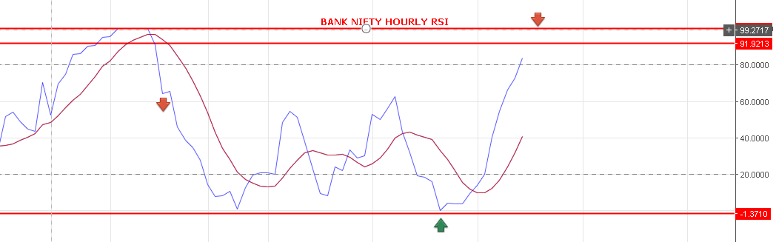

**BUY BNS 24480+ BOOK PROFIT NEAR 24850-890 BNS AND SHORT .**

**GAP UP OPENING EXPECTED ABOVE 24600BNS LEVELS.**

**BUY BNF@24580 STOP 24480 TGT 24710-24830-24870-24900.**

**SHORT BNF@24425 STOP 24475 TGT 24312-24190.**

**TOMORROW BNF CAN SWING 300+ THEN 300- AS ROLLERCOASTER RIDE.**

