**BANK NIFTY SPOT PREDICTION FOR 05/03/2018:**

**BANK NIFTY HOLDING BELOW 25200 WILL MOVE TOWARDS 24650-24000BNS.**

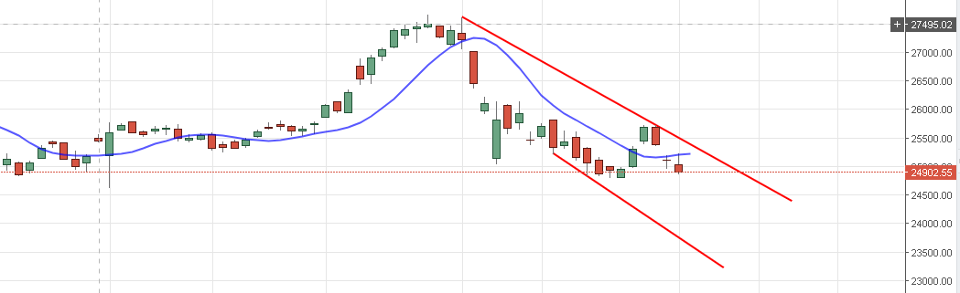

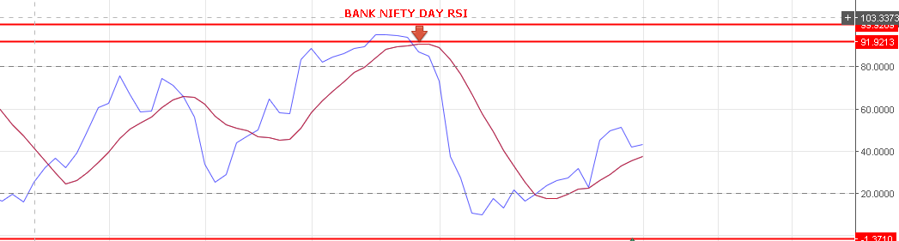

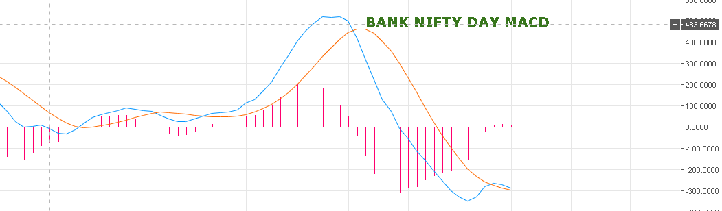

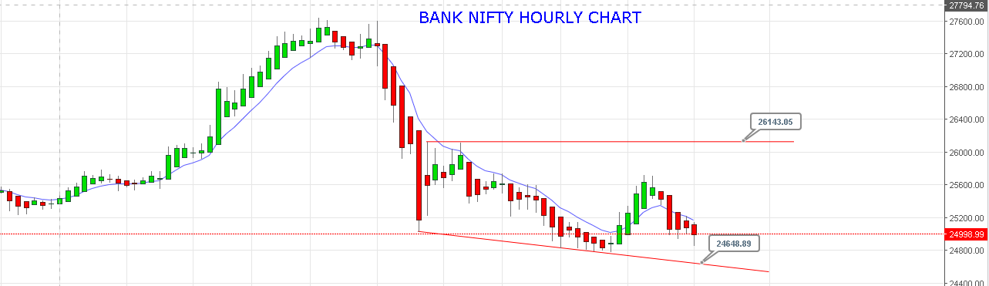

**PRICE CLOSING ABOVE 25175+ CAN SEE QUICK RISE TOWARDS 25300-25800-26100 LEVELS.**

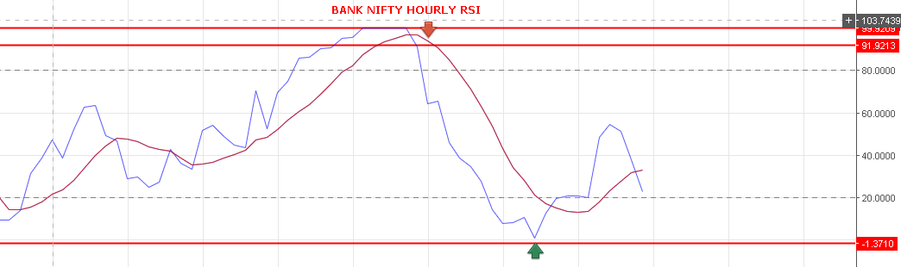

**BUY BNF @25040 STOP 25000 TGT 25138-25251-25290.**

**SHORT BNF @24860 STOP 25000 TGT 24790-24740-24690-24645-24600.**

