**NIFTY PREDICTION FOR 02/02/2018:**

**LTCG TAX CAN PAUSE THE MOVE IN COMING DAYS. NIFTY CLOSE BELOW SAR.**

**SAR: 11031NS.**

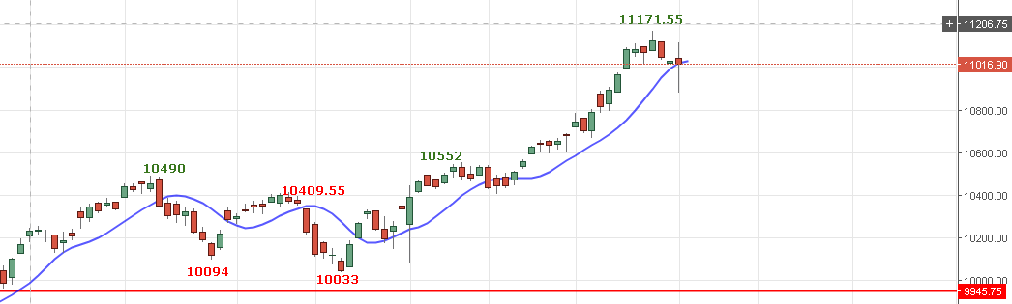

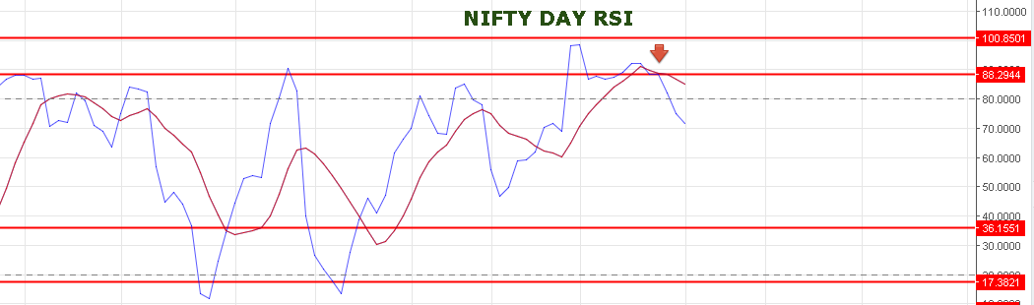

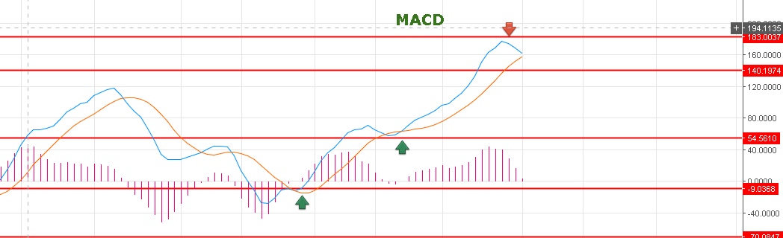

**MACD BENDING WILL TRIGGER SELL IF BLUE LINE CROSS ORANGE LINE.**

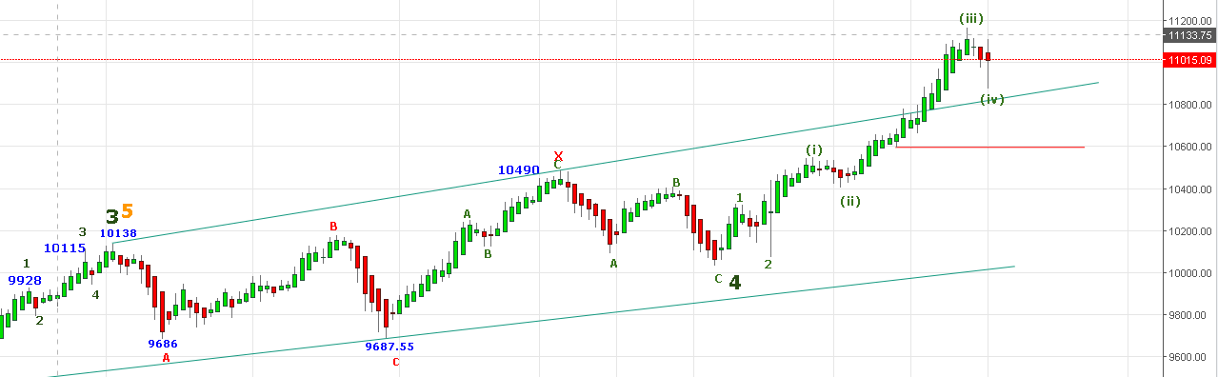

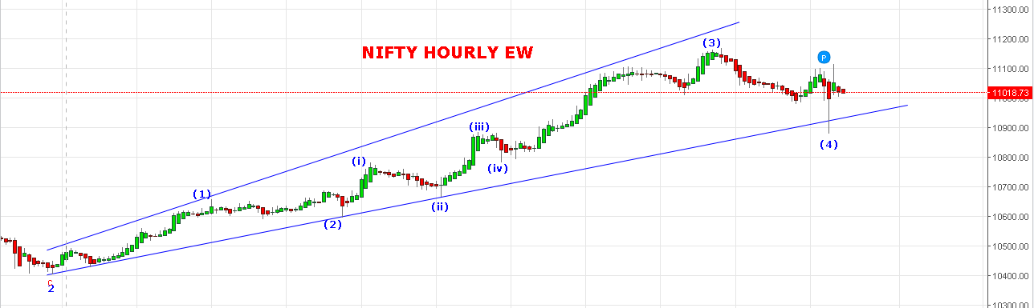

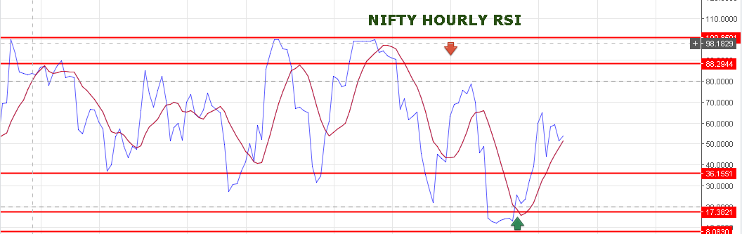

**NIFTY TAKEN STANDARD SUPPORT LEVEL MENTIONED IN PREVIOUS REPORT 10885 AS TARGET OF (4) WAVE & PRICE BOUNCE SHARPLY AND CLOSED ABOVE 11000 MARK BUT BELOW 11030NS.**

**NOW BEARISH BELOW 11000 LEVELS FOR TARGETS 10867-10702 LEVELS IF 4C FURTHER EXTEND.**

**BULLISH ONLY ABOVE 11120NS FOR 11330-11550-11830.**

**BUY NF @11055 STOP 11025 TGT 11080-11103>11125-11136.**

**SHORT NF @11009 STOP 11017 TGT 10975-10952-10936<10880-10840.**

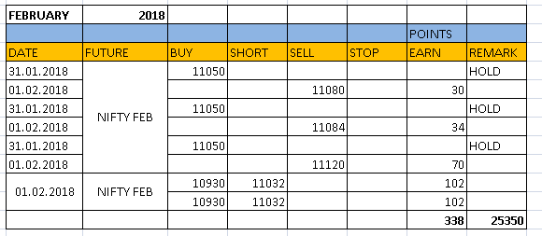

**NIFTY OPTIONS:**

**BUY 11150CE @98+ STOP 91 TGT 105-116-121-132-146.**

**BUY 10950PE @108+ STOP 101 TGT 115-121-134-143-155.**

