NIFTY PREDICTION FOR 24/01/2018:
NIFTY IS HEADING TOWARDS 11140-11200 LEVELS IF 11040 HOLD.
SAR: 10797.
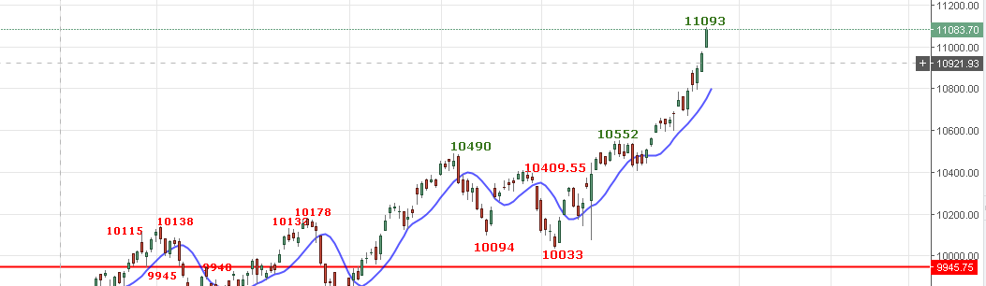
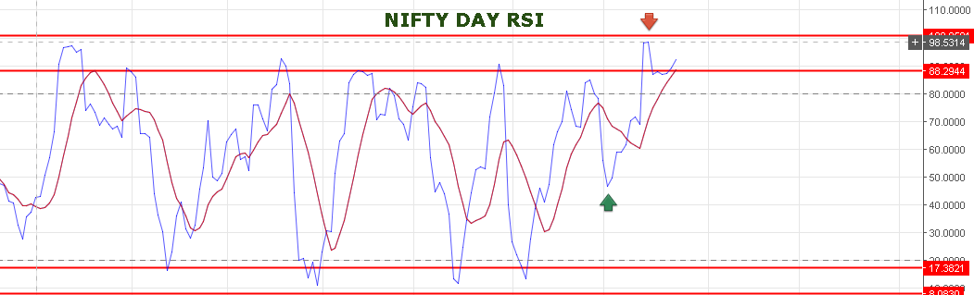
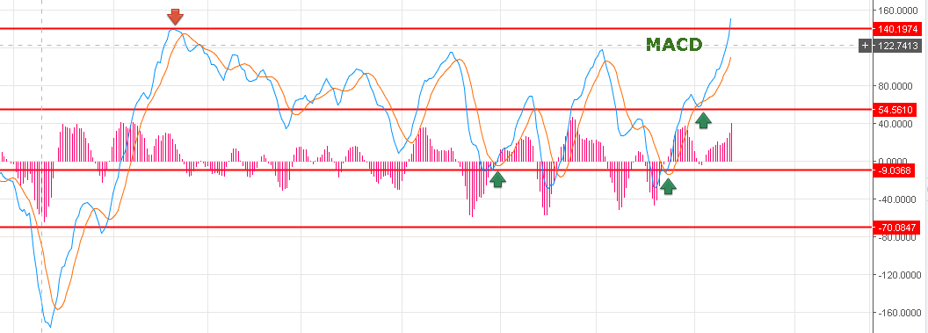
MACD RANGE BREAKOUT. DAY RSI TURNED UP.
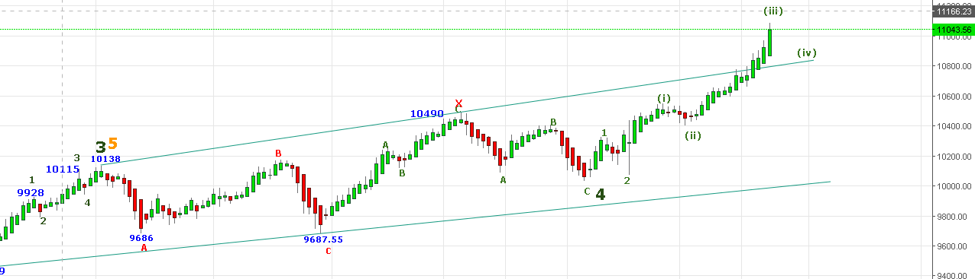
WAVE (iii) STILL IN PROGRESS (iv) & (v) PENDING.
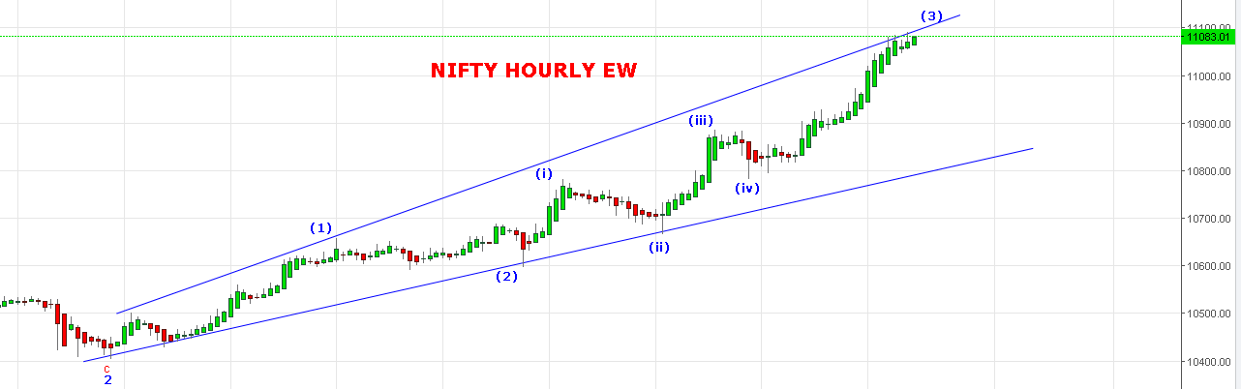
ONLY BELOW 11040 WILL CONFIRM WAVE 3RD OVER.
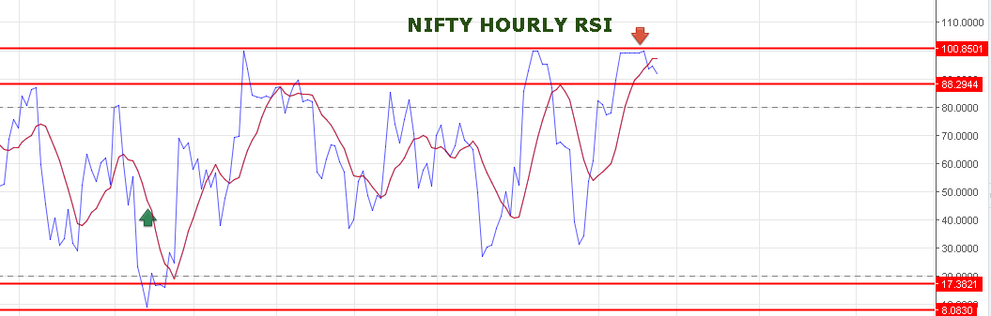
NO DOUBT THAT NIFTY IS IN AT HIGHLY OVERBOUGHT LEVEL. EITHER GAP DOWN OPENING OR SOME CORRECTION WILL TAKE PLACE VERY SOON TO MOVE AGAIN 11800-12100 LEVELS IN COMING WEEKS.
BELOW 11050 PRICE SUPPORT @11030-11000-10985-10962.
61.8% RETACEMENT FROM 10885-11093 IS @10964.
BEARISH BELOW 10927 FOR 10850 LEVELS.
SHORT NF @11060 STOP 10080 TGT 11025-10997-10982.
BUY NF @11110 STOP 11085 TGT 11136-11174-11190.
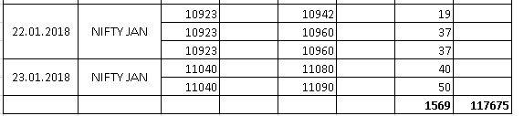
NIFTY OPTION:
BUY 11150PE @98 STOP 88 TGT 107-116-125-136-165.
BUY 11000CE @108+ STOP 100 TGT 119-128-144.
