NIFTY PREDICTION FOR 29/12/2017:
NIFTY SET FOR LAST TRADING DAY FOR THE YEAR 2017, RUNS 2342 NOT OUT.
SAR: 10447NS.
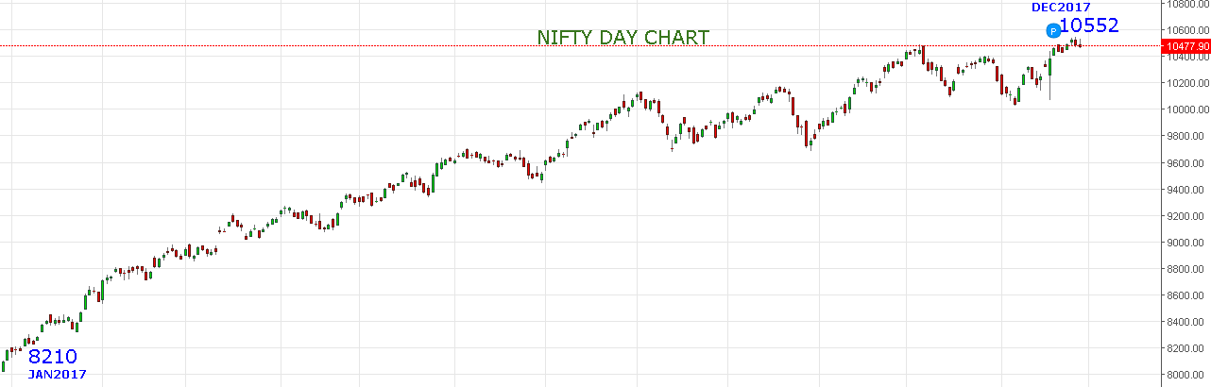
ONE DAY TO GO .
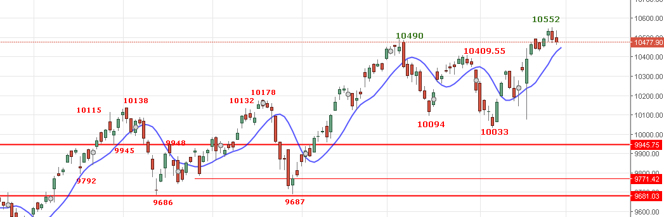
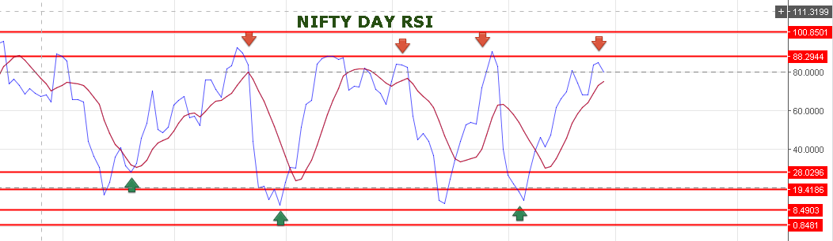
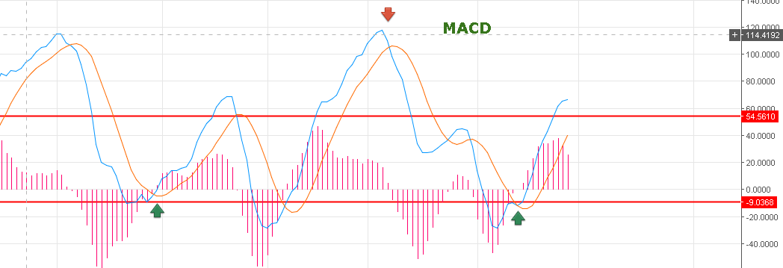
PRICE CLOSED BELOW 10490 LEVELS AND REMAIN WEAK AS LONG TRADING BELOW 10490NS.
BUT PRICE HOLDING THE SUPPORT LEVEL 10475-10450NS.
BEARISH BELOW 10425NS ONLY FOR 10390-10225NS.
BULLISH ABOVE 10525NS FOR NEW LIFE HIGH.
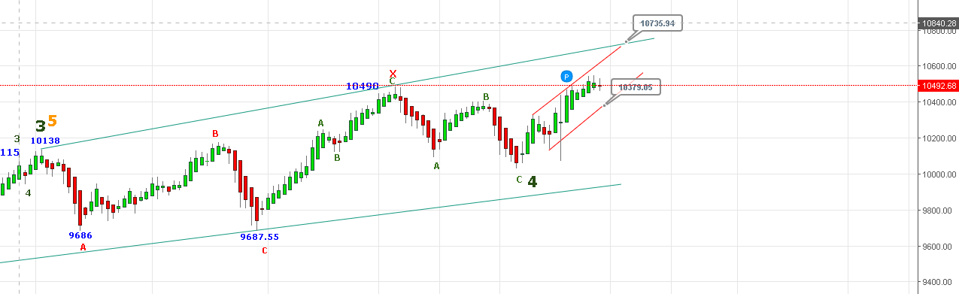
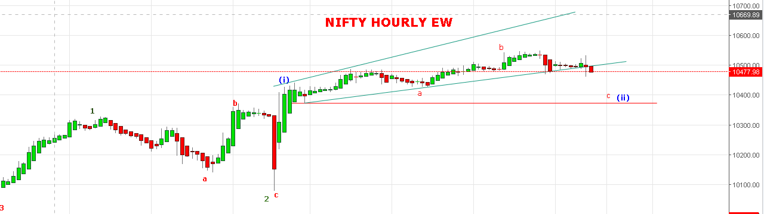
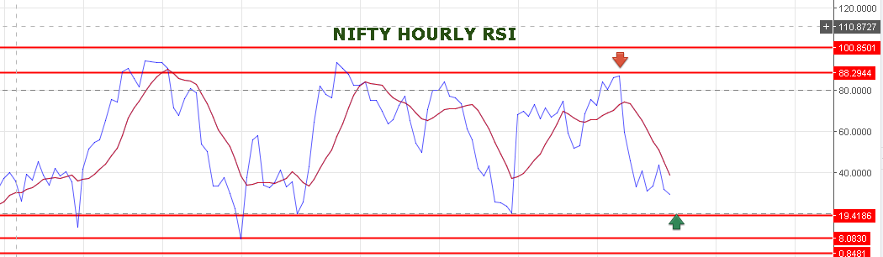
HOLDING LONG IN NF.STOP 10495NF TARGETS 10575-10605NF.
SHORT NF @10490 STOP 10510NF TARGETS 10478-10465-10455NF.
NIFTY IS BUY ON DECLINE MODE TILL 10435NS.
NIFTY OPTIONS:
BUY 10400PE @96 STOP 84 TARGETS 106-118-124-135.
HOLDING 10700CE STOP 42 TARGETS 56-67-74-90.

