NIFTY PREDICTION FOR 18/12/2017:
NIFTY HOLDING 10237-10280 WILL SEE 10569-10620>10800 LEVELS.
SAR: 10237NS.
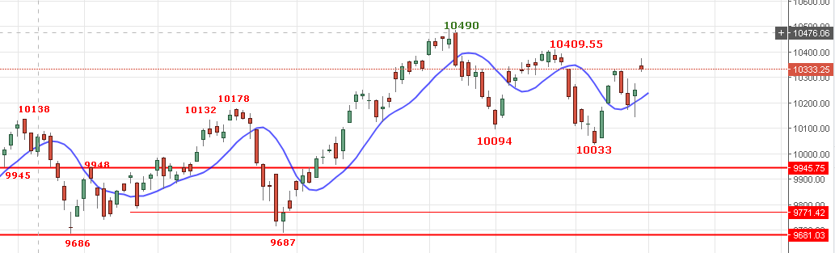
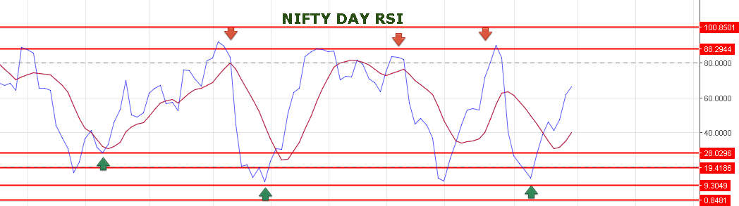
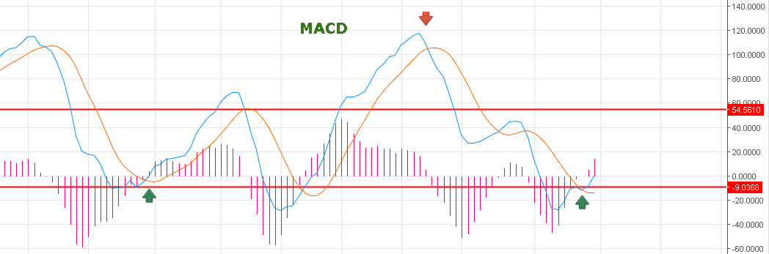
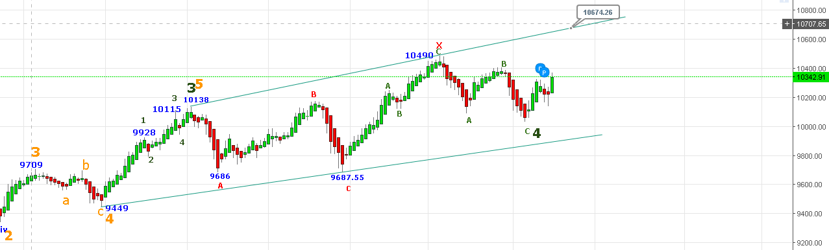
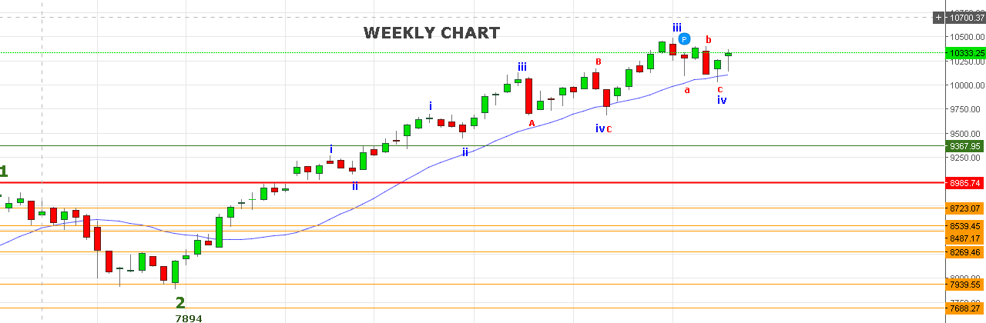
WEEKLY SUPPORT NOW 10100NS.
BEARISH BELOW 10100NS FOR 9955-9850-9780 LEVELS.
SHORT NIFTY BELOW 10262NS FOR 10100<9853 NS STOP 10312NS.
WEAKNESS BELOW 10305NS.
RESISTANCE NOW 10362-10410-10438-10497-10569NS.
SUPPORT: 10315-10305-10285NS.

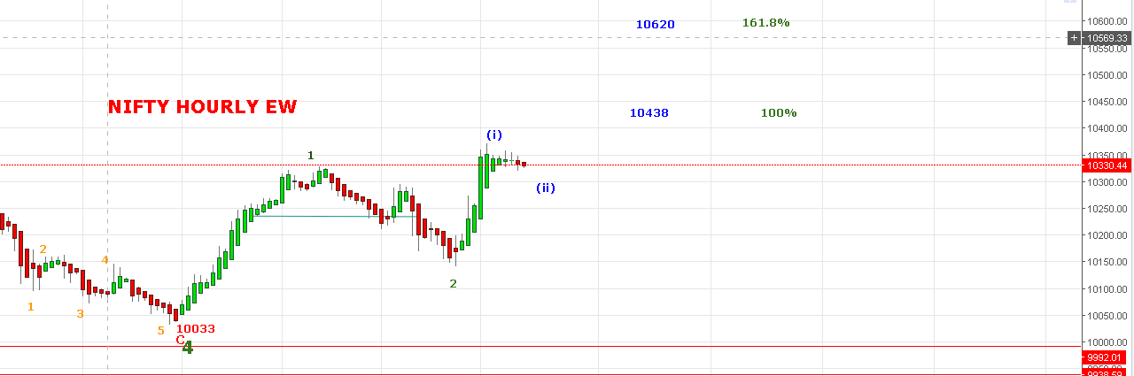

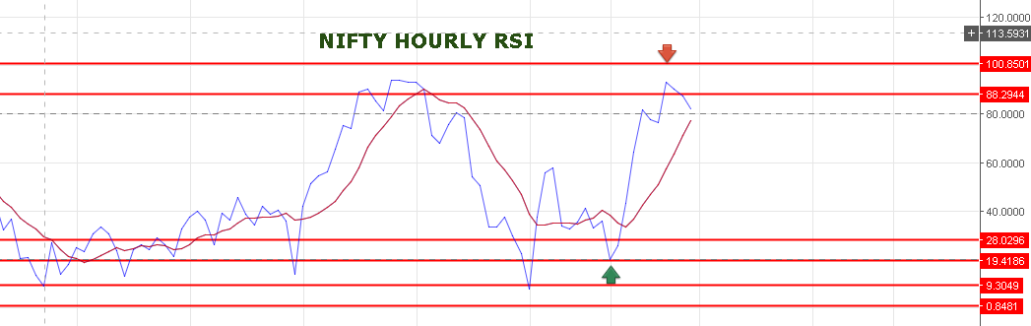
PROBABLY WE ARE IN 5(3)(ii) WAVE TARGET 10315 TO 10285 NS.TARGETS OF 3(iii) 10438-10620.
IF DAY MACD RISE THEN PRICE WILL SEE NEW LIFE HIGH.
WE DON’T HAVE ANY POSITION IN NF.
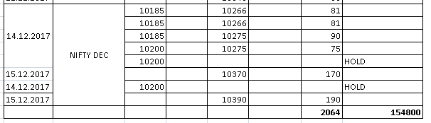
BUY NF @10370+ STOP 10350 TARGETS 10402-10454-10481-10509-10540-10581.
SHORT NF@10333 STOP 10353 TAREGTS 10291-10255-10232NF<10211-10192-10160-10122NF.

NIFTY OPTIONS:
HOLDING 10600CE @19 STOP AT COST NOW TARGETS 42-50-60-72-85>99-108.
HOLDING 10100PE @44 STOP 34 NOW TARGETS 55-59-70-81-95.
