NIFTY PREDICTION FOR 01/01/2018:
NIFTY YEAR 2018 RANGE 9550-12500.BEARISH BELOW 9500 LEVELS.
SAR: 10466NS.
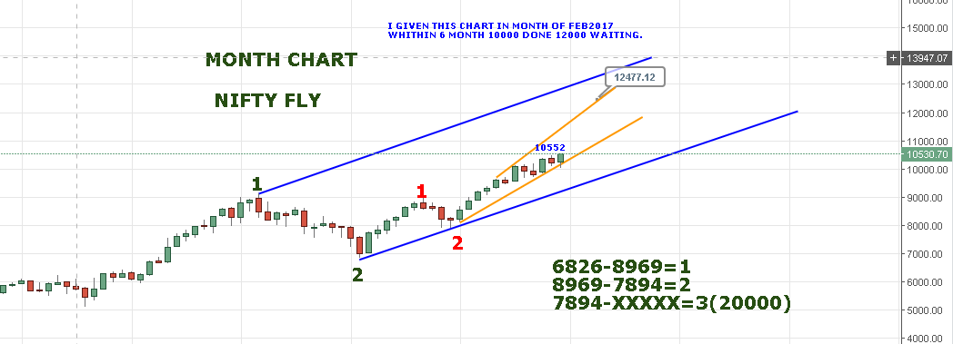
MONTH LOWER SUPPORT 9850 IF 10033 BROKEN AND REMAIN STRONG ABOVE 10329NS.

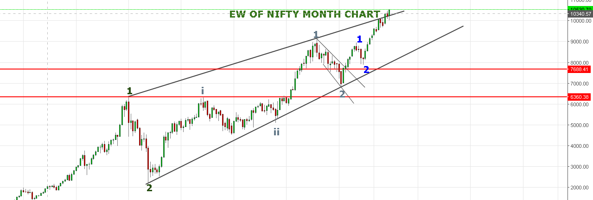
PRICE BROKEN OUT AND SUSTAINING ABOVE THE MONTH CHANNEL.

YEARLY CHART IS BULLISH ENGULFING CANDLE.
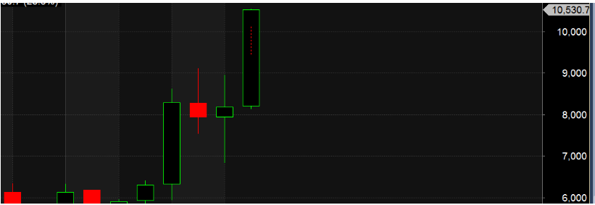
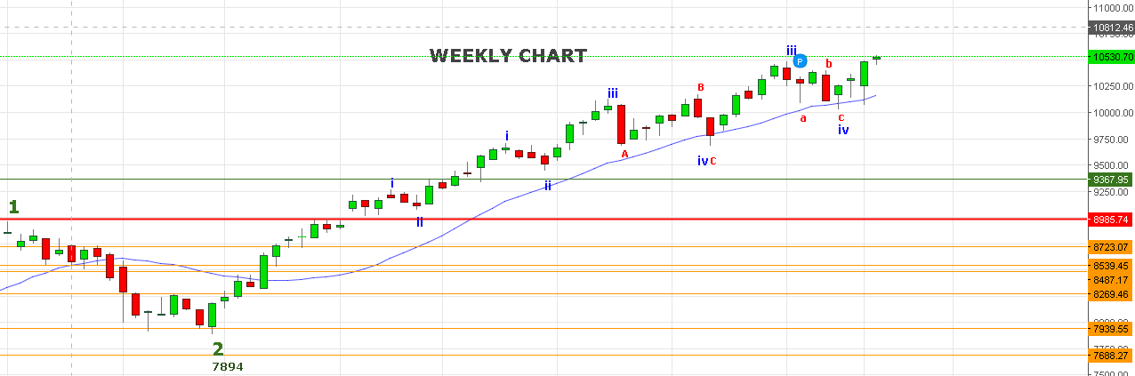
CANDLE IS LIKE HANGING MAN CUM SPINNING TOP CUM DOJI.
WEEKLY LOW WAS 10460 MUST HOLD ELSE BEARS WILL ENTER BELOW IT AND PRICE WILL COME DOWN TOWARDS 10330-10192/10163 LEVELS.
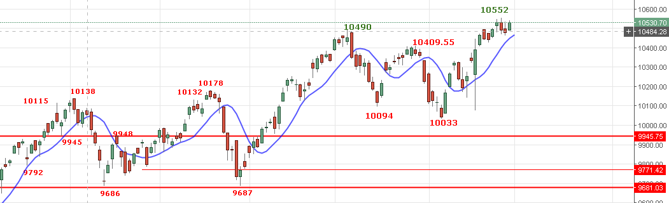
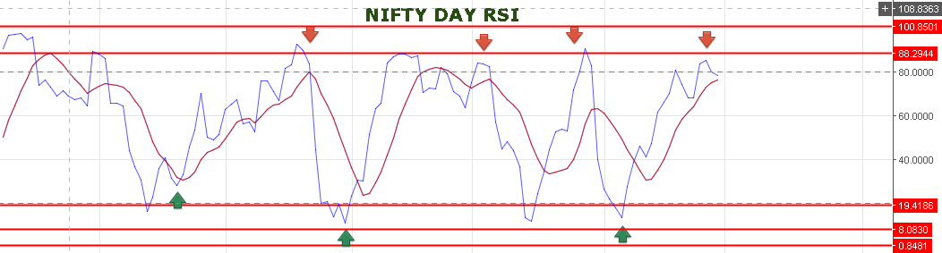
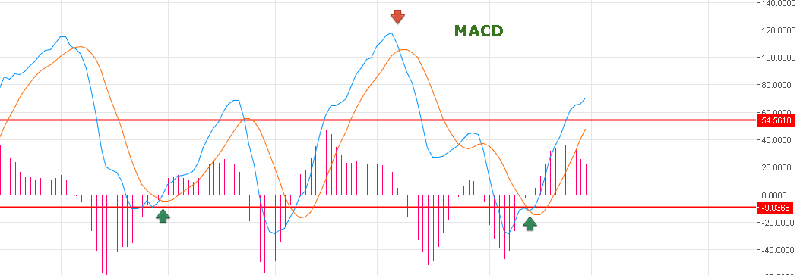
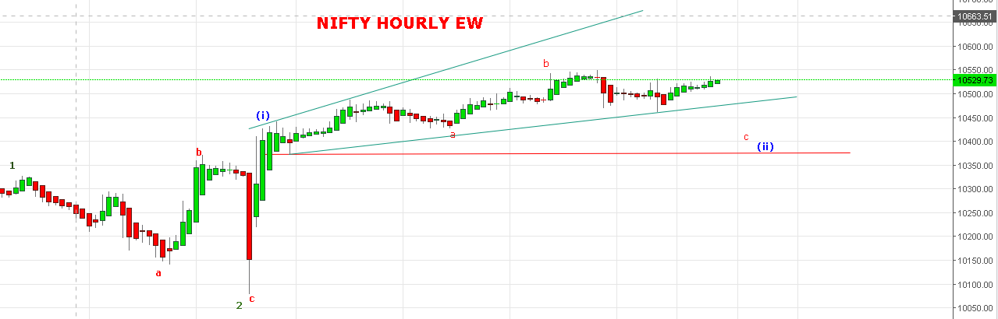
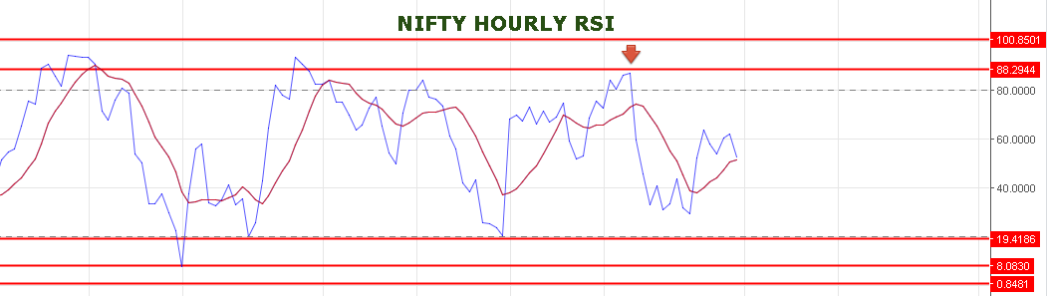

WEAKNESS BELOW 10500NS.
SUPPORT: 10458-10450<10412.
RESISTANCE:10556-10581-10623.
BUY NIFTY SPOT ABOVE 10540 AND SELL BELOW 10460NS.
BUY NIFTY FUTURE @10575-10580 STOP 10550 TARGETS 10604-10631-10650.
SHORT NF @10530 STOP 10556 TARGETS 10510-10480-10469.
NIFTY OPTIONS:
BUY 10700CE @62+ STOP 56 TARGETS 66-76-84.
BUY 10400PE @83 STOP 73 TARGETS 88-93-104-111-120.

WITH BEST WISHES: HAVE A PROFITABLE NEW YEAR .

